Münster, North Rhine-Westphalia, Germany
Germany's bicycle capital blends medieval grandeur with youthful energy — where the Peace of Westphalia was signed and iron cages still hang from a Gothic spire.
⚓ River pier (no tender) · 🕒 Typical call: 8-10 hrs · 💶 Euro (€) · 🗣️ German (English widely spoken) · 🚲 Cycling city
✍️ MY DAY IN PORT (FILL IN)
Ship / Date
In port | arrive ______ · all aboard ______
Booked excursion
Notes / meeting point
GETTING ASHORE
- Docking: River quay at Stadthafen I / Kreativkai on the Dortmund-Ems Canal
- Walk to center: ~20-25 min (1.8 km) to Prinzipalmarkt; flat and easy
- Best For: History, cycling, medieval architecture, German culture
- Don't Miss: Friedenssaal in the Historic Town Hall & St. Lamberti's iron cages
GETTING AROUND
- 🚕 Taxi: €14–26 — Licensed taxis are readily available; the meter starts at €4.30 (day) with ~€2.70–3.00/km. A ride from the canal quay to
- 📱 Rideshare: ✅ Uber, Bolt
- 🚌 Hop-on hop-off: ✅ Münsterbus / City Sightseeing Münster
TOP THINGS TO DO
- Hall of Peace & Historic Town Hall — Step inside the wood-paneled Friedenssaal where the Peace of Westphalia was signed in 1648, ending the Thirty Years' War.
- St. Paul's Cathedral & Astronomical Clock — This 13th-century cathedral blends Romanesque and Gothic architecture.
- Cycling the Promenade Ring — Rent a bike and circle the entire old town on the Promenade — a tree-lined ring path built on the medieval city walls.
- Pablo Picasso Art Museum — Germany's only museum dedicated exclusively to Picasso's graphic works — an unexpected gem in the heart of Westphalia.
- Aasee Lake Stroll — A large, peaceful lake just southwest of the old town.
BEST WALKS
- Quay to Prinzipalmarkt Old Town Walk: 1.8 km · 25 min · Flat — From the Kreativkai dock, walk along Schillerstraße into the historic center.
- Cathedral & Hall of Peace Loop: 2.5 km · 35 min · Flat — From the Prinzipalmarkt, walk to St.
WEATHER · DAYLIGHT · MONEY
Month | High °F | Low °F | Rainy days
May | 65 | 48 | 10
Jul | 74 | 58 | 13
Sep | 68 | 53 | 10
Daylight: May 5:35AM–9:16PM · Jul 5:28AM–9:42PM · Sep 7:04AM–7:43PM
cruiseports.org/stadt-munster · Confirm terminal & all-aboard time with your ship

Münster, North Rhine-Westphalia, Germany — Port Map
Red = walkable sights · Amber = excursions farther out · P = cruise terminal
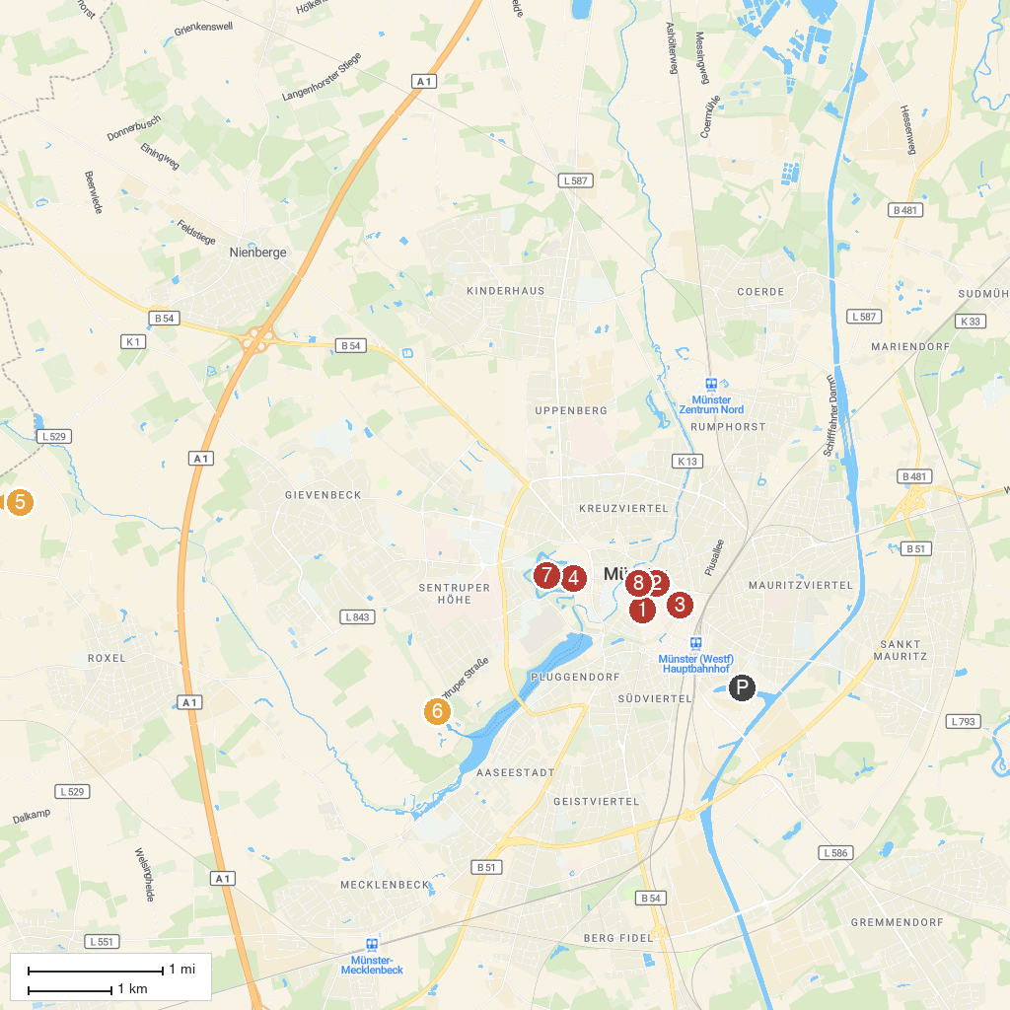
MAP KEY
1. Art Museum Pablo Picasso | 5. Burg Hülshoff
2. St. Lamberti | 6. LWL Museum of Natural History with Planetarium
3. Stadtmuseum Münster | 7. Botanical Garden of the University of Münster
4. Schlossplatz | 8. St.-Paulus-Dom
P. Cruise port / terminal
Map © MapTiler © OpenStreetMap contributors · cruiseports.org

