St Mary's, Isles of Scilly, England
Twenty-eight miles off Cornwall's tip, St Mary's rewards cruise visitors with white-sand beaches that look Caribbean, an Elizabethan garrison with sweeping island views, and a harbor town with no chain stores in sight.
⚓ Tender port · 🕒 Typical call: 6–8 hrs · 💷 British Pound (GBP) · 🗣️ English · 🌊 Weather-dependent tendering
✍️ MY DAY IN PORT (FILL IN)
Ship / Date
In port | arrive ______ · all aboard ______
Booked excursion
Notes / meeting point
GETTING ASHORE
- Docking: Tender to St Mary's Quay, Hugh Town
- Walk to center: 2 min from tender pier to Hugh Town
- Best For: Beaches, coastal walks, ancient history, island-hopping
- Don't Miss: The Garrison Walk & a tripper boat to Tresco Abbey Garden
GETTING AROUND
- 🚕 Taxi: £5–£15 — Local taxis (Toots Taxi, DJ Cabs) cover the whole island. Fares are short given the island's size; book ahead on busy po
TOP THINGS TO DO
- The Garrison Walk — A 1.5-mile loop along Elizabethan garrison walls starting just 10 minutes uphill from the pier.
- Tresco Abbey Garden Day Trip — A 20-minute tripper boat ride reaches the world-famous sub-tropical garden on Tresco — 20,000 plant specimens from 80 countries…
- Bronze Age Burial Chambers — Bant's Carn and Halangy Down Ancient Village on the island's north side offer a well-preserved Iron Age settlement and a Bronze…
- Wildlife RIB Safari — RIB boat tours depart from the quay to spot Atlantic grey seals on rocky haul-outs, puffins (May–July), dolphins, and seabirds…
- Porthcressa Beach & Hugh Town — A 7-minute walk from the pier brings you to Porthcressa, a crescent of white sand with turquoise water that looks Mediterranean.
BEST WALKS
- The Garrison Loop: 1.5 miles · 45–60 min · Moderate (uphill start) · Free — From St Mary's Quay, follow the road up to the Garrison gate.
- Pelistry Bay & Toll's Island: 4 miles round trip · 1.5–2 hrs · Easy · Free — Head northeast out of Hugh Town along the coast path to secluded Pelistry Bay.
- Peninnis Head Cliff Walk: 3 miles round trip · 1–1.5 hrs · Easy · Free — Walk south from Hugh Town to the dramatic granite tors and lighthouse of Peninnis Head.
WEATHER · DAYLIGHT · MONEY
Month | High °F | Low °F | Rainy days
May | 54 | 52 | 9
Jul | 63 | 61 | 8
Sep | 62 | 60 | 11
Daylight: May 5:39AM–9:04PM · Jul 5:33AM–9:28PM · Sep 7:01AM–7:38PM
cruiseports.org/st-marys-island-england · Confirm terminal & all-aboard time with your ship

St Mary's, Isles of Scilly, England — Port Map
Red = walkable sights · Amber = excursions farther out · P = cruise terminal
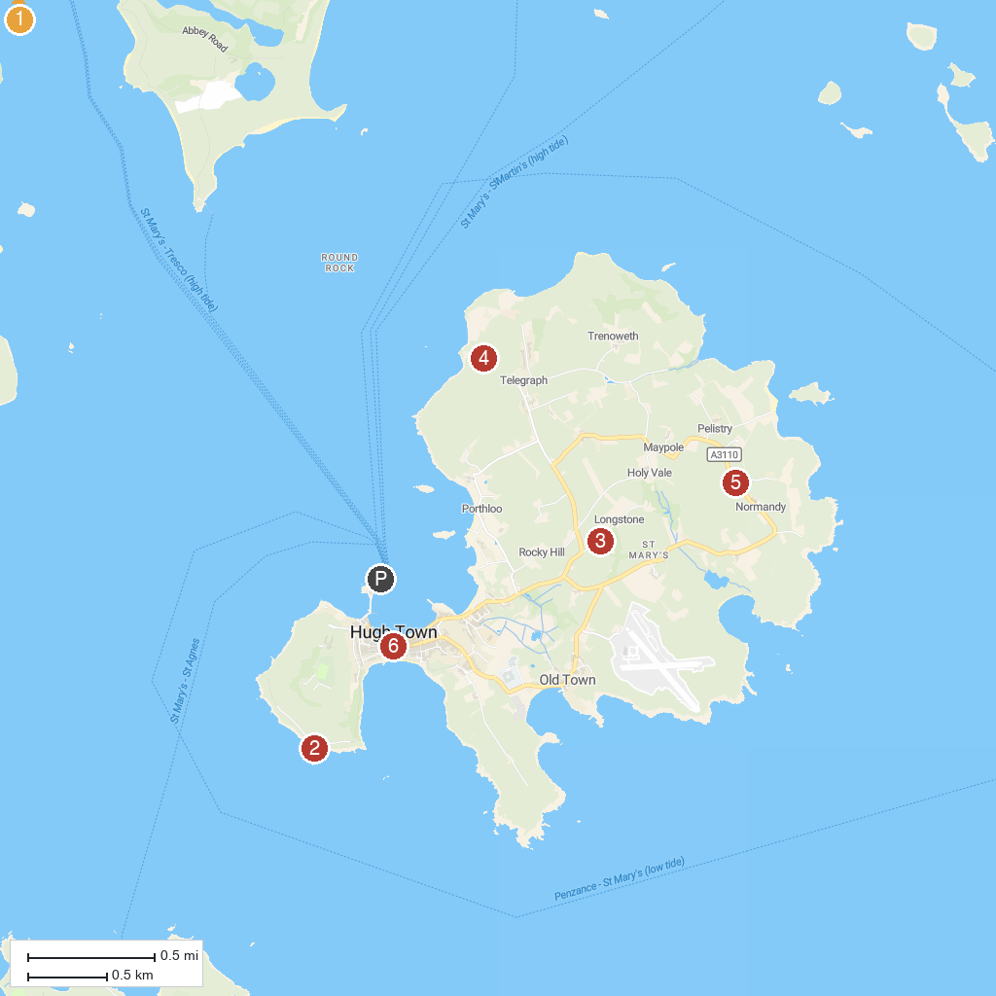
MAP KEY
1. Cromwell's Castle | 4. Bant's Carn Burial Chamber and Halangy Down Ancient Village
2. Garrison Walls | 5. Isles of Scilly Heritage Coast
3. Carreg Dhu Gardens | 6. Isles Of Scilly Museum
P. Cruise port / terminal
Map © MapTiler © OpenStreetMap contributors · cruiseports.org

