St Marys, Georgia, USA
A moss-draped colonial river town where wild horses roam Carnegie ruins and 17 miles of untouched Atlantic beach wait just a ferry ride away.
⚓ Pier (small-ship dock) · 🕒 Typical call: 6-8 hrs · 💵 US Dollar · 🗣️ English · 🐴 Wild horses on Cumberland Island
✍️ MY DAY IN PORT (FILL IN)
Ship / Date
In port | arrive ______ · all aboard ______
Booked excursion
Notes / meeting point
GETTING ASHORE
- Docking: Pier — St Marys City Dock / Gateway Marina (no tendering)
- Walk to center: 0 min — downtown begins at the gangway
- Best For: Cumberland Island day trip, historic walking, Southern seafood
- Don't Miss: Wild horses and Dungeness Mansion ruins on Cumberland Island
GETTING AROUND
- 🚕 Taxi: Metered — Happy Cab (912-729-2227) serves St. Marys and the surrounding area. Short rides within town are inexpensive given the sm
- 📱 Rideshare: ✅ Uber, Lyft
TOP THINGS TO DO
- Cumberland Island National Seashore Day Trip — Take the 45-minute NPS ferry to one of America's most pristine barrier islands.
- Historic Downtown Walking Tour — St Marys is one of America's oldest cities (est.
- St Marys Submarine Museum — Located right on the waterfront, this museum honors nearby Kings Bay Naval Submarine Base — home to East Coast Trident submarines.
- Wild Horse and Ruins Walk on Cumberland Island — From the ferry dock at Sea Camp, walk 1.5 miles south through the maritime forest to the iconic Dungeness ruins.
- Rock Shrimp Lunch on the Waterfront — St Marys is famous for local rock shrimp — a deep-water variety that tastes like a cross between lobster and shrimp.
BEST WALKS
- Historic Downtown Loop: 1.5 miles • 30-40 min • Easy — From the City Dock, walk up Osborne Street through the heart of historic downtown.
- Cumberland Island: Dungeness Trail: 3 miles round trip • 1.5-2 hrs • Easy (flat sand) — From the Sea Camp ferry dock on Cumberland Island, take the main south trail through maritime…
WEATHER · DAYLIGHT · MONEY
Month | High °F | Low °F | Rainy days
May | 84 | 66 | 11
Jul | 89 | 75 | 21
Sep | 84 | 72 | 18
Daylight: May 6:31AM–8:14PM · Jul 6:34AM–8:30PM · Sep 7:11AM–7:31PM
cruiseports.org/st-marys-ga · Confirm terminal & all-aboard time with your ship

St Marys, Georgia, USA — Port Map
Red = walkable sights · Amber = excursions farther out · P = cruise terminal
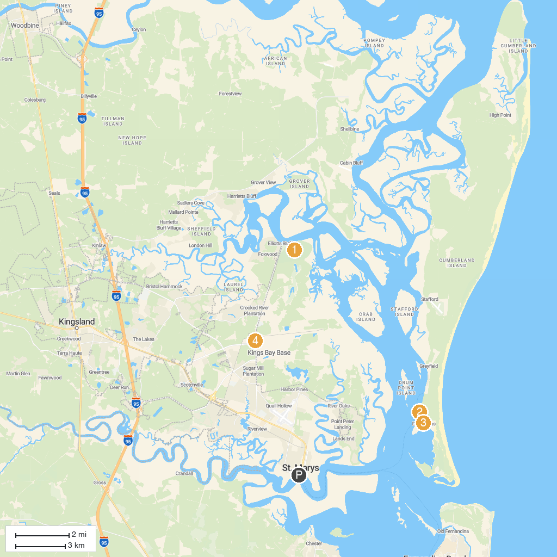
MAP KEY
1. Crooked River State Park | 5. Dungeness Ruins
2. Central Park | 6. Amelia Island Museum of History
3. Amelia River Cruises & Charters | 7. McIntosh Sugarmill Park
4. Ice House Museum
P. Cruise port / terminal
Map © MapTiler © OpenStreetMap contributors · cruiseports.org

