Philipsburg, Sint Maarten / Saint-Martin
One island, two nations, zero border hassle — and one of the Caribbean's best spectacles. The Dutch side packs duty-free shops, casinos, and Maho's jet-blast beach into a walkable strip from the pier; the French side rewards a short taxi ride with Grand Case's bistros, Orient Bay's turquoise water, and a noticeably different vibe.
⚓ Docked — Dr. A.C. Wathey Cruise Pier · 🕒 Typical call: 8–10 hrs · 💵 U.S. Dollar (Dutch side) · Euro (French side) · 🗣️ Dutch / English / French
✍️ MY DAY IN PORT (FILL IN)
Ship / Date
In port | arrive ______ · all aboard ______
Booked excursion
Notes / meeting point
GETTING ASHORE
- Docking: Dr. A.C. Wathey Cruise & Cargo Facility, Great Bay — up to 6 ships simultaneously
- To center: 5 min walk or short water taxi to Front Street, Philipsburg
- Best For: Duty-Free Shopping · Maho Beach · French Side Day Trip
- Don't Miss: Planes landing over Maho Beach — check Flightradar24 for timing
GETTING AROUND
- 🚕 Taxi: $7 USD round-trip — The easiest way from the cruise terminal to Philipsburg city center. Round-trip tickets sold at a booth near the pier; c
- 📱 Rideshare: ❌ not available
- 🚌 Hop-on hop-off: ✅
TOP THINGS TO DO
- Maho Beach Plane-Spotting — Princess Juliana International Airport's runway ends just meters from the beach — commercial jets pass directly overhead at…
- Orient Bay — French Side Showcase — The French side's signature beach stretches nearly a mile along calm turquoise water.
- Grand Case: Caribbean Culinary Capital — A single main street on the French side lined with the best French-Creole restaurants in the entire region.
- America's Cup Sailing Race — Race a retired 12-metre America's Cup yacht in Great Bay alongside fellow passengers.
- Loterie Farm & Fly Zone Ziplines — A private eco-reserve on Pic Paradis (the island's highest point) with rainforest trails, a spring-fed pool, and zipline runs…
BEST WALKS
- Pier to Front Street & Great Bay Beach: ~1.5 km · 20 min · easy — Walk straight off the pier along the Great Bay promenade.
- Fort Amsterdam & Little Bay: ~2.5 km · 45 min · easy-moderate — Head west from the pier to the Fort Amsterdam headland — a 17th-century Dutch fortification (the…
- Great Bay Boardwalk Loop: 1.5 km · flat · 30 min — Walk the Great Bay Beach boardwalk from Bobby's Marina westward, dipping in and out of Front…
WEATHER · DAYLIGHT · MONEY
Month | High °F | Low °F | Rainy days
May | 57 | 34 | 13
Jul | 78 | 50 | 6
Sep | 67 | 42 | 8
Daylight: May 5:59AM–9:00PM · Jul 5:56AM–9:21PM · Sep 7:11AM–7:43PM
cruiseports.org/st-maarten · Confirm terminal & all-aboard time with your ship

Philipsburg, Sint Maarten / Saint-Martin — Port Map
Red = walkable sights · Amber = excursions farther out · P = cruise terminal
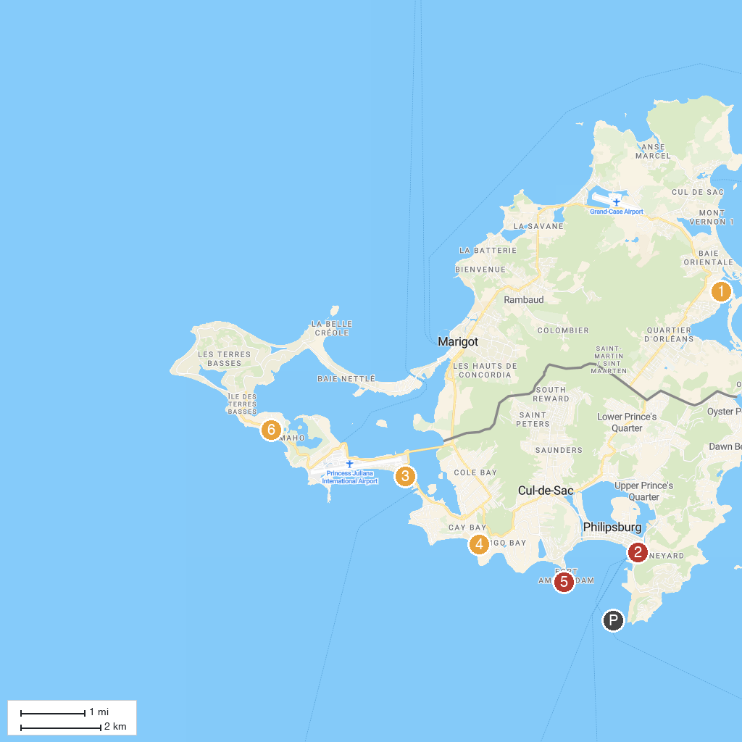
MAP KEY
1. The Butterfly Farm | 4. Seaside Ranch St. Maarten
2. Diamond Casino SXM | 5. Fort Amsterdam
3. Mary, Star of the Sea Catholic Church | 6. Starz City Casino
P. Cruise port / terminal
Map © MapTiler © OpenStreetMap contributors · cruiseports.org

