Castries, St. Lucia, Caribbean
St. Lucia is one of the Caribbean's most visually dramatic islands — the twin volcanic peaks of the Pitons rise straight from the sea near Soufrière, the rainforest is genuinely wild, and the waterfalls and hot springs are the real thing. Castries is a working port with easy access to all of it.
⚓ Docked — Pointe Séraphine / La Place Carenage · 🕒 Typical call: 8–10 hrs · 💵 Eastern Caribbean Dollar (XCD) · USD widely accepted · 🗣️ English (official) · St. Lucian Creole
✍️ MY DAY IN PORT (FILL IN)
Ship / Date
In port | arrive ______ · all aboard ______
Booked excursion
Notes / meeting point
GETTING ASHORE
- Docking: Pointe Séraphine (north side of Castries Harbour) or La Place Carenage (city-side dock)
- To center: La Place Carenage: steps from Derek Walcott Square. Pointe Séraphine: ~10-min walk around the harbour or a short water taxi across (small fee)
- Best For: The Pitons · Diamond Falls · Rainforest zip-lines · Sulphur Springs · Marigot Bay
- Don't Miss: A boat or road trip south to Soufrière and the Pitons — St. Lucia's defining landscape
GETTING AROUND
- 🚕 Taxi: $10–$20 USD — Government-regulated taxis queue at both terminals. Short rides within Castries run $10–$20 USD; always agree on the far
- 📱 Rideshare: ✅ Uber
TOP THINGS TO DO
- Soufrière & the Pitons by Boat — The classic St.
- Diamond Falls Botanical Gardens — Set in the lush grounds of the Soufrière Estate, Diamond Falls is a ~15-metre (roughly 50-foot) waterfall fed by mineral-rich…
- Rainforest Zip-line & Aerial Tram — St.
- Reduit Beach at Rodney Bay — The most accessible good beach from Castries — a long crescent of calm Caribbean water backed by hotels, bars, and beach rentals…
- Pigeon Island National Landmark — A fortified promontory on the northwest coast connected to the mainland by a causeway, Pigeon Island has dramatic ruins of…
BEST WALKS
- Castries Waterfront & City Center Loop: ~1.5 km · 30–45 min · easy — From La Place Carenage, walk east along the waterfront to Derek Walcott Square — the city's main…
- Morne Fortune Hilltop Viewpoint: ~3 km drive or steep 45-min walk · moderate — Morne Fortune ('Hill of Good Luck') rises directly behind Castries to about 260 metres and was the…
- Castries City Centre Walk: 1-2 hrs • Flat • Walkable from La Place Carenage — A simple loop through downtown Castries takes in the bustling Central Market (spices, crafts…
WEATHER · DAYLIGHT · MONEY
Month | High °F | Low °F | Rainy days
May | 85 | 76 | 12
Jul | 84 | 76 | 23
Sep | 86 | 77 | 21
Daylight: May 5:37AM–6:23PM · Jul 5:44AM–6:35PM · Sep 5:53AM–6:04PM
cruiseports.org/st-lucia · Confirm terminal & all-aboard time with your ship

Castries, St. Lucia, Caribbean — Port Map
Red = walkable sights · Amber = excursions farther out · P = cruise terminal
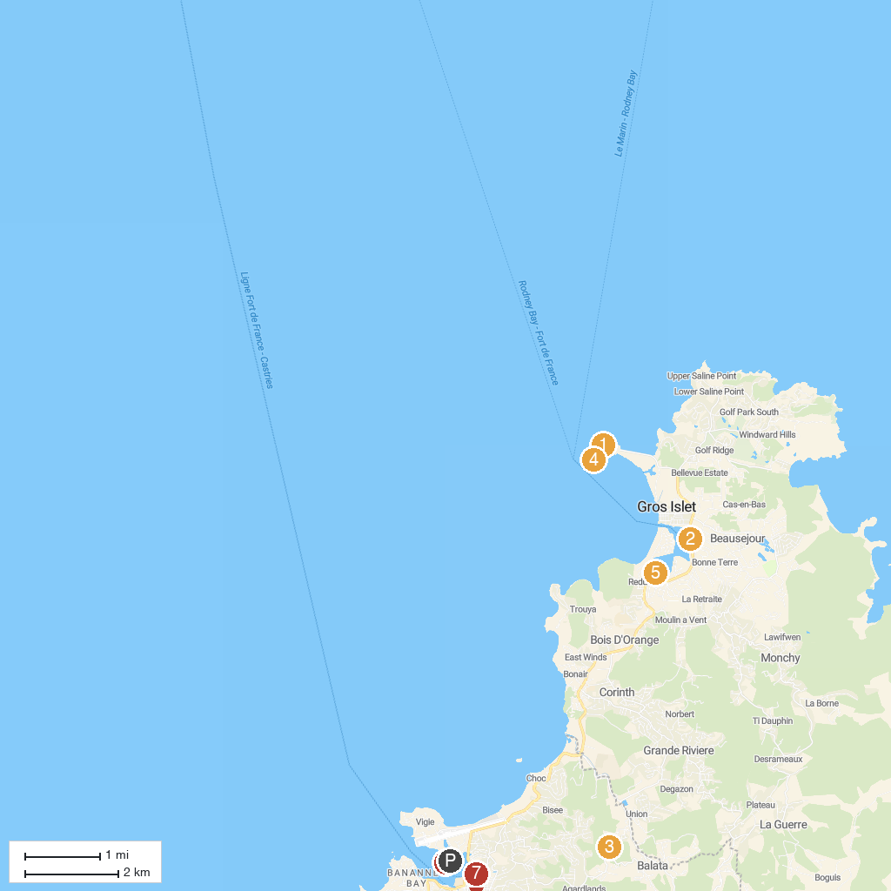
MAP KEY
1. Signal Peak | 5. Treasure Bay Casino
2. Sea Spray Cruises Ltd. | 6. Constitution Park
3. Lushan Country Life | 7. The Minor Basilica of the Immaculate Conception (Cathedral)
4. Fort Rodney | 8. Cruise Pier Castries
P. Cruise port / terminal
Map © MapTiler © OpenStreetMap contributors · cruiseports.org

