St John's, Newfoundland
The steep walk from the downtown core up to Signal Hill rewards visitors with sweeping harbor views and a glimpse of the city's colorful architecture.
Cape Spear · Signal Hill · The Rooms · Quidi Vidi
✍️ MY DAY IN PORT (FILL IN)
Ship / Date
In port | arrive ______ · all aboard ______
Booked excursion
Notes / meeting point
GETTING ASHORE
- Best view: Panoramic harbor vista from the summit of Signal Hill.
- Local specialty: Fresh Atlantic cod or a traditional Screech-in ceremony at a local pub.
- Must-visit: Cape Spear, the easternmost point of North America.
- Unique feature: The iconic brightly painted jellybean houses lining downtown streets.
GETTING AROUND
- 🚕 Taxi: US$6–16 — Taxis wait at the cruise terminal and are the primary transport option. Short trips within St. John's city cost US$6 per
- 📱 Rideshare: ❌ not available
TOP THINGS TO DO
- Signal Hill & Cape Spear Tour — Visit iconic Signal Hill, site of Marconi's first transatlantic wireless signal, then continue to Cape Spear, the easternmost…
- Jellybean Row Walk — Stroll the vibrant downtown streets lined with colorful Victorian row houses and learn their unique history.
- Coastal Wildlife Boat Tour — Head out on the Atlantic for chances to spot puffins, whales, and icebergs along the rugged coastline.
- The Rooms Museum Visit — Explore Newfoundland and Labrador's art, artifacts, and stories at this striking hilltop cultural complex.
BEST WALKS
- Signal Hill Walk: Panoramic harbor and city views. — Climb from downtown to the historic signal station where the first transatlantic wireless message…
- Waterfront Promenade: Easy harbor stroll. — Stroll the waterfront path past fishing boats, seafood spots, and local shops.
- Jellybean Row Walk: Colorful houses and local charm. — Wander the steep, narrow streets lined with the city's signature painted row houses.
WEATHER · DAYLIGHT · MONEY
Month | High °F | Low °F | Rainy days
May | 48 | 36 | 11
Jul | 66 | 55 | 11
Sep | 62 | 52 | 12
Daylight: May 5:23AM–8:31PM · Jul 5:19AM–8:53PM · Sep 6:38AM–7:12PM
cruiseports.org/st-johns · Confirm terminal & all-aboard time with your ship

St John's, Newfoundland — Port Map
Red = walkable sights · Amber = excursions farther out · P = cruise terminal
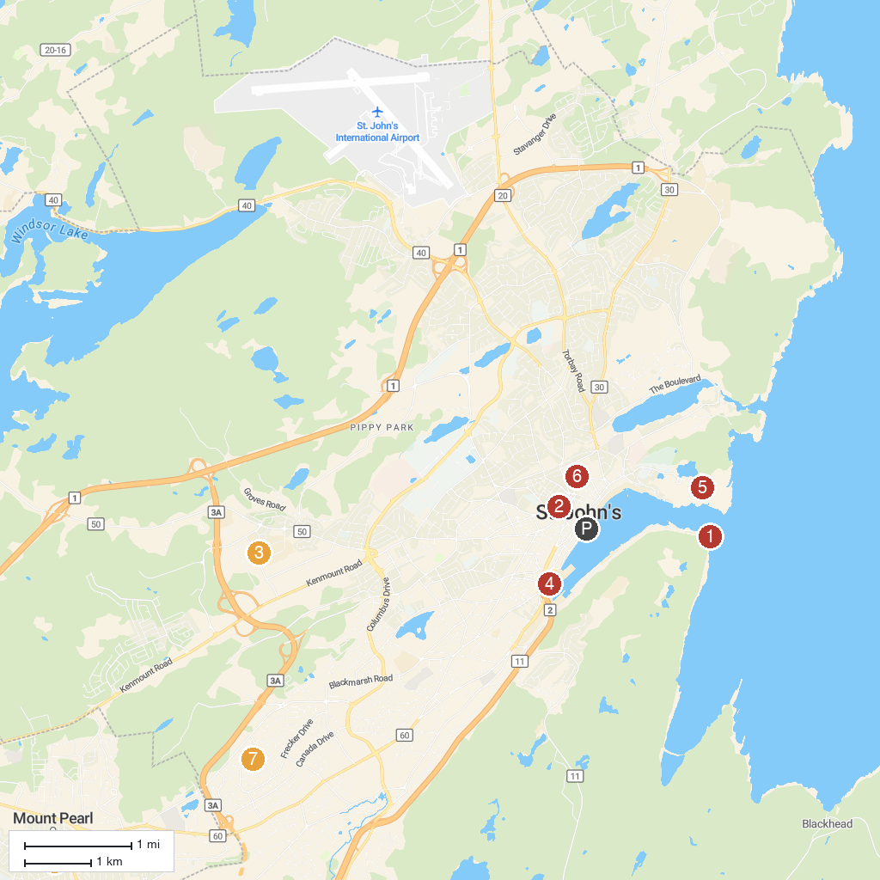
MAP KEY
1. Fort Amherst | 5. Signal Hill National Historic Site
2. The Basilica Cathedral of St. John the Baptist | 6. Bannerman Park
3. East Coast Trail Association | 7. Kitty Gaul Park
4. Newman Wine Vaults Provincial Historic Site | 8. St. David's Park
P. Cruise port / terminal
Map © MapTiler © OpenStreetMap contributors · cruiseports.org

