St. George's, Grenada, Caribbean
Grenada's horseshoe harbor bursts with color, spice aromas, and one of the Caribbean's finest beaches just a water taxi away. Fort George crowns the hill; the world's first underwater sculpture park waits offshore.
⚓ Docked (Melville Street Terminal) · 🕒 Typical call: 7-9 hrs · 💵 Eastern Caribbean Dollar (USD widely accepted) · 🗣️ English
✍️ MY DAY IN PORT (FILL IN)
Ship / Date
In port | arrive ______ · all aboard ______
Booked excursion
Notes / meeting point
GETTING ASHORE
- Docking: Melville Street Cruise Terminal — 2 berths, 375 m each; ships anchor/tender on busy days
- Walk to center: 5 min to Carenage waterfront; 10 min to Market Square
- Best For: Spice heritage, rainforest hikes, Grand Anse Beach, underwater sculpture snorkeling
- Don't Miss: Grand Anse Beach, Fort George views, Molinière Underwater Sculpture Park
GETTING AROUND
- 🚕 Taxi: $4–$5 USD (city center); $15–$20 USD (Grand Anse Beach) — Government-regulated taxis queue at the cruise terminal. Agree on the fare before departure — prices are per person unle
- 📱 Rideshare: ❌ not available
- 🚌 Hop-on hop-off: ✅
TOP THINGS TO DO
- Grand Anse Beach — Two miles of powder-white sand and calm turquoise water, consistently ranked among the Caribbean's finest.
- Fort George Walk — Built by the French between 1706 and 1710, Fort George tops the hill above the Carenage with sweeping views of the harbor and…
- Grand Etang National Park — A volcanic crater lake surrounded by lush rainforest about 35 minutes from port.
- Molinière Underwater Sculpture Park — The world's first underwater art gallery, created by sculptor Jason deCaires Taylor.
- Spice Plantation & Market Tour — Grenada is the world's second-largest nutmeg producer.
BEST WALKS
- Carenage Waterfront & Market Square Loop: 1.5 km · 30-45 min · Easy — Walk from the Melville Street terminal through the Esplanade Mall to the Carenage waterfront…
- Fort George Climb: 2 km round-trip · 45-60 min · Moderate (steep uphill) — From the Carenage, climb Church Street up to Fort George, a well-preserved French fort built in…
WEATHER · DAYLIGHT · MONEY
Month | High °F | Low °F | Rainy days
May | 84 | 78 | 14
Jul | 83 | 78 | 23
Sep | 85 | 79 | 20
Daylight: May 5:43AM–6:23PM · Jul 5:50AM–6:35PM · Sep 5:56AM–6:07PM
cruiseports.org/st-georges-grenada · Confirm terminal & all-aboard time with your ship

St. George's, Grenada, Caribbean — Port Map
Red = walkable sights · Amber = excursions farther out · P = cruise terminal
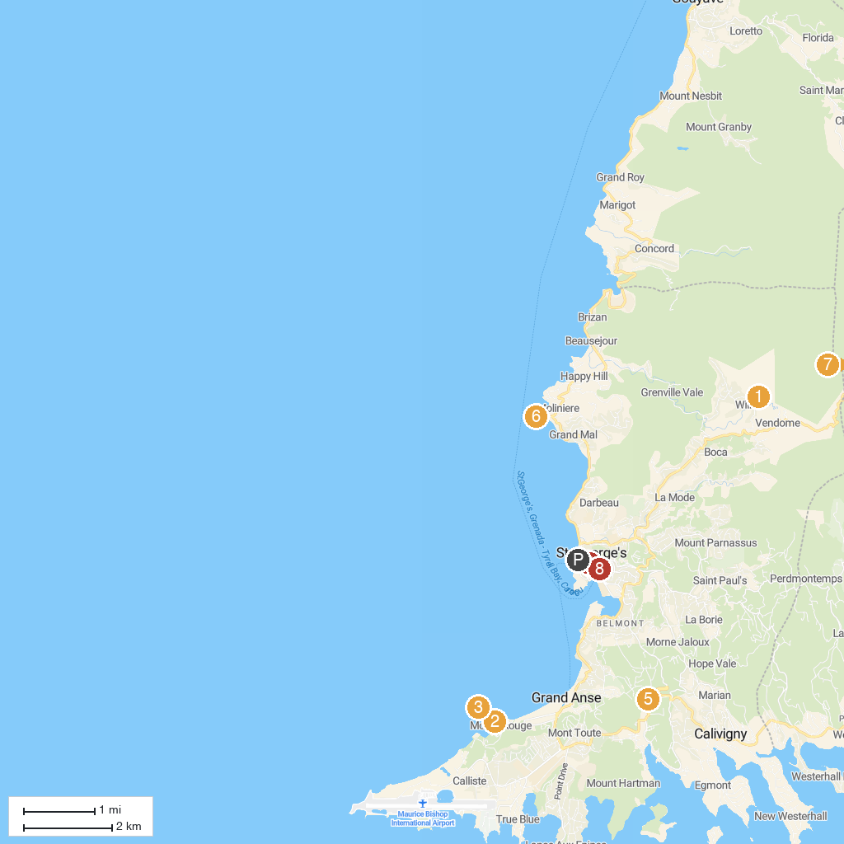
MAP KEY
1. Annandale Waterfall & Forest Park | 5. Clarke's Court Rum
2. BBC Beach | 6. Grenada Underwater Sculpture Park
3. Quarantine Point | 7. Grand Étang National Park
4. Cathedral of the Immaculate Conception | 8. Christ Of The Deep
P. Cruise port / terminal
Map © MapTiler © OpenStreetMap contributors · cruiseports.org

