St George, Bermuda
The oldest continuously inhabited English town in the New World, St George is a living museum of pastel cottages, winding lanes, and Atlantic history — all walkable from the pier.
⚓ Pier (small/mid ships) or Tender (large ships) · 🕒 Typical call: 7-9 hrs · 💵 USD = BMD (1:1 accepted everywhere) · 🗣️ English · 🏖️ Beaches nearby
✍️ MY DAY IN PORT (FILL IN)
Ship / Date
In port | arrive ______ · all aboard ______
Booked excursion
Notes / meeting point
GETTING ASHORE
- Docking: Penno's Wharf / Ordnance Island for ships under ~680 ft; larger ships anchor and tender in
- Walk to center: 1 min from pier to King's Square
- Best For: History, walkable town, snorkeling at Tobacco Bay
- Don't Miss: St Peter's Church, the Unfinished Church, Tobacco Bay Beach
GETTING AROUND
- 🚕 Taxi: ~$5.95 USD — Government-regulated taxis meet ships at the pier. Meter starts at ~$5.95; short hops within town are inexpensive. Confi
- 📱 Rideshare: ✅ HITCH
- 🚌 Hop-on hop-off: ✅
TOP THINGS TO DO
- UNESCO Old Town Walking Tour — Wander King's Square, duck into St Peter's Church (oldest Anglican church in the Western Hemisphere), visit the roofless…
- Tobacco Bay Beach — A sheltered volcanic cove 20 minutes' walk from the pier — the best snorkeling in the St George area.
- Fort St Catherine — Bermuda's largest fort commands sweeping ocean views from the island's northeastern tip.
- Lili Bermuda Perfumery — Free guided tour of the perfume studio in historic Stewart Hall, where local flowers — Easter lily, oleander, jasmine — are…
- Dunking Stool Reenactment — On weekday middays in cruise season, the Town Crier stages a mock 18th-century trial in King's Square ending in a dunking.
BEST WALKS
- Old Town Heritage Loop: 1.5 km · 45 min · Easy — From Ordnance Island, cross to King's Square, then wind up to St Peter's Church, through Somers…
- Pier to Tobacco Bay: 1.8 km · 20 min · Moderate (hilly) — Head north along Coot Pond Road and Barry Road to reach Tobacco Bay — the most spectacular swimming…
- Tobacco Bay to Fort St Catherine: 1.2 km · 15 min · Easy — Continue past Tobacco Bay along the coast path to Fort St Catherine Beach and the fort itself for…
WEATHER · DAYLIGHT · MONEY
Month | High °F | Low °F | Rainy days
May | 72 | 69 | 11
Jul | 80 | 78 | 15
Sep | 81 | 78 | 14
Daylight: May 6:20AM–8:09PM · Jul 6:22AM–8:26PM · Sep 7:02AM–7:24PM
cruiseports.org/st-george · Confirm terminal & all-aboard time with your ship

St George, Bermuda — Port Map
Red = walkable sights · Amber = excursions farther out · P = cruise terminal
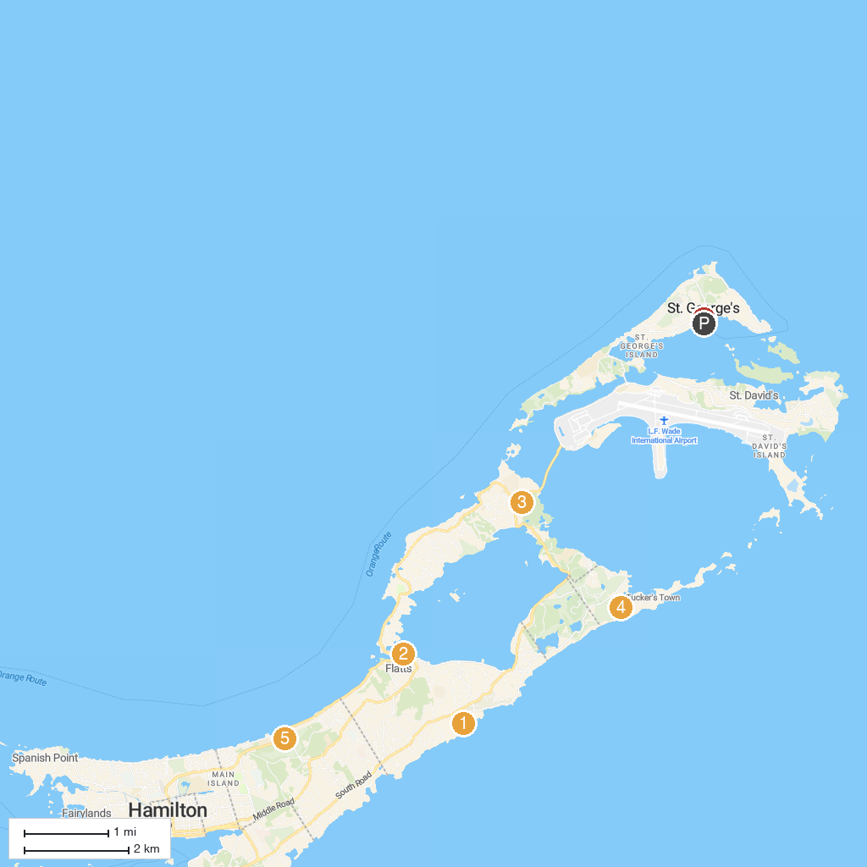
MAP KEY
1. Spittal Pond | 5. Mid Ocean Club
2. Queen Elizabeth Par-La-Ville Sculpture Park | 6. Ocean View Golf Course
3. Bermuda Aquarium, Museum & Zoo | 7. Kings Square
4. Crystal and Fantasy Caves
P. Cruise port / terminal
Map © MapTiler © OpenStreetMap contributors · cruiseports.org

