St Croix, U.S. Virgin Islands
The largest and least-visited of the U.S. Virgin Islands rewards curious cruisers with Danish colonial forts, one of the Caribbean's premier reef snorkel sites, award-winning rum distilleries, and uncrowded beaches steps from the pier.
⚓ Pier (docked) · 🕒 Typical call: 7-9 hrs · 💵 USD (no currency exchange needed) · 🗣️ English · 🇺🇸 U.S. Territory
✍️ MY DAY IN PORT (FILL IN)
Ship / Date
In port | arrive ______ · all aboard ______
Booked excursion
Notes / meeting point
GETTING ASHORE
- Docking: Ann E. Abramson Marine Facility, Frederiksted — deep-water pier, no tender
- Walk to center: 5-min walk along pier into Frederiksted town
- Best For: Snorkeling Buck Island, rum distillery tours, Danish colonial history
- Don't Miss: Fort Frederik (steps from pier) and a Crucian Hook bracelet
GETTING AROUND
- 🚕 Taxi: $6–$36 — Government-regulated taxis queue at the Frederiksted Pier on cruise days. Fares are per person: within Frederiksted ~$6,
TOP THINGS TO DO
- Buck Island Reef National Monument — One of only three underwater national monuments in the U.S., Buck Island features a marked underwater snorkel trail through…
- Fort Frederik & Frederiksted Walk — Steps from the pier, Fort Frederik is where Governor von Scholten emancipated enslaved people in 1848.
- Christiansted National Historic Site — The island's former capital features Fort Christiansvaern — a striking yellow Danish fort — plus the Custom House and Steeple…
- Cruzan Rum Distillery Tour — St Croix is rum country.
- Rainbow Beach Day — Lively beach bar north of the pier with Rhythms at Rainbow Beach restaurant, chair and umbrella rentals, jet ski hire, and…
BEST WALKS
- Frederiksted Waterfront & Fort Walk: 0.5 mi · 20 min · Easy — From the pier, walk directly to Fort Frederik, then continue along Strand Street past pastel…
- Frederiksted Beach Stroll: 0.5 mi north · 10 min · Easy — Walk north past the fort to Frederiksted Beach for a swim with your cruise ship in the background.
WEATHER · DAYLIGHT · MONEY
Month | High °F | Low °F | Rainy days
May | 83 | 77 | 17
Jul | 85 | 79 | 18
Sep | 85 | 80 | 19
Daylight: May 5:47AM–6:44PM · Jul 5:53AM–6:57PM · Sep 6:07AM–6:21PM
cruiseports.org/st-croix-island-usvi · Confirm terminal & all-aboard time with your ship

St Croix, U.S. Virgin Islands — Port Map
Red = walkable sights · Amber = excursions farther out · P = cruise terminal
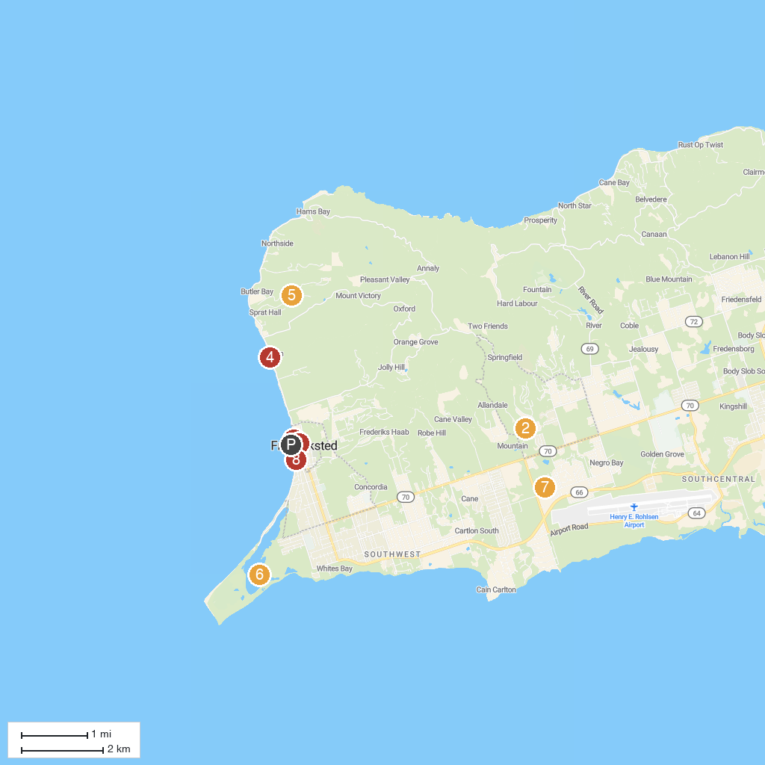
MAP KEY
1. Fort Frederik | 5. Estate Mount Washington
2. St George Village Botanical Gardens | 6. Sandy Point National Wildlife Refuge
3. Gecko's Island Adventures | 7. Cruzan Rum Distillery
4. Cruzan Cowgirls | 8. Frederiksted Historic District
P. Cruise port / terminal
Map © MapTiler © OpenStreetMap contributors · cruiseports.org

