St. Augustine, Florida, USA
Founded in 1565, St. Augustine is the oldest continuously occupied European settlement in the continental US — a living museum of Spanish forts, coquina architecture, and sun-washed cobblestone lanes just steps from the ship.
⚓ Pier (small ships) / Shore excursion from Jacksonville · 🕒 Typical call: 6–8 hrs · 💵 US Dollar · 🗣️ English · 🏛️ Historic District walkable from dock
✍️ MY DAY IN PORT (FILL IN)
Ship / Date
In port | arrive ______ · all aboard ______
Booked excursion
Notes / meeting point
GETTING ASHORE
- Docking: Small ships pier at St. Augustine Municipal Marina; large ships visit via excursion from Jacksonville (~45 mi)
- Walk to Center: Under 5 min from marina to St. George Street and Castillo de San Marcos
- Best For: History buffs, architecture lovers, beach day, Southern food & craft spirits
- Don't Miss: Castillo de San Marcos, St. George Street, St. Augustine Lighthouse, St. Augustine Distillery free tour
GETTING AROUND
- 🚕 Taxi: $10–$20 — Local taxis (e.g., Abraxi Taxi) use zone-based flat rates within St. Augustine. Downtown fares start around $5; trips to
- 📱 Rideshare: ✅ Uber, Lyft
- 🚌 Hop-on hop-off: ✅ Old Town Trolley Tours
TOP THINGS TO DO
- Castillo de San Marcos — America's oldest masonry fort (1695), built of coquina shell-stone that famously absorbed cannonballs.
- St. George Street & Plaza de la Constitución — The pedestrian heart of the Old City — centuries-old storefronts, street musicians, the 18th-century Cathedral Basilica, and the…
- St. Augustine Lighthouse — Climb 219 steps inside the 1874 lighthouse for panoramic views of the Atlantic and historic downtown.
- St. Augustine Alligator Farm — One of Florida's oldest continuously running attractions (since 1893) — the only place on earth where all 24 crocodilian species…
- Anastasia State Park Beach — Four miles of undeveloped white-sand Atlantic beach with dunes, kayak rentals, and paddleboard hire.
BEST WALKS
- Bayfront to Old City Loop: 1.5 miles · Easy · 45–60 min — Follow the bayfront north from the marina past the Castillo de San Marcos, turn south onto St.
- Flagler College & Lightner Museum Quarter: 0.75 miles · Easy · 30 min — Head west from the Plaza to Flagler College (the 1888 Ponce de León Hotel, now containing the…
WEATHER · DAYLIGHT · MONEY
Month | High °F | Low °F | Rainy days
May | 80 | 70 | 9
Jul | 86 | 77 | 21
Sep | 83 | 75 | 19
Daylight: May 6:32AM–8:11PM · Jul 6:35AM–8:27PM · Sep 7:10AM–7:29PM
cruiseports.org/st-augustine-fl · Confirm terminal & all-aboard time with your ship

St. Augustine, Florida, USA — Port Map
Red = walkable sights · Amber = excursions farther out · P = cruise terminal
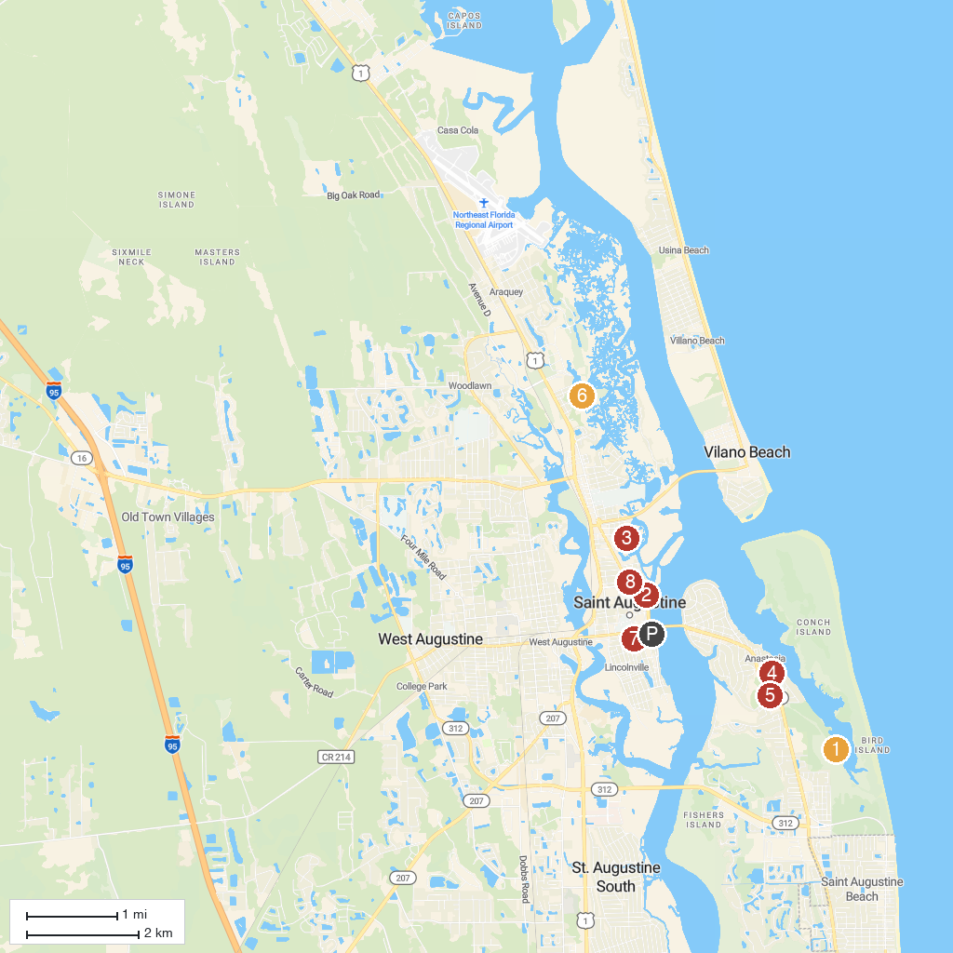
MAP KEY
1. Anastasia State Park | 5. St. Augustine Alligator Farm Zoological Park
2. Castillo de San Marcos National Monument | 6. Fort Mose Historic State Park
3. Ponce de Leon's Fountain of Youth Archaeological Park | 7. Lightner Museum
4. St. Augustine Lighthouse & Maritime Museum | 8. Ghosts & Gravestones Tour St. Augustine
P. Cruise port / terminal
Map © MapTiler © OpenStreetMap contributors · cruiseports.org

