St Agnes, Isles of Scilly, England
Barely a mile across and home to just 80 residents, St Agnes is one of England's most remote inhabited islands — no cars, no noise, just clifftop paths, turquoise coves, and a legendary pub steps from the quay.
⚓ Tender port (anchor off Porth Conger) · 🕒 Typical call: 5–7 hrs · 💷 Currency: British Pound (GBP) · 🗣️ Language: English · 🚶 Fully walkable — no vehicles
✍️ MY DAY IN PORT (FILL IN)
Ship / Date
In port | arrive ______ · all aboard ______
Booked excursion
Notes / meeting point
GETTING ASHORE
- Docking: Tender to Porth Conger Quay; larger ships may tender to St Mary's first, then inter-island boat
- Walk to center: The Turk's Head pub is 1 min from the quay; island loop ~2 hrs
- Best For: Wild beaches, coastal walking, puffins (May–Jul), off-the-beaten-path charm
- Don't Miss: Crossing the sandbar to Gugh at low tide — check tide tables at the quay first
GETTING AROUND
- 📱 Rideshare: ❌ not available
TOP THINGS TO DO
- Island Circuit Walk — A 4-mile coastal loop takes in clifftop heathland, hidden coves, the pebble Troytown Maze, the old lighthouse, and sweeping views…
- Gugh Island & The Old Man of Gugh — At low tide a natural sandbar connects St Agnes to tiny Gugh, where you'll find a Bronze Age standing stone, ancient burial…
- Seabird & Wildlife Watching — Between May and July, puffins nest on rocky islets just offshore.
- Beady Pool Beachcombing — A 17th-century Dutch trading ship wrecked offshore here, and its cargo of Venetian-made glass and ceramic beads still washes onto…
- Troytown Farm Ice Cream — The only dairy farm in the Isles of Scilly makes its own ice cream on-site from Jersey cows.
BEST WALKS
- Island Coastal Loop: 4 miles | ~2 hrs | Easy-moderate | All terrain — Start at Porth Conger Quay, walk south past the Turk's Head and up through the village to the old…
- Quay to Gugh via The Bar: 1 mile each way | 30–45 min each way | Easy | Check tides! — From the quay, walk five minutes along the harbour-side path to The Bar — the natural sandbar that…
WEATHER · DAYLIGHT · MONEY
Month | High °F | Low °F | Rainy days
May | 54 | 52 | 9
Jul | 63 | 61 | 8
Sep | 62 | 60 | 11
Daylight: May 5:39AM–9:04PM · Jul 5:33AM–9:28PM · Sep 7:01AM–7:38PM
cruiseports.org/st-agnes-island-england · Confirm terminal & all-aboard time with your ship

St Agnes, Isles of Scilly, England — Port Map
Red = walkable sights · Amber = excursions farther out · P = cruise terminal
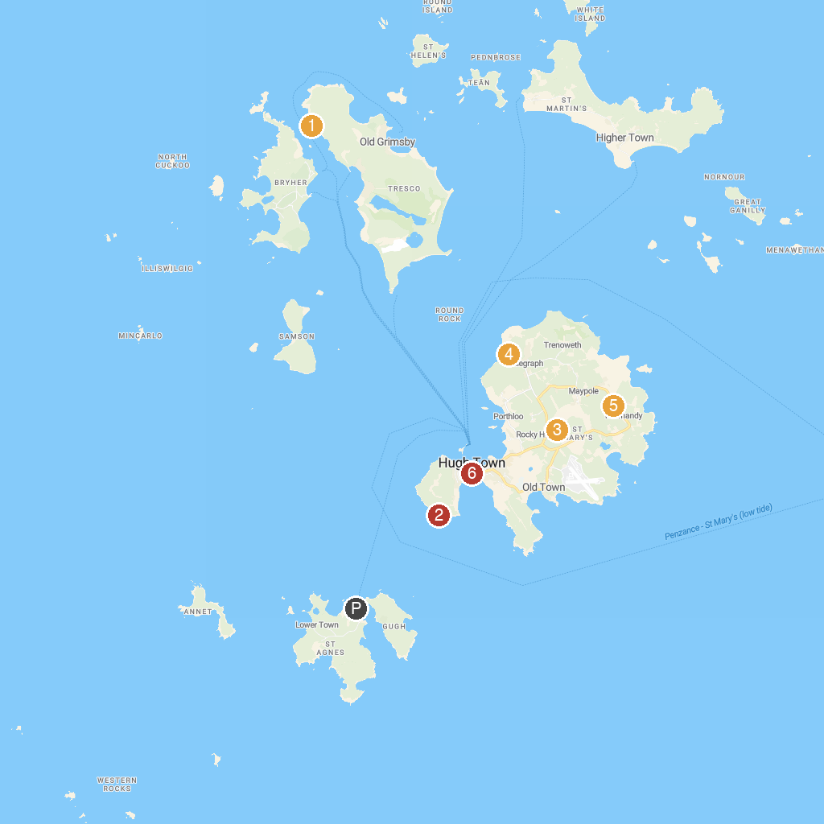
MAP KEY
1. Cromwell's Castle | 4. Bant's Carn Burial Chamber and Halangy Down Ancient Village
2. Garrison Walls | 5. Isles of Scilly Heritage Coast
3. Carreg Dhu Gardens | 6. Isles Of Scilly Museum
P. Cruise port / terminal
Map © MapTiler © OpenStreetMap contributors · cruiseports.org

