Split, Dalmatia, Croatia
A Roman emperor's retirement palace turned living city — Split's old town is Diocletian's Palace, a 1,700-year-old UNESCO labyrinth where people still live, eat, and drink among ancient columns.
⚓ Docked (city port — central) · 🕒 Typical call: 8–10 hrs · 💶 Euro (EUR) — since Jan 2023 · 🗣️ Croatian · English widely spoken
✍️ MY DAY IN PORT (FILL IN)
Ship / Date
In port | arrive ______ · all aboard ______
Booked excursion
Notes / meeting point
GETTING ASHORE
- Docking: Split Passenger Terminal — steps from the old town
- Walk to Diocletian's Palace: ~5–10 min on foot from the pier
- Best For: Roman history · Riva waterfront · island day trips
- Don't Miss: Peristyle courtyard inside the Palace
GETTING AROUND
- 🚕 Taxi: €18–€24 — Metered taxis are available at the port. Pre-booking a private transfer online can save up to 40% vs. a street taxi.
- 📱 Rideshare: ✅ Uber, Bolt
- 🚌 Hop-on hop-off: ✅ City Sightseeing Split
TOP THINGS TO DO
- Diocletian's Palace Self-Guided Walk — The Palace is not a museum you visit — it's the living old town.
- Hvar Island Day Trip — A fast catamaran (~1 hr from Split Ferry Terminal, tickets ~€25 each way) reaches Hvar Town — one of Croatia's most photogenic…
- Trogir UNESCO Town — Just 27 km from Split, Trogir is a tiny island city whose medieval core is a UNESCO World Heritage Site.
- Krka National Park Waterfalls — About 85 km north of Split, Krka National Park offers travertine waterfalls and turquoise river pools.
- Sea Kayaking the Palace Walls — Guided sea kayaking tours launch from the Riva and paddle along the sea-facing walls of Diocletian's Palace, then out to the…
BEST WALKS
- Riva to the Peristyle — Heart of the Palace: ~500 m · 10 min · flat · easy — Walk east along the Riva from the pier to the Bronze Gate (southern Palace entrance).
- Palace to Marjan Hill Viewpoint: ~2 km one-way · 45 min · uphill · moderate — Exit the Palace via the Iron Gate (western side) to the People's Square (Narodni Trg), then head…
- Golden Gate to the Green Market: ~700 m · 15 min · flat · easy — Enter the Palace through the northern Golden Gate — the most ornate of the four entrances — where a…
WEATHER · DAYLIGHT · MONEY
Month | High °F | Low °F | Rainy days
May | 72 | 58 | 11
Jul | 87 | 71 | 4
Sep | 78 | 64 | 8
Daylight: May 5:29AM–8:12PM · Jul 5:27AM–8:32PM · Sep 6:33AM–7:04PM
cruiseports.org/split · Confirm terminal & all-aboard time with your ship

Split, Dalmatia, Croatia — Port Map
Red = walkable sights · Amber = excursions farther out · P = cruise terminal
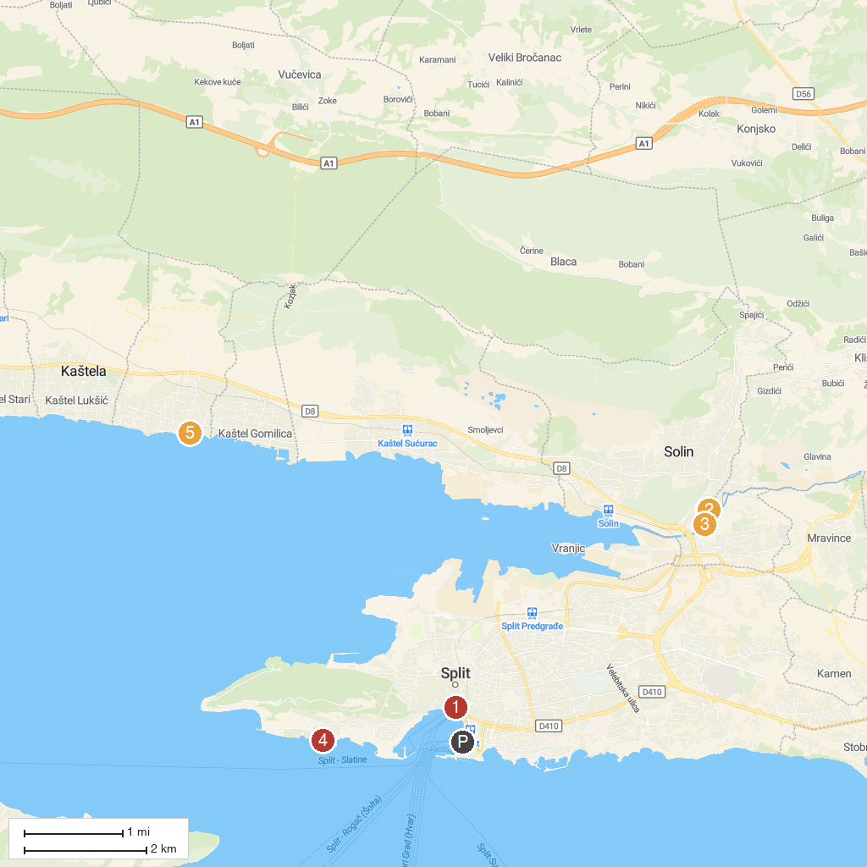
MAP KEY
1. Diocletian's Palace | 4. Meštrovićeve Crikvine - Kaštilac
2. Gradina Solin | 5. Kula Cambi
3. Church of Our Lady
P. Cruise port / terminal
Map © MapTiler © OpenStreetMap contributors · cruiseports.org

