Spitsbergen Island, Svalbard, Norway
Europe's last true wilderness. Spitsbergen delivers tidewater glaciers, polar bears prowling sea ice, walrus colonies, and a sky that never fully darkens in summer — all from the Arctic settlement of Longyearbyen.
⚓ Dock or Tender (varies by ship size) · 🕒 Typical call: 8-12 hrs · 💵 Norwegian Krone (NOK) · 🗣️ Norwegian / English widely spoken · 🐻‍❄️ Polar bear country — guides required outside town
✍️ MY DAY IN PORT (FILL IN)
Ship / Date
In port | arrive ______ · all aboard ______
Booked excursion
Notes / meeting point
GETTING ASHORE
- Docking: Bykaia pier or tender via Tenderkaia; 1.5 km flat walk to town center
- Walk to center: 20 min on foot from Bykaia pier; shuttle buses often provided
- Best For: Arctic wildlife, glacier photography, expedition history, midnight sun
- Don't Miss: Boat safari to Monaco Glacier or Pyramiden ghost town
GETTING AROUND
- 🚕 Taxi: NOK 170–180 (~$16–17) — Longyearbyen Taxi AS and Svalbard Buss og Taxi serve the pier. Fares are metered with a NOK 150 base plus ~NOK 17.60/km.
- 📱 Rideshare: ❌ not available
TOP THINGS TO DO
- Polar Bear & Wildlife Boat Safari — Zodiac or small-ship safari into Adventfjorden and surrounding waters hunting for polar bears on sea ice, walrus haul-outs…
- Glacier Boat Safari — Monaco Glacier — Cruise deep into the fjords to witness tidewater glaciers calving house-sized icebergs into turquoise water.
- Pyramiden — Soviet Ghost Town — A 2.5-hour scenic boat ride to an abandoned Soviet coal-mining town preserved in amber since 1998.
- Gruve 3 Coal Mine Tour — Explore a real historic coal mine just 10 minutes from the harbor.
- Svalbard Museum + Town Walk — The Svalbard Museum covers polar exploration, Norwegian and Soviet mining history, and Arctic ecology.
BEST WALKS
- Bykaia Pier to Longyearbyen Town Center: 1.5 km • 20 min • Flat • No guide needed — A simple flat walk along the harbor road into the heart of Longyearbyen.
- Town Center Loop — Museum & Church: 2 km • 30-40 min • Easy • Self-guided — From the main street, walk up to the Svalbard Museum, continue to the Svalbard Church (the world's…
WEATHER · DAYLIGHT · MONEY
Month | High °F | Low °F | Rainy days
May | 30 | 24 | 9
Jul | 49 | 44 | 10
Sep | 39 | 32 | 13
Daylight: Sep 5:39AM–8:01PM
cruiseports.org/spitsbergen-island · Confirm terminal & all-aboard time with your ship

Spitsbergen Island, Svalbard, Norway — Port Map
Red = walkable sights · Amber = excursions farther out · P = cruise terminal
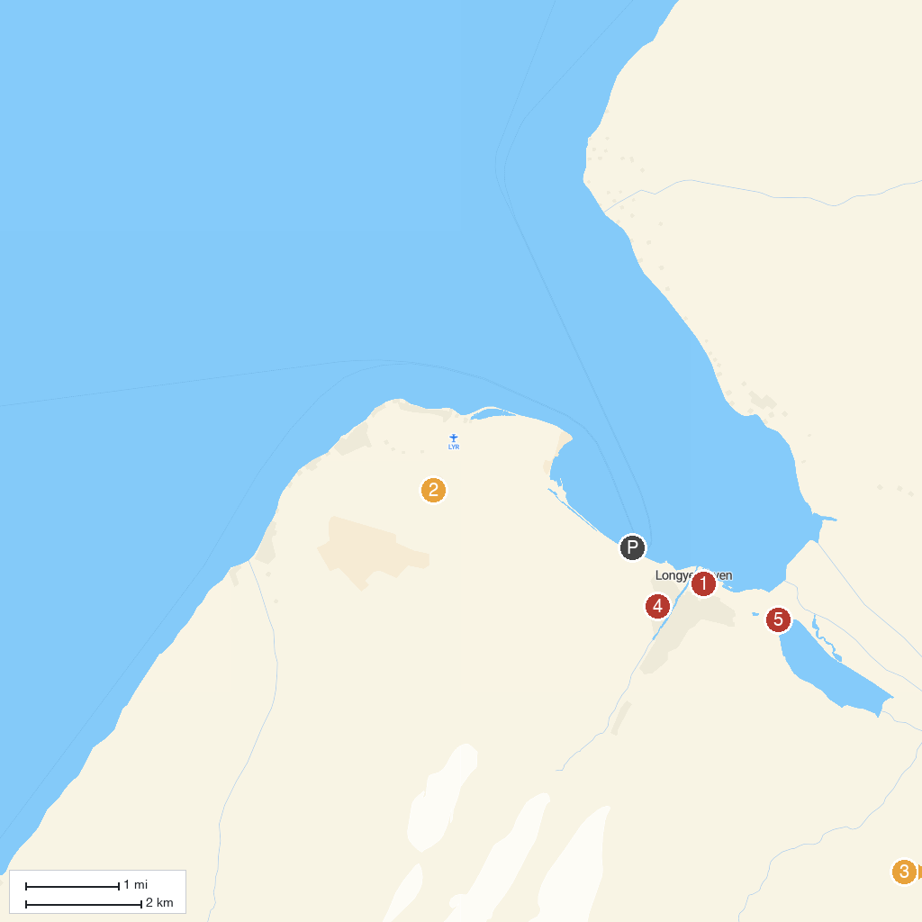
MAP KEY
1. North Pole Expedition Museum | 4. Svalbard Kirke
2. Gruve 3 | 5. Polar Bear Sign
3. Svalbard Husky AS
P. Cruise port / terminal
Map © MapTiler © OpenStreetMap contributors · cruiseports.org

