Spetses Island, Saronic Gulf, Greece
One of Greece's most elegant islands, Spetses bans private cars entirely — you'll explore its pine-scented lanes by horse-drawn carriage, bicycle, or on foot, with a harbor lined with historic cannons and pebble-mosaic streets.
⚓ Tender port · 🕒 Typical call: 6–8 hrs · 💶 Currency: Euro (€) · 🗣️ Language: Greek · 🚗 No private cars on island
✍️ MY DAY IN PORT (FILL IN)
Ship / Date
In port | arrive ______ · all aboard ______
Booked excursion
Notes / meeting point
GETTING ASHORE
- Docking: Tender only — ships anchor offshore; boats land at Dapia harbor
- Walk to center: You step ashore in the center; Old Harbor 20 min east
- Best For: History, car-free atmosphere, beaches, Greek cuisine
- Don't Miss: Bouboulina Museum & Fish à la Spetsiota
GETTING AROUND
- 🚕 Taxi: Varies — Only about seven taxis operate on the island. Fares vary by distance; plan ahead as availability is limited.
- 📱 Rideshare: ❌ not available
TOP THINGS TO DO
- Bouboulina Museum — Tour the 300-year-old mansion of Laskarina Bouboulina — the world's first female naval admiral and heroine of the 1821 Greek War…
- Spetses Museum (Mexis Mansion) — This late 18th-century nobleman's mansion houses 4,000 years of island finds, folk art, and — remarkably — Bouboulina's own bones…
- Kaiki Beach (College Beach) — A 15-minute walk west of Dapia past the grand Anargyrios School.
- E-Bike Island Circuit — Rent an e-bike at Dapia and follow the coastal ring road around the island — pine forests, clifftop views, and secluded coves.
- Old Harbor (Baltiza) Walk — A scenic 20-minute stroll east leads to the atmospheric Old Harbor, where luxury yachts share the waterfront with traditional…
BEST WALKS
- Dapia to Old Harbor Coastal Walk: 2 km · 20–25 min · Flat — Head east from the tender pier along the waterfront past the Cathedral of Agios Nikolaos (where the…
- Dapia to Kaiki Beach: 1 km · 15 min · Flat — Walk west from the harbor past the iconic Belle Époque façade of the Poseidonion Grand Hotel and…
WEATHER · DAYLIGHT · MONEY
Month | High °F | Low °F | Rainy days
May | 76 | 62 | 4
Jul | 91 | 76 | 1
Sep | 83 | 71 | 4
Daylight: May 6:18AM–8:29PM · Jul 6:19AM–8:47PM · Sep 7:09AM–7:34PM
cruiseports.org/spetses-island · Confirm terminal & all-aboard time with your ship

Spetses Island, Saronic Gulf, Greece — Port Map
Red = walkable sights · Amber = excursions farther out · P = cruise terminal
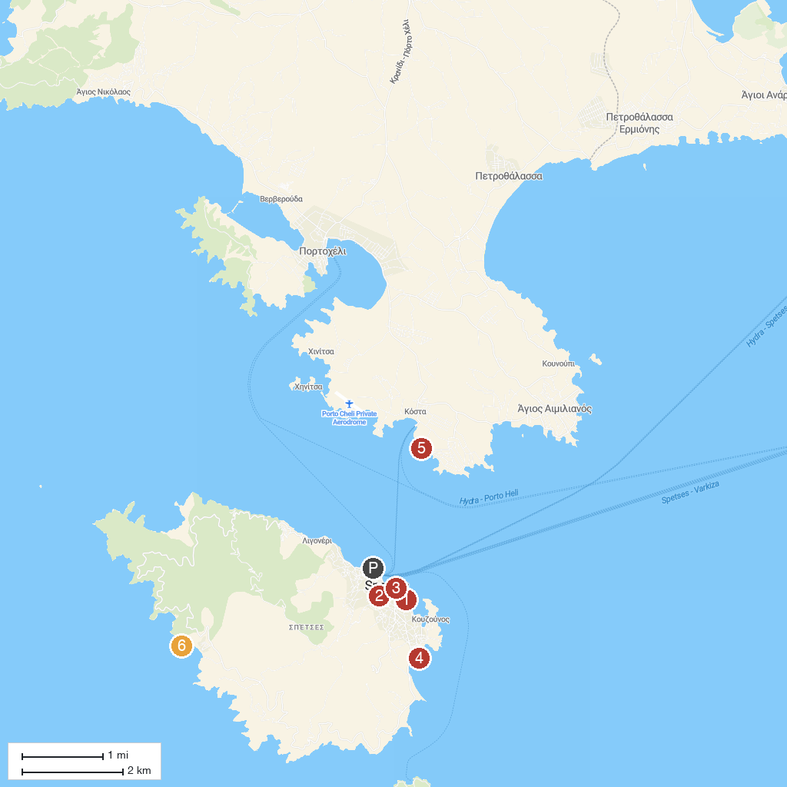
MAP KEY
1. Μουσείο Μελιού & Μέλισσας - Honey and bee museum - Bairaktaris apiary | 5. Αγία Μαρίνα
2. Saint Nikolaos Spetses Holy Orthodox Church | 6. Kostoula
3. Museum of Spetses | 7. Σπήλαιο Μπεκίρι
4. Agios Mamas Church
P. Cruise port / terminal
Map © MapTiler © OpenStreetMap contributors · cruiseports.org

