Spanish Wells, Eleuthera, Bahamas
The Lobster Capital of the Bahamas, Spanish Wells is a tidy, pastel-hued fishing village on a two-mile island where golf carts replace cars and white-sand sandbars appear at low tide like something out of a dream.
⚓ Tender port (no cruise pier) · 🕒 Typical call: 6–8 hrs · 💵 USD accepted everywhere · 🗣️ English · 🦞 Lobster & fishing culture
✍️ MY DAY IN PORT (FILL IN)
Ship / Date
In port | arrive ______ · all aboard ______
Booked excursion
Notes / meeting point
GETTING ASHORE
- Docking: Tender to Government Dock, south side of island
- Walk to beach: ~10–15 min on foot to North Beach (0.6 mi)
- Best For: Beach days, golf cart exploring, snorkeling, fresh seafood
- Don't Miss: The low-tide sandbars on North Beach and lobster at The Shipyard
GETTING AROUND
- 🚕 Taxi: $5–$6/person — If connecting from North Eleuthera (Gene's Bay Dock), a short water taxi crosses to Spanish Wells. Add ~$15/person for a
- 📱 Rideshare: ❌ not available
TOP THINGS TO DO
- Swimming Pigs at Meeks Patch — A 15-minute boat ride brings you to a tiny deserted island where friendly pigs (and ducks) wade right into the water to greet you.
- Devil's Backbone Snorkeling — A legendary shallow reef that wrecked Spanish galleons for centuries.
- North Beach Sandbar Day — Walk or golf-cart to Spanish Wells' North Beach and wade out onto vast sandbars that emerge at low tide.
- Deep-Sea or Bonefishing Charter — Spanish Wells' fishing captains are some of the best in the Bahamas.
- Golf Cart Island Tour — Rent a cart and explore the entire island at your own pace — pastel cottages, the harbor lined with million-dollar lobster boats…
BEST WALKS
- Government Dock to North Beach: 0.6 mi · ~12 min · Easy — Walk straight across the island from the tender dock to the stunning North Beach.
- Spanish Wells to Russell Island Bridge: 1.5 mi · ~25 min or 5 min by cart · Easy — Head west along the harbor road to the bridge connecting Spanish Wells (St.
WEATHER · DAYLIGHT · MONEY
Month | High °F | Low °F | Rainy days
May | 81 | 75 | 16
Jul | 86 | 80 | 18
Sep | 85 | 80 | 19
Daylight: May 6:21AM–7:45PM · Jul 6:25AM–8:00PM · Sep 6:53AM–7:10PM
cruiseports.org/spanish-wells-bahamas · Confirm terminal & all-aboard time with your ship

Spanish Wells, Eleuthera, Bahamas — Port Map
Red = walkable sights · Amber = excursions farther out · P = cruise terminal
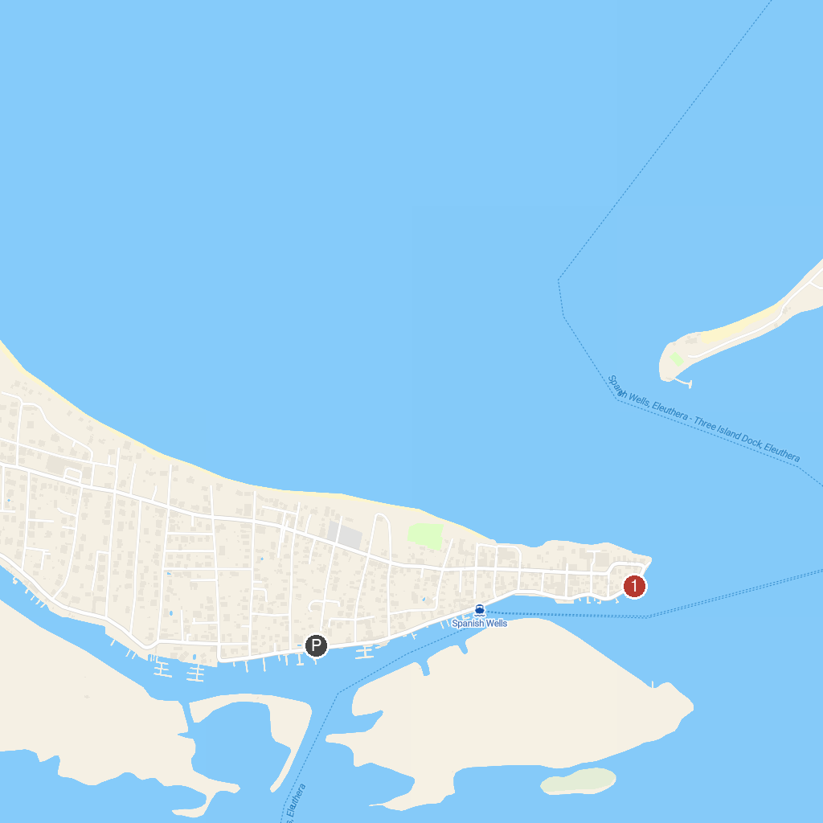
MAP KEY
1. Spanish Wells Fishing Charters
P. Cruise port / terminal
Map © MapTiler © OpenStreetMap contributors · cruiseports.org

