Southampton, England, United Kingdom
The UK's cruise capital sits at the heart of southern England — Titanic history, medieval walls, and the world's greatest day-trip menu all within reach of the docks.
⚓ All berths alongside — no tendering · 🕒 Typical call: home port (full day) · 💷 Currency: Pound Sterling (GBP) · 🗣️ Language: English · 🚂 London: 75–85 min by train
✍️ MY DAY IN PORT (FILL IN)
Ship / Date
In port | arrive ______ · all aboard ______
Booked excursion
Notes / meeting point
GETTING ASHORE
- Docking: Five dedicated cruise terminals (Western & Eastern Docks) — all berths alongside, no tendering ever
- Walk to centre: 15–30 min depending on terminal; City & Horizon terminals closest, Ocean furthest
- Best For: London day trips, Titanic history, Stonehenge, New Forest, Portsmouth naval heritage
- Don't Miss: SeaCity Museum Titanic galleries, Bargate medieval gate, medieval town walls walk
GETTING AROUND
- 🚕 Taxi: £8–£12 — Licensed taxis wait outside all four cruise terminals. The short ride to city centre or West Quay shopping typically cos
- 📱 Rideshare: ✅ Uber
TOP THINGS TO DO
- London in a Day — Direct trains to London Waterloo take just 75–85 minutes, making an independent day trip very achievable.
- Stonehenge & Salisbury Cathedral — One of England's defining day trips: the UNESCO-listed prehistoric stone circle paired with Salisbury Cathedral, home to one of…
- New Forest National Park — Ancient woodland, free-roaming ponies, donkeys, and cattle just 20–30 minutes from the docks.
- Portsmouth Historic Dockyard — A 45-minute drive or 30-minute train journey east.
- Windsor Castle — The oldest occupied castle in the world and an official royal residence, Windsor is about 90 minutes by road or two hours by…
BEST WALKS
- Medieval Walls & Titanic Heritage Loop: 3 km · 50–70 min · Easy — Start at Bargate — the iconic medieval gatehouse — and follow the walls south past the Arcades and…
- Waterfront & West Quay Stroll: 2 km · 25–35 min · Easy — A relaxed flat walk from the Mayflower Terminal area to West Quay shopping centre — useful for…
WEATHER · DAYLIGHT · MONEY
Month | High °F | Low °F | Rainy days
May | 62 | 47 | 11
Jul | 71 | 57 | 10
Sep | 67 | 53 | 9
Daylight: May 5:16AM–8:48PM · Jul 5:09AM–9:13PM · Sep 6:41AM–7:19PM
cruiseports.org/southampton · Confirm terminal & all-aboard time with your ship

Southampton, England, United Kingdom — Port Map
Red = walkable sights · Amber = excursions farther out · P = cruise terminal
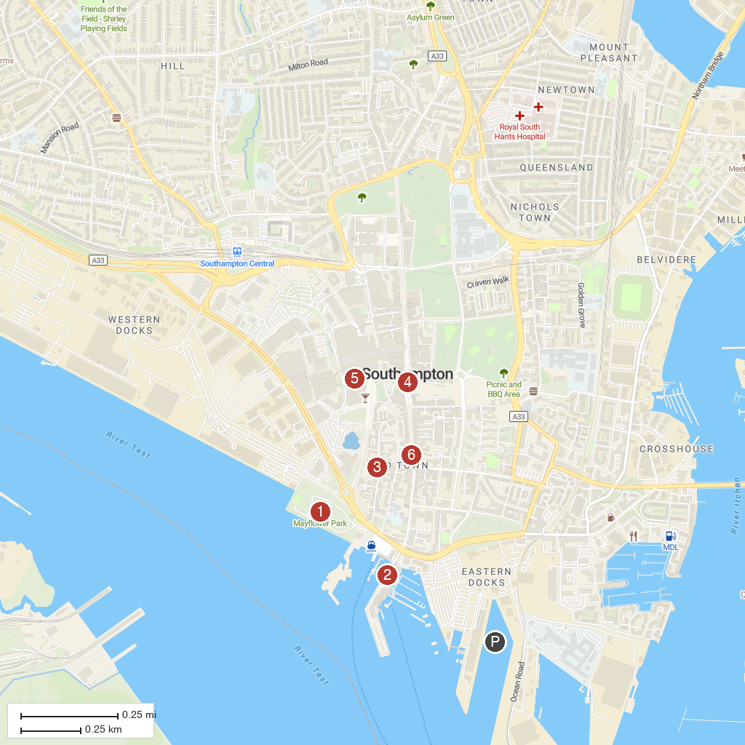
MAP KEY
1. Mayflower Park | 4. The Bargate
2. Town Quay | 5. SeaCity Museum
3. Tudor House & Garden | 6. Holyrood Church
P. Cruise port / terminal
Map © MapTiler © OpenStreetMap contributors · cruiseports.org

