Sousse, Sahel, Tunisia
Tunisia's "Pearl of the Sahel" packs a UNESCO Medina, an 8th-century fortress, and a trove of Roman mosaics into a walkable waterfront city — all steps from where your ship ties up.
⚓ Pier (docked) · 🕒 Typical call: 6–9 hrs · 💵 Tunisian Dinar (TND) · 🗣️ Arabic / French · 🌡️ Hot Mediterranean climate
✍️ MY DAY IN PORT (FILL IN)
Ship / Date
In port | arrive ______ · all aboard ______
Booked excursion
Notes / meeting point
GETTING ASHORE
- Docking: Pier — no tender needed; port sits at the edge of the Medina
- Walk to Medina: 5–10 min from gangway to Bab El Bhar (Medina main gate)
- Best For: History, souks, Roman mosaics, North African cuisine
- Don't Miss: Ribat watchtower view over the Medina and your ship
GETTING AROUND
- 🚕 Taxi: 3–8 TND — Metered taxis are plentiful and cheap — the port sits right at the edge of the city center, making most rides very short
TOP THINGS TO DO
- Ribat & Great Mosque — Climb the 8th-century ribat (fortified monastery) watchtower for sweeping views of the Medina, the Great Mosque, and your ship at…
- Sousse Archaeological Museum — Housed in the hilltop Kasbah, this museum holds the world's second-largest collection of Roman mosaics (after Tunis's Bardo).
- Medina Souk Walk — The souks inside the Medina are divided by trade — spices, carpets, leather, metalwork.
- Port El Kantaoui Beach Day — A purpose-built tourist marina 10 km north with clean white-sand beaches, sunbed rentals, water sports, and restaurants.
- Catacombs of Sousse — Over 5 km of underground galleries containing early Christian tombs from the 2nd–4th centuries.
BEST WALKS
- Medina Heritage Loop: 2–3 km · 1.5–2.5 hrs · Easy — Enter through Bab El Bhar, visit the Great Mosque and the Ribat, push uphill through the souk lanes…
- Seafront Promenade Stroll: 1.5 km · 20–30 min · Easy — Walk north from the port gate along Boulevard 14 Janvier past the Corniche seafront to the…
WEATHER · DAYLIGHT · MONEY
Month | High °F | Low °F | Rainy days
May | 80 | 60 | 5
Jul | 95 | 73 | 0
Sep | 88 | 71 | 4
Daylight: May 5:12AM–7:15PM · Jul 5:13AM–7:33PM · Sep 6:00AM–6:24PM
cruiseports.org/sousse · Confirm terminal & all-aboard time with your ship

Sousse, Sahel, Tunisia — Port Map
Red = walkable sights · Amber = excursions farther out · P = cruise terminal
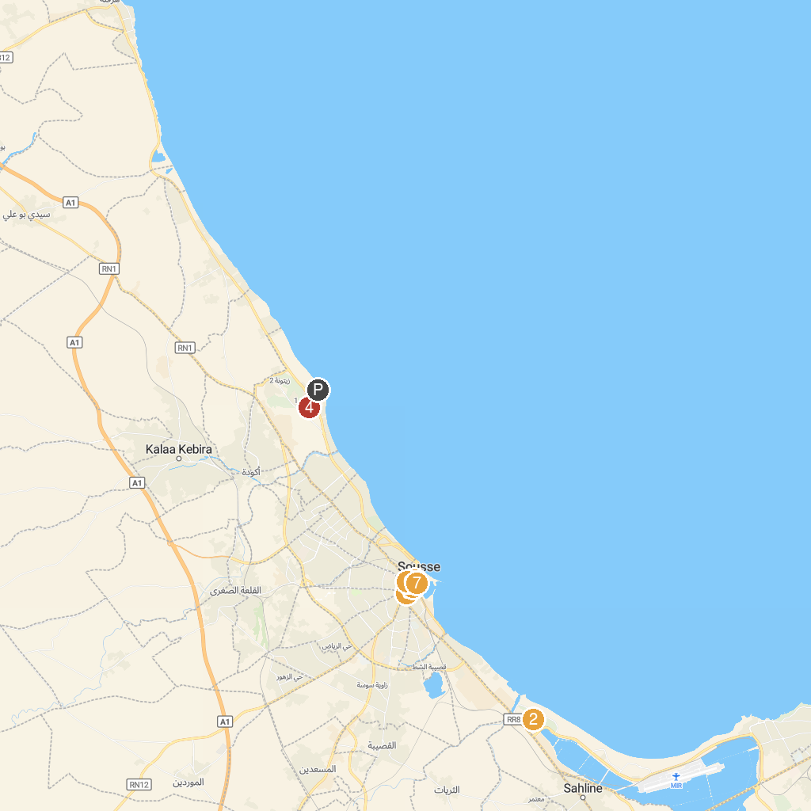
MAP KEY
1. Ribat of Sousse | 5. El-Kobba Museum
2. Golf Palm Links Course | 6. Dar Essid Museum
3. Sousse Archaeological Museum | 7. Great Mosque of Sousse
4. Acqua Palace
P. Cruise port / terminal
Map © MapTiler © OpenStreetMap contributors · cruiseports.org

