Soufrière, St. Lucia, Caribbean
Two volcanic spires rise straight from the sea. Below them: a drive-in volcano, jewel-colored waterfalls, and the most dramatic small port in the Caribbean.
⚓ Tender port · 🕒 Typical call: 7-9 hrs · 💵 USD widely accepted (XCD local) · 🗣️ English & French Creole · 🌿 Rainforest & volcano
✍️ MY DAY IN PORT (FILL IN)
Ship / Date
In port | arrive ______ · all aboard ______
Booked excursion
Notes / meeting point
GETTING ASHORE
- Docking: Tender — ships anchor in the bay; boats shuttle to Soufrière Town Jetty
- Walk to center: Jetty drops you right in town; major sights require taxi or water taxi
- Best For: Volcano mud baths, Piton views, snorkeling, lush nature excursions
- Don't Miss: Sulphur Springs mud bath + Sugar Beach by water taxi between the Pitons
GETTING AROUND
- 🚕 Taxi: From ~XCD 15 (~$6 USD) flag fare; 4-hr private tour ~$100–150 USD per person — Taxis congregate near the jetty and town square. Fares are government-regulated but unmetered — always agree on a price
TOP THINGS TO DO
- Sulphur Springs & Volcanic Mud Bath — The Caribbean's only drive-in volcano.
- Pitons Views from the Water — A catamaran or small boat cruise gives you the unbeatable perspective: both Gros Piton and Petit Piton rising 2,500 ft straight…
- Gros Piton Hike — A strenuous 4–5 hour round-trip climb to the 2,619-ft summit with panoramic views across St.
- Diamond Falls Botanical Gardens & Mineral Baths — Six lush acres of tropical gardens lead to the Diamond Waterfall, its rocks stained orange, yellow, and green by mineral deposits.
- Sugar Beach (Anse de Pitons) by Water Taxi — The beach between the Pitons.
BEST WALKS
- Soufrière Waterfront & Town Square: 30–45 min · Flat · Free — From the jetty, walk along the waterfront promenade to the town square and the historic Our Lady of…
- Hummingbird Beach Stroll: 15 min walk · Flat · Free — Head north along the coastal road from the jetty roughly 10–15 minutes to reach Hummingbird Beach…
WEATHER · DAYLIGHT · MONEY
Month | High °F | Low °F | Rainy days
May | 86 | 78 | 8
Jul | 86 | 78 | 17
Sep | 87 | 79 | 19
Daylight: May 5:37AM–6:23PM · Jul 5:44AM–6:35PM · Sep 5:53AM–6:05PM
cruiseports.org/soufriere · Confirm terminal & all-aboard time with your ship

Soufrière, St. Lucia, Caribbean — Port Map
Red = walkable sights · Amber = excursions farther out · P = cruise terminal
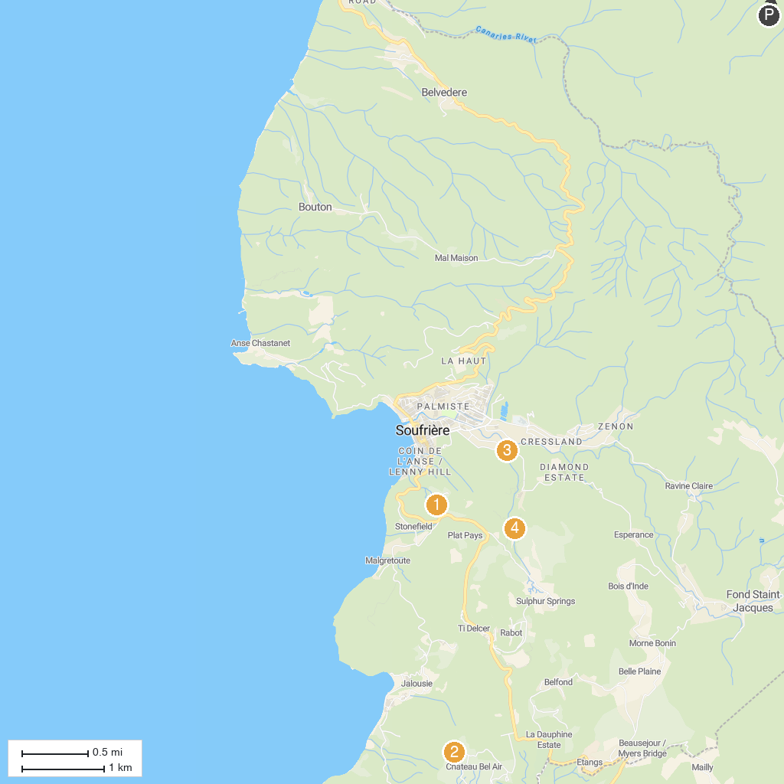
MAP KEY
1. Morne Coubaril Historical Adventure Park | 3. Diamond Falls Botanical Gardens & Mineral Baths
2. Tet Paul Nature Trail | 4. Sapphire Falls & Jungle Spa Hike
P. Cruise port / terminal
Map © MapTiler © OpenStreetMap contributors · cruiseports.org

