Sorrento, Campania, Italy
Perched on sheer cliffs above the Bay of Naples, Sorrento is the Mediterranean's ultimate day-trip hub — ferries to Capri, trains to Pompeii, and a lemon-scented old town all within easy reach.
⚓ Tender port (anchor offshore) · 🕒 Typical call: 8–10 hrs · 💶 Currency: Euro · 🗣️ Language: Italian
✍️ MY DAY IN PORT (FILL IN)
Ship / Date
In port | arrive ______ · all aboard ______
Booked excursion
Notes / meeting point
GETTING ASHORE
- Docking: Tender to Marina Piccola
- Walk to center: Lift/elevator (~€1.10) or steep stairs — 10–15 min to Piazza Tasso
- Best For: Capri day trip, Pompeii, Amalfi Coast excursions, limoncello shopping
- Don't Miss: Vallone dei Mulini gorge overlook & Gnocchi alla Sorrentina
GETTING AROUND
- 🚕 Taxi: ~€14 — Official taxis wait at Marina Piccola port. The ride to Piazza Tasso (city center) is roughly 1 km and takes about 5 min
- 📱 Rideshare: ❌ not available
- 🚌 Hop-on hop-off: ✅ City Sightseeing Sorrento
TOP THINGS TO DO
- Capri Day Trip by Ferry — High-speed ferries depart Marina Piccola for Capri in 20 minutes.
- Pompeii by Circumvesuviana Train — Walk to Sorrento station, take the Circumvesuviana to Pompei Scavi-Villa dei Misteri (30 min), and walk straight into the ruins.
- Amalfi Coast by Ferry or Bus — Ferries from Marina Piccola reach Positano and Amalfi in under an hour.
- Sorrento Old Town Walk — Explore Piazza Tasso, the Chiostro di San Francesco, Vallone dei Mulini gorge overlook, and the inlaid wood shops of Via San…
- Museo Correale di Terranova — A patrician villa surrounded by citrus groves housing Neapolitan art, 18th-century porcelain, and archaeological finds.
BEST WALKS
- Piazza Tasso to Vallone dei Mulini & Back: 45 min · Easy · Free — From the top of the Sorrento Lift, walk west along Corso Italia to Piazza Tasso, then duck south on…
- Town Center to Marina Grande: 30 min down · 20 min bus back · Moderate — From Piazza Tasso head west on Via Marina Grande (signed downhill path) to the old fishing harbor…
WEATHER · DAYLIGHT · MONEY
Month | High °F | Low °F | Rainy days
May | 70 | 58 | 11
Jul | 84 | 72 | 4
Sep | 78 | 67 | 8
Daylight: May 5:45AM–8:12PM · Jul 5:44AM–8:31PM · Sep 6:43AM–7:11PM
cruiseports.org/sorrento · Confirm terminal & all-aboard time with your ship

Sorrento, Campania, Italy — Port Map
Red = walkable sights · Amber = excursions farther out · P = cruise terminal
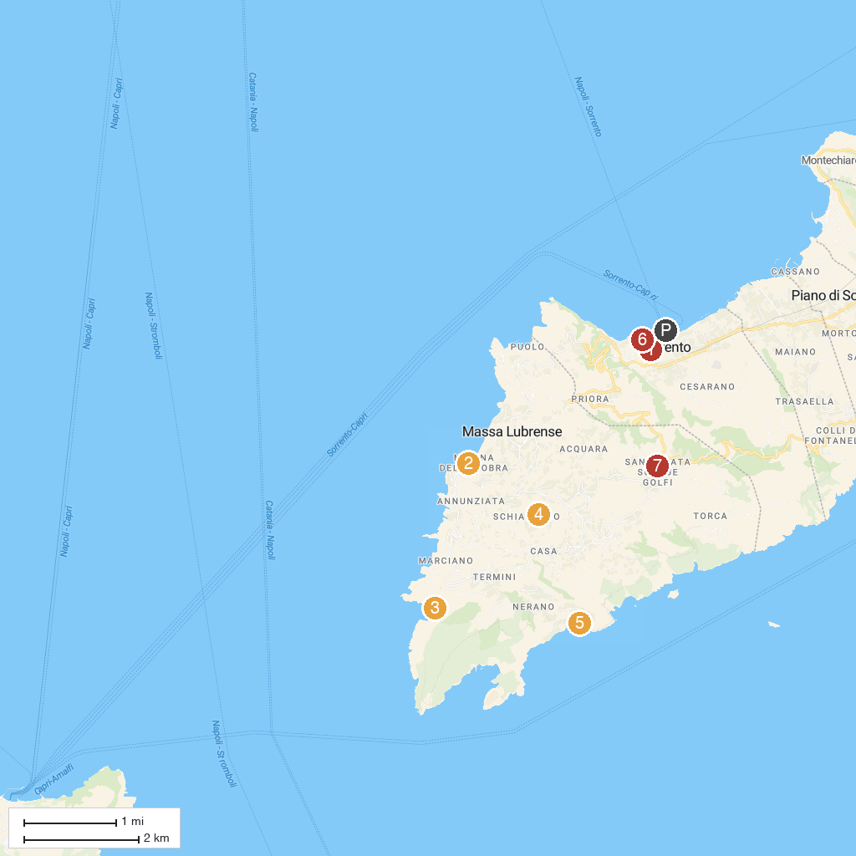
MAP KEY
1. Church of Santi Felice and Baccolo | 5. Azienda Agrituristica "La Masseria"
2. Villa Jovis | 6. Cooperativa S.Antonio
3. Marina Lobra | 7. Bagni Salvatore
4. Cala di Mitigliano | 8. Santa Maria delle Grazie
P. Cruise port / terminal
Map © MapTiler © OpenStreetMap contributors · cruiseports.org

