Sommarøy Island, Troms, Norway
North of the Arctic Circle yet lined with coral-white sand beaches and shallow turquoise water, Sommarøy earns its 'Arctic Caribbean' nickname. The tiny island—barely 1.5 km long—is walkable end-to-end and famous for a bridge draped in abandoned watches, where visitors leave time itself behind.
⚓ Tender or small-ship pier · 🕒 Typical call: 5–7 hrs · 💳 Cashless — cards everywhere · 🗣️ Norwegian (English widely spoken) · ☀️ Midnight Sun: May 18 – Jul 26
✍️ MY DAY IN PORT (FILL IN)
Ship / Date
In port | arrive ______ · all aboard ______
Booked excursion
Notes / meeting point
GETTING ASHORE
- Docking: Tender to harbor float; small expedition ships may dock at fishing pier
- Walk to center: 1–3 min from tender pier to hotel & village core
- Best For: Arctic beaches, scenic hikes, midnight sun photography
- Don't Miss: The Watch Bridge — railings covered in wristwatches left by visitors
GETTING AROUND
- 🚕 Taxi: NOK 1,400–1,800 (~$133–$171) — Taxis can be arranged for the ~1-hour drive to Tromsø city center. No taxis are permanently stationed on the island; pre
- 📱 Rideshare: ❌ not available
TOP THINGS TO DO
- Ørnfløya (Eagle Hill) Viewpoint Hike — Cross the Sommarøy bridge on foot and hike the easy trail to Ørnfløya for the iconic aerial view of both islands curving through…
- Sea Kayaking the Archipelago — Paddle through the maze of skerries surrounding Sommarøy in glassy Arctic water.
- RIB Boat Safari — High-speed rigid inflatable boat tours blast out to the outer islands in search of white-tailed sea eagles, seals, and dramatic…
- Arctic Beach Walk & Polar Plunge — Stroll to Sandsvika beach on the island's western side — pure white shell-sand, turquoise water, and open ocean views.
- Hillesøyfjellet Mountain Hike — Cross to neighboring Hillesøy Island (short bridge) and climb the peak for a 360° panorama of the Atlantic and the surrounding…
BEST WALKS
- Village, Watch Bridge & Sandsvika Beach Loop: 3–4 km | Easy | 1–1.5 hrs — From the tender pier, walk through the village past traditional red rorbuer fishing cabins to the…
- Ørnfløya Viewpoint Trail: ~4 km round trip | Easy–moderate | 1.5–2 hrs — Cross the Sommarøy bridge to Kvaløya and follow the marked trail up Ørnfløya (Eagle Hill).
WEATHER · DAYLIGHT · MONEY
Month | High °F | Low °F | Rainy days
May | 45 | 37 | 17
Jul | 61 | 51 | 13
Sep | 52 | 45 | 18
Daylight: Sep 6:02AM–7:21PM
cruiseports.org/sommaroy-island · Confirm terminal & all-aboard time with your ship

Sommarøy Island, Troms, Norway — Port Map
Red = walkable sights · Amber = excursions farther out · P = cruise terminal
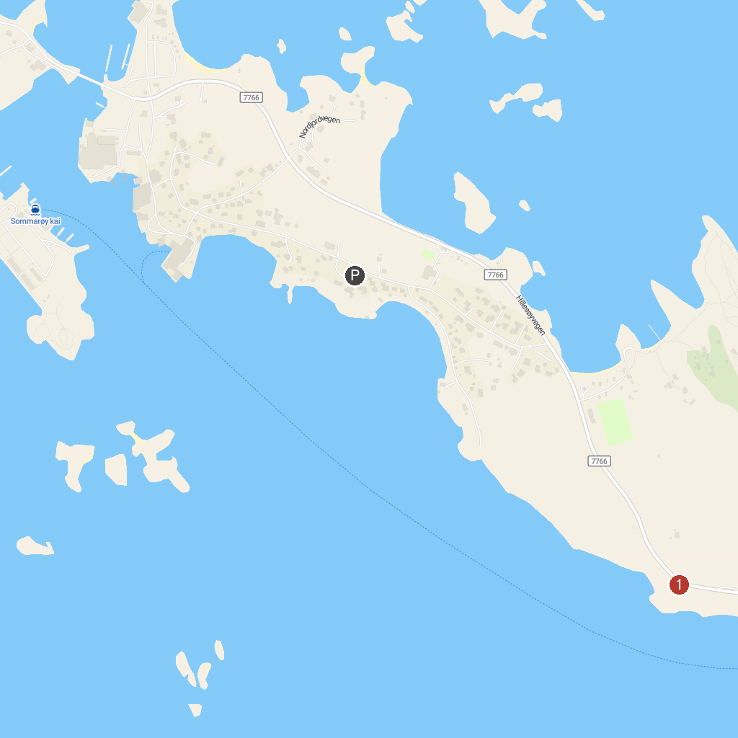
MAP KEY
1. Sommarøy | 2. Husøy Lighthouse
P. Cruise port / terminal
Map © MapTiler © OpenStreetMap contributors · cruiseports.org

