Sochi, Krasnodar Krai, Russia
Where subtropical palm trees meet snow-capped Caucasus peaks, Sochi is Russia's premier resort city — a Black Sea playground with an Olympic legacy, Soviet-era grandeur, and surprisingly affordable mountain adventures.
⚓ Docked (pier) · 🕒 Typical call: 8-10 hrs · 💵 Russian Ruble (RUB) — Western cards do not work · 🗣️ Russian (Cyrillic script) · ⚠️ Visa required for independent touring
✍️ MY DAY IN PORT (FILL IN)
Ship / Date
In port | arrive ______ · all aboard ______
Booked excursion
Notes / meeting point
GETTING ASHORE
- Docking: Pier — Marine Station (Morskoy Vokzal), two berths up to 220m
- Walk to center: Promenade is steps away; Navaginskaya St ~15 min (1 km)
- Best For: Soviet history, mountain day trips, Black Sea beaches, unique food
- Don't Miss: Krasnaya Polyana cable car, Stalin's Dacha, Sochi Arboretum
GETTING AROUND
- 🚕 Taxi: 300–700 RUB (~–8 USD) — Taxis are available at the port gate. Agree on a fare before getting in, or use Yandex Go for metered pricing. Most ride
- 📱 Rideshare: ✅ Yandex Go
TOP THINGS TO DO
- Stalin's Dacha — Joseph Stalin's favorite summer residence is preserved exactly as he left it — original green carpets, bulletproof couch, and a…
- Krasnaya Polyana & Rosa Khutor — Take the Lastochka train or taxi an hour into the Caucasus to the 2014 Winter Olympic mountain cluster.
- 2014 Olympic Park — The coastal Olympic cluster in Adler district hosts the Fisht Stadium, Formula 1 circuit, and the spectacular Singing Fountains…
- Sochi Arboretum (Dendrarium) — A world-class botanical garden with 1,800+ exotic plant species spread across hillside terraces.
- Agura Waterfalls & Eagle's Rocks — A popular half-day hike in the hills above Sochi following the Agura River past a series of waterfalls up to Eagle's Rocks, where…
BEST WALKS
- Waterfront Promenade to Riviera Park: 3 km | ~45 min | Flat — Step off the ship onto Primorsky Boulevard and stroll north along the Black Sea waterfront.
- City Center & Navaginskaya Street: 2 km loop | ~30 min | Flat — Walk inland from the terminal to Sochi's main pedestrian street, lined with towering palms, flower…
WEATHER · DAYLIGHT · MONEY
Month | High °F | Low °F | Rainy days
May | 68 | 56 | 13
Jul | 80 | 69 | 12
Sep | 76 | 64 | 11
Daylight: May 4:56AM–7:39PM · Jul 4:53AM–7:59PM · Sep 6:00AM–6:31PM
cruiseports.org/sochi · Confirm terminal & all-aboard time with your ship

Sochi, Krasnodar Krai, Russia — Port Map
Red = walkable sights · Amber = excursions farther out · P = cruise terminal
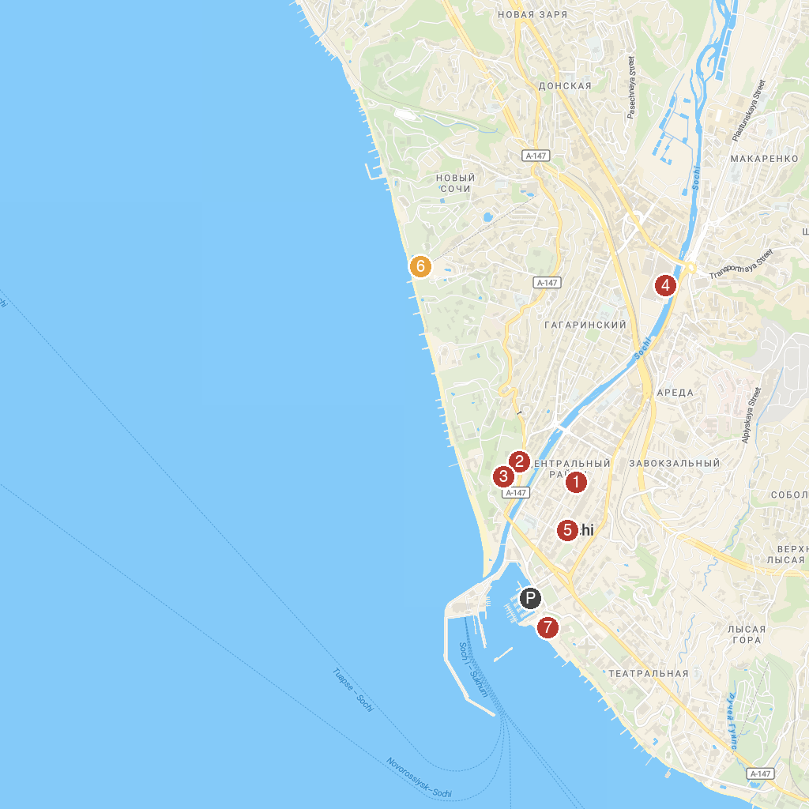
MAP KEY
1. Muzey Istorii Goroda-Kurorta Sochi | 5. Mega Muzey Sssr
2. Retro Vystavka Avtomobiley | 6. Пляж радуга
3. secrets of the Ocean | 7. Morskaya Naberezhnaya Tsentral'noy Chasti Sochi
4. Trogatel'nyy Zoopark
P. Cruise port / terminal
Map © MapTiler © OpenStreetMap contributors · cruiseports.org

