Smögen, Bohuslän, Sweden
A labyrinth of red boathouses, salty piers, and cliff-top swimming holes — Smögen is Sweden's most photogenic fishing village, best devoured with a paper cone of fresh-caught shrimp in hand.
⚓ Tender (no large pier) · 🕒 Typical call: 5–7 hrs · 💵 Swedish Krona (SEK) · 🗣️ Swedish (English widely spoken) · 🦐 Famous for shrimp
✍️ MY DAY IN PORT (FILL IN)
Ship / Date
In port | arrive ______ · all aboard ______
Booked excursion
Notes / meeting point
GETTING ASHORE
- Docking: Tender — ships anchor offshore; tenders bring passengers to the guest harbour
- Walk to centre: 5 min from tender dock to Smögenbryggan pier
- Best For: Scenic walks, fresh seafood, cliff swimming, archipelago day trips
- Don't Miss: Smögenbryggan boardwalk and shrimp at a pier-side stall
GETTING AROUND
- 🚕 Taxi: 110–150 SEK (short trip) — Local taxis serve the Smögen/Kungshamn area. Short hops (e.g. Kungshamn to Smögen) run ~110–150 SEK; hail at the harbour
TOP THINGS TO DO
- Smögenbryggan Boardwalk Stroll — Walk the full 800-metre wooden pier past candy-coloured boathouses, souvenir shops, and seafood shacks.
- Hållö Island & Lighthouse — A 10-minute boat ride from the harbour, Hållö is a small island with a historic lighthouse and Marmorbassängen — a tidal rock…
- Cliff Swimming at Vallevik — A short walk from the pier, Vallevik offers smooth granite cliffs, a diving platform, and a sheltered sandy bay for children.
- Nordens Ark Wildlife Park — Sweden's leading endangered-species conservation centre, about 20 minutes east of Smögen.
- Smögens Hembygdsmuseum — This intimate heritage museum recreates a late-19th-century fisherman's cottage and displays traditional nets, boats, and gear…
BEST WALKS
- Smögenbryggan End-to-End: 1.6 km return · Easy · 30–45 min — Start at the tender landing and walk the full length of the famous wooden boardwalk to its far end…
- Village to Vallevik Swimming Cliffs: 1 km · Easy · 15 min walk — Follow the coastal path from the pier toward Vallevik bay for cliff-top swimming with views across…
- Smögenbron Bridge Viewpoint: 2 km return · Easy · 30 min — Walk over the bridge connecting Smögen to the mainland for panoramic views back over the island's…
WEATHER · DAYLIGHT · MONEY
Month | High °F | Low °F | Rainy days
May | 58 | 46 | 11
Jul | 68 | 58 | 12
Sep | 62 | 53 | 13
Daylight: May 4:48AM–9:35PM · Jul 4:33AM–10:07PM · Sep 6:45AM–7:33PM
cruiseports.org/smogen · Confirm terminal & all-aboard time with your ship

Smögen, Bohuslän, Sweden — Port Map
Red = walkable sights · Amber = excursions farther out · P = cruise terminal
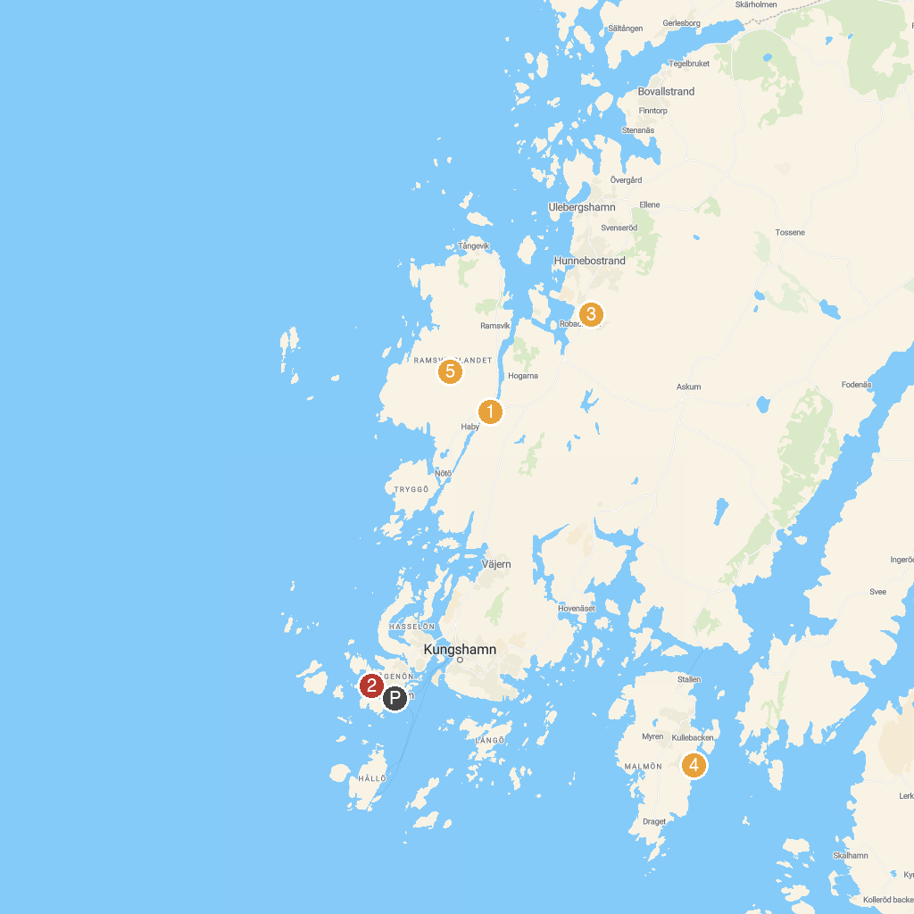
MAP KEY
1. Sotekanalen | 4. Stångehuvuds nature reserve
2. Smögenbryggan | 5. Pärlane strand
3. Stenhuggerimuseet | 6. Ramsvikslandet
P. Cruise port / terminal
Map © MapTiler © OpenStreetMap contributors · cruiseports.org

