Slano, Dubrovnik-Neretva, Croatia
A horseshoe bay so sheltered it looks like a saltwater lake — Slano trades Dubrovnik's crowds for pine-fringed pebble beaches, a 15th-century Franciscan church, and some of Croatia's best oysters just up the road.
⚓ Tender or small-ship quay · 🕒 Typical call: 6–8 hrs · 💶 Euro (€) · 🗣️ Croatian
✍️ MY DAY IN PORT (FILL IN)
Ship / Date
In port | arrive ______ · all aboard ______
Booked excursion
Notes / meeting point
GETTING ASHORE
- Docking: Tender (large ships); small ships dock at town quay or ACI Marina
- Walk to center: 2 min from town quay; 15 min from ACI Marina
- Best For: Beach days, local Dalmatian food, day trips to Ston & Trsteno
- Don't Miss: Franciscan Church of St. Hieronymus & fresh oysters in Ston
GETTING AROUND
- 🚕 Taxi: €5–€15 within village; €60–€80 to Dubrovnik — Local taxi services (taxi-slano.com) cover the village and regional transfers. A taxi to Dubrovnik (~35 km) costs roughl
TOP THINGS TO DO
- Ston Walls & Oyster Tasting — Ston, 20 minutes away, has the longest medieval fortification walls in Europe outside China.
- Trsteno Arboretum — One of Europe's oldest arboretums (15th century), filled with exotic plants, a Baroque aqueduct-fed fountain, and sea views.
- Bay Beach Day — Slano Bay's sheltered waters are nearly always flat calm.
- Dubrovnik Old Town — The UNESCO-listed walled city is 30–40 minutes by taxi.
- Franciscan Church & Rector's Palace — The 15th-century Franciscan Church of St.
BEST WALKS
- Bay Promenade Loop: 2.5 km · 35–40 min · Flat paved path — A paved seaside path wraps around the entire horseshoe bay under pine shade.
- Village History Stroll: 1 km · 20 min · Flat — From the pier, walk up into the village to the Rector's Palace ruins, the Church of St.
WEATHER · DAYLIGHT · MONEY
Month | High °F | Low °F | Rainy days
May | 72 | 58 | 12
Jul | 87 | 71 | 5
Sep | 79 | 65 | 10
Daylight: May 5:26AM–8:04PM · Jul 5:23AM–8:24PM · Sep 6:28AM–6:57PM
cruiseports.org/slano · Confirm terminal & all-aboard time with your ship

Slano, Dubrovnik-Neretva, Croatia — Port Map
Red = walkable sights · Amber = excursions farther out · P = cruise terminal
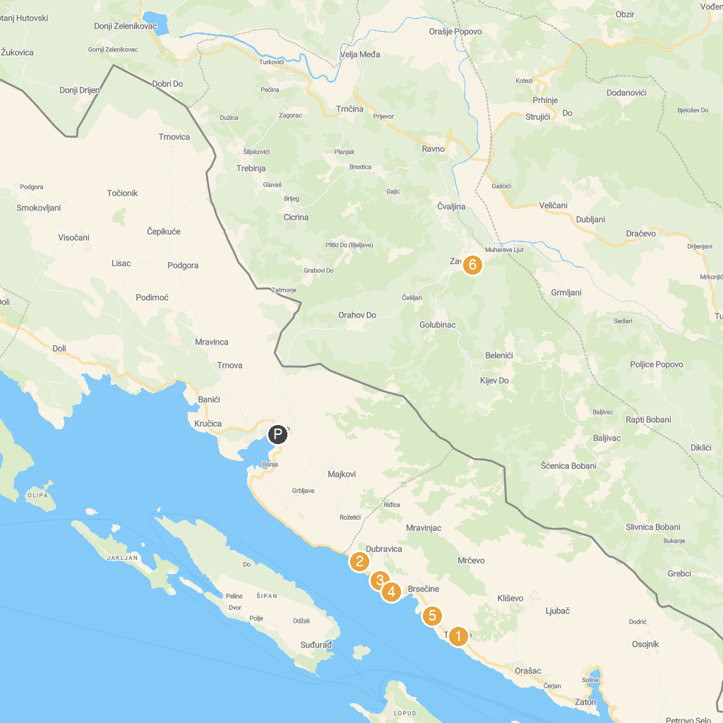
MAP KEY
1. Trsteno Arboretum | 4. Sjekirica Beach
2. Veliki Žal Beach | 5. Plaža Trsteno Brsečine
3. Plaža Dobro | 6. Špilja Vjetrenica
P. Cruise port / terminal
Map © MapTiler © OpenStreetMap contributors · cruiseports.org

