Skyros Island, Sporades, Greece
Perched on a dramatic rocky bluff, Skyros's whitewashed Chora looks straight out of the Cyclades — yet this hidden Sporades gem still feels genuinely off the beaten path, with miniature wild horses, a 10th-century castle-monastery, and lobster pasta you won't stop thinking about.
⚓ Small pier / tender possible (Linaria) · 🕒 Typical call: 6–8 hrs · 💶 Euro (€) · 🗣️ Greek · 🌊 Sporades, Aegean
✍️ MY DAY IN PORT (FILL IN)
Ship / Date
In port | arrive ______ · all aboard ______
Booked excursion
Notes / meeting point
GETTING ASHORE
- Docking: Linaria port (west coast); small ships dock at pier, larger vessels may anchor and tender
- Walk to Chora: 12 km from Linaria — bus or taxi required
- Best For: Cycladic architecture, Byzantine history, uncrowded beaches, local crafts
- Don't Miss: Castle-monastery of Agios Georgios, Faltaits Folk Museum, and fresh lobster pasta
GETTING AROUND
- 🚕 Taxi: €18–22 — Taxis wait at Linaria port and charge roughly €18–22 for the 10 km ride to Skyros Town (Chora). Agree on the fare before
- 📱 Rideshare: ❌ not available
TOP THINGS TO DO
- Skyros Town (Chora) & Byzantine Castle — The island capital climbs a rocky bluff amphitheatrically, its white cubic houses giving it a Cycladic feel unique in the Sporades.
- Faltaits Folk Art Museum — One of Greece's finest folk museums, established in 1964 in a traditional Skyrian house in Chora.
- Skyrian Horse Encounter — Skyros is home to an endangered breed of miniature wild horses — among the smallest in the world and possibly descended from…
- Molos & Magazia Beaches — Skyros's best-organized beaches sit on the east coast just below Chora — long sandy stretches with clear water, sunbed hire, and…
- Coastal Boat Trip — Embark on a short cruise around Skyros's rugged coastline to discover sea caves like Pentakali, hidden coves inaccessible by…
BEST WALKS
- Linaria Waterfront to Acherounes Beach: Easy · ~2 km round-trip · 30 min — A flat, pleasant walk north along the harbor from Linaria pier to the long sandy Acherounes beach.
- Chora Old Town & Castle Climb: Moderate · 1–2 km in town · allow 2 hrs — From Chora's main square (Rupert Brooke Square), follow the cobbled lanes uphill past traditional…
WEATHER · DAYLIGHT · MONEY
Month | High °F | Low °F | Rainy days
May | 70 | 61 | 4
Jul | 83 | 74 | 1
Sep | 77 | 70 | 4
Daylight: May 6:09AM–8:27PM · Jul 6:09AM–8:46PM · Sep 7:03AM–7:29PM
cruiseports.org/skyros-island · Confirm terminal & all-aboard time with your ship

Skyros Island, Sporades, Greece — Port Map
Red = walkable sights · Amber = excursions farther out · P = cruise terminal
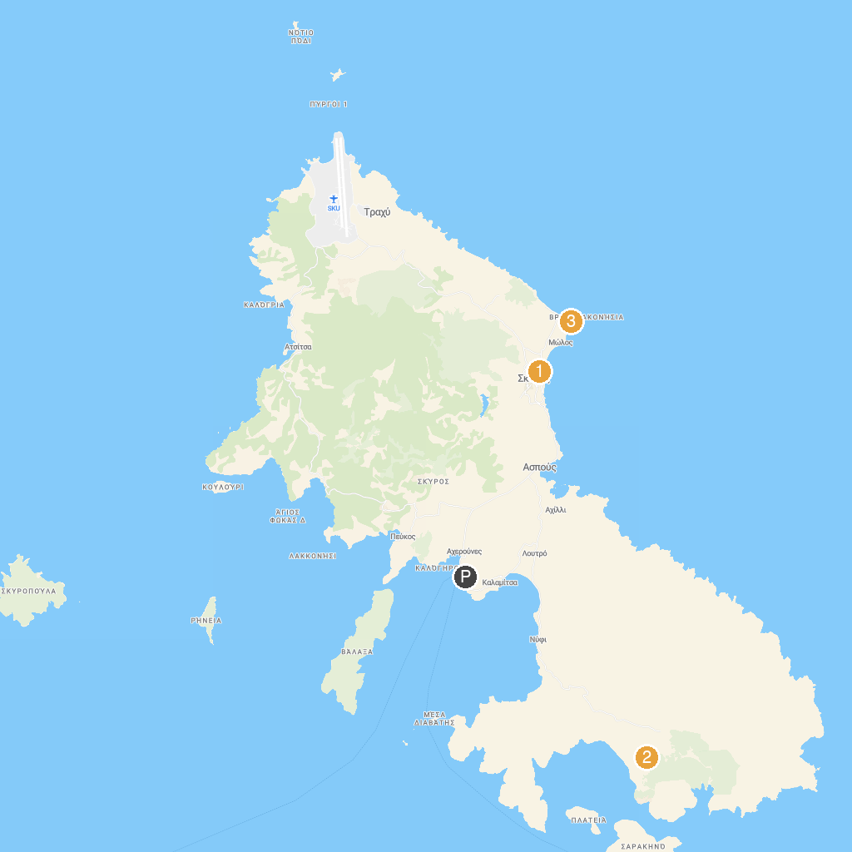
MAP KEY
1. Archaeological Museum of Skyros | 3. Church Agios Nikolaos
2. The Grave of Rupert Brooke | 4. Archaeological Site of Palamari at Skyros
P. Cruise port / terminal
Map © MapTiler © OpenStreetMap contributors · cruiseports.org

