Skopelos Island, Sporades, Greece
Greece's greenest island — pine-forested, cobblestoned, and famously the star of Mamma Mia! — delivers authentic Aegean charm without the tourist crowds of better-known islands.
⚓ Tender (anchor in bay) · 🕒 Typical call: 6–8 hrs · 💶 Euro (€) · 🗣️ Greek (English widely spoken)
✍️ MY DAY IN PORT (FILL IN)
Ship / Date
In port | arrive ______ · all aboard ______
Booked excursion
Notes / meeting point
GETTING ASHORE
- Docking: Tender — ships anchor in Skopelos Town bay; short boat ride to harbor
- Walk to town: Tender drops directly at the harbor promenade — town is immediate
- Best For: Mamma Mia fans, beach lovers, Greek village wandering, food
- Don't Miss: Agios Ioannis Chapel (the wedding-scene rock church) and local tiropita
GETTING AROUND
- 🚕 Taxi: €3.50 start + €0.70/km — Local taxis are available at the port. Taxis are unmetered — agree on fare before departing. A ride across the island to
- 📱 Rideshare: ❌ not available
TOP THINGS TO DO
- Agios Ioannis Chapel — The Mamma Mia Wedding Rock — A tiny whitewashed chapel perched atop a dramatic 100-metre rock pinnacle.
- Skopelos Town (Chora) Walking Tour — The old town is a designated settlement of outstanding beauty — car-free lanes, whitewashed houses, bougainvillea, and over 120…
- Kastani Beach & Mamma Mia Scenes — Sandy beach fringed by pine trees where 'Does Your Mother Know' and 'Lay All Your Love on Me' were filmed.
- Byzantine Monasteries of Mount Palouki — A cluster of beautifully preserved Byzantine-era monasteries on the hillside above Skopelos Town, including Evangelistria…
- Skopelos Food & Taverna Experience — Try the island's signature Skopelitiki tiropita — a deep-fried spiral cheese pie made with local goat cheese — unavailable…
BEST WALKS
- Harbor & Old Town Loop: 1.5–2 hrs | Easy to moderate | Free — From the tender dock, stroll the flat harbor promenade past cafes and fishing boats, then duck into…
WEATHER · DAYLIGHT · MONEY
Month | High °F | Low °F | Rainy days
May | 70 | 61 | 6
Jul | 82 | 75 | 2
Sep | 76 | 70 | 7
Daylight: May 6:12AM–8:31PM · Jul 6:11AM–8:50PM · Sep 7:06AM–7:33PM
cruiseports.org/skopelos-island · Confirm terminal & all-aboard time with your ship

Skopelos Island, Sporades, Greece — Port Map
Red = walkable sights · Amber = excursions farther out · P = cruise terminal
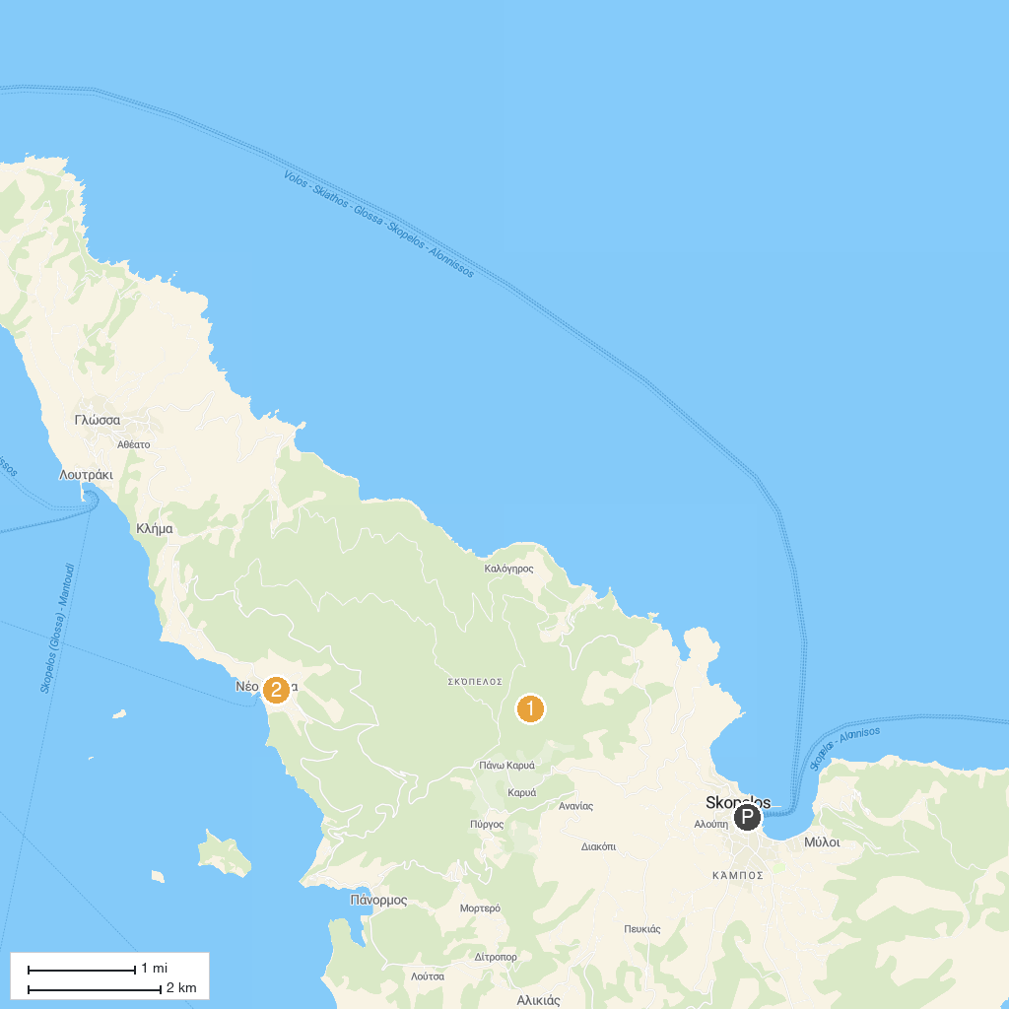
MAP KEY
1. Carved Graves Sedoukia | 3. Albedo Travel
2. Panormoscar
P. Cruise port / terminal
Map © MapTiler © OpenStreetMap contributors · cruiseports.org

