Skomer Island, Pembrokeshire, Wales, UK
An uninhabited island nature reserve where puffins walk up to your feet, half the world's Manx Shearwaters nest underground, and Atlantic seals lounge on the rocks below ancient clifftops.
⚓ Tender / Zodiac landing · 🕒 Typical call: 5-7 hrs · 💷 GBP (£) · 🗣️ English · 🐦 Wildlife season: Apr–Sep
✍️ MY DAY IN PORT (FILL IN)
Ship / Date
In port | arrive ______ · all aboard ______
Booked excursion
Notes / meeting point
GETTING ASHORE
- Docking: Expedition ships anchor offshore; Zodiac tender to North Haven landing. Larger ships dock at Milford Haven or Pembroke Dock, then transfer to Martin's Haven.
- Walk to centre: 87 steep stone steps from landing jetty to island plateau. No vehicles. Main loop 4 miles / 2-3 hrs; short route to The Wick ~1.5 miles.
- Best For: Puffin encounters (May–mid-Jul), birdwatching, seal spotting, wildflowers, and unspoilt coastal scenery
- Don't Miss: The Wick puffin colony — birds nest at arm's length from the path; The Garland Stone for grey seals
GETTING AROUND
- 🚕 Taxi: £35–50 — Local taxis from Martin's Haven can reach Haverfordwest or Milford Haven (approx. 25 min). No metered taxis operate on t
- 📱 Rideshare: ❌ not available
TOP THINGS TO DO
- Puffin Walk to The Wick — Hike across the island plateau to The Wick, a dramatic south-facing cliff where 40,000+ puffins nest in burrows right beside the…
- Grey Seal & Porpoise Spotting at Garland Stone — Follow the northern trail to the Garland Stone, the best vantage point on the island for watching Atlantic grey seals lounging on…
- Island Circuit Walk — The full 4-mile perimeter trail loops the entire island, passing bluebell carpets in May, Bronze Age Harold Stone, Manx…
- Skomer by Boat (Circumnavigation) — For those who can't manage the 87-step climb, Dale Sailing and similar operators run cruise trips around the island perimeter…
- Farm Visitor Centre & Skomer Vole Exhibit — The restored central farmstead houses a small interactive exhibition on the island's conservation history, its Bronze Age past…
BEST WALKS
- North Haven to The Wick (Puffin Cliff): 1.5 miles / 45-60 mins one-way | Moderate — From the North Haven landing, follow the signed path southwest across the plateau, past the Farm…
- Full Island Loop: 4 miles / 2.5-3 hrs | Moderate — A circular trail around Skomer's coast and interior, taking in The Wick puffin cliff, Garland Stone…
WEATHER · DAYLIGHT · MONEY
Month | High °F | Low °F | Rainy days
May | 58 | 48 | 13
Jul | 65 | 56 | 14
Sep | 63 | 54 | 15
Daylight: May 5:28AM–9:07PM · Jul 5:21AM–9:32PM · Sep 6:56AM–7:35PM
cruiseports.org/skomer-island · Confirm terminal & all-aboard time with your ship

Skomer Island, Pembrokeshire, Wales, UK — Port Map
Red = walkable sights · Amber = excursions farther out · P = cruise terminal
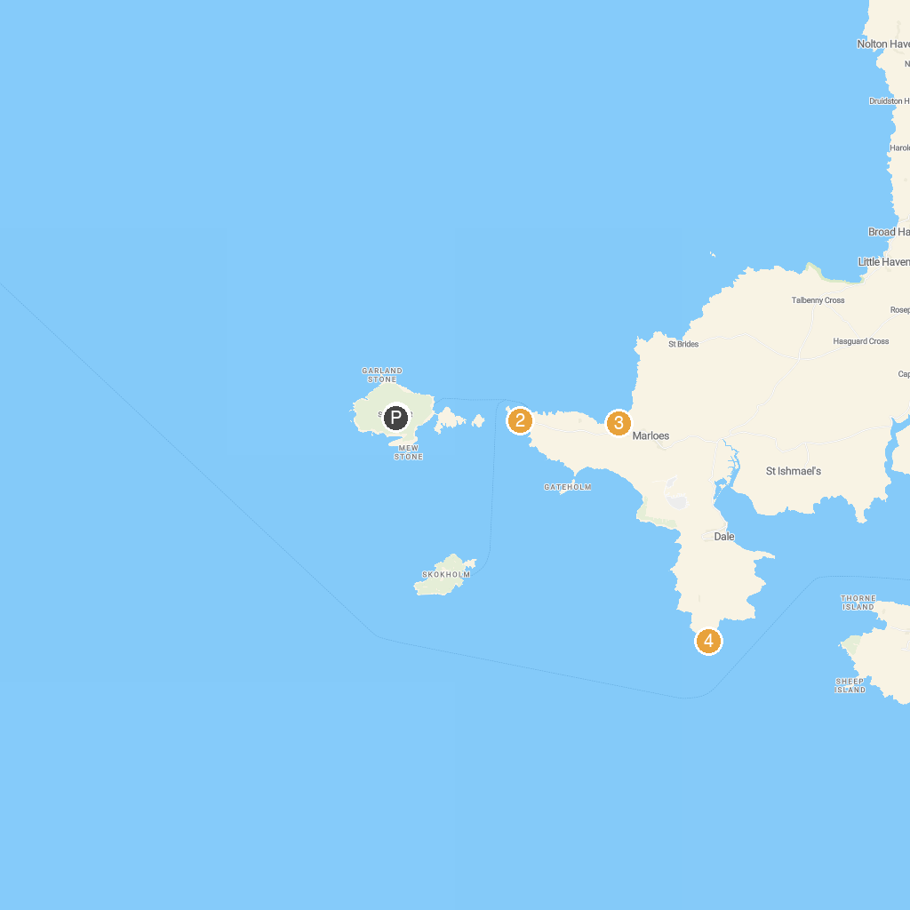
MAP KEY
1. Skomer Island | 5. Broad Haven Beach
2. Deer Park | 6. Porthclais Harbour Authority
3. Musselwick Sands | 7. Chapel Bay Fort & Museum
4. St Ann's Head Lighthouse
P. Cruise port / terminal
Map © MapTiler © OpenStreetMap contributors · cruiseports.org

