Skarsvåg, Finnmark, Norway
Perched at the very top of the world, Skarsvåg is a village of ~60 souls where reindeer roam the roads, king crabs lurk beneath the harbor, and North Cape's cliff rises 14 km away. This is the edge of the earth — and it looks the part.
⚓ Tender port · 🕒 Typical call: 4–6 hrs · 💵 Norwegian Krone (NOK) — cards widely accepted · 🗣️ Norwegian · ☀️ Midnight Sun (mid-May–late July)
✍️ MY DAY IN PORT (FILL IN)
Ship / Date
In port | arrive ______ · all aboard ______
Booked excursion
Notes / meeting point
GETTING ASHORE
- Docking: Tender to small floating pier in harbor
- Walk to center: 2 min from tender pier (100–200 m)
- Best For: North Cape visit, Kirkeporten hike, king crab safari
- Don't Miss: Norwegian waffle with cloudberry jam at the Christmas House
GETTING AROUND
- 🚕 Taxi: NOK 500–650 — Local taxis (Nordkapp Taxisentral DA) run the ~15 km to Honningsvåg in about 22 minutes. Best option for flexibility; pr
- 📱 Rideshare: ❌ not available
TOP THINGS TO DO
- North Cape (Nordkapp) — Europe's northernmost point rises 307 m above the Barents Sea.
- Kirkeporten Natural Arch Hike — A spectacular rock arch frames a view of the fjord and the North Cape plateau.
- King Crab Safari — Skarsvåg is ground zero for the giant Red King Crab.
- Christmas House (Julehuset) — This family-run cottage is decorated for Christmas 365 days a year.
- E-Bike to North Cape — For fit visitors who want to earn that globe photo: rent an e-bike and tackle the 14 km uphill haul to Nordkapp.
BEST WALKS
- Harbor & Village Loop: 30–45 min | Easy | Free — A gentle stroll from the tender pier around the harbor, past the colorful wooden houses, the fish…
- Kirkeporten Arch Hike: 1–1.5 hrs | Easy–moderate | Free — Follow signs from the harbor toward Kirkeporten Camping, then take the marked trail up the hillside…
WEATHER · DAYLIGHT · MONEY
Month | High °F | Low °F | Rainy days
May | 42 | 36 | 16
Jul | 56 | 48 | 12
Sep | 49 | 43 | 16
Daylight: Sep 5:27AM–6:53PM
cruiseports.org/skarsvag · Confirm terminal & all-aboard time with your ship

Skarsvåg, Finnmark, Norway — Port Map
Red = walkable sights · Amber = excursions farther out · P = cruise terminal
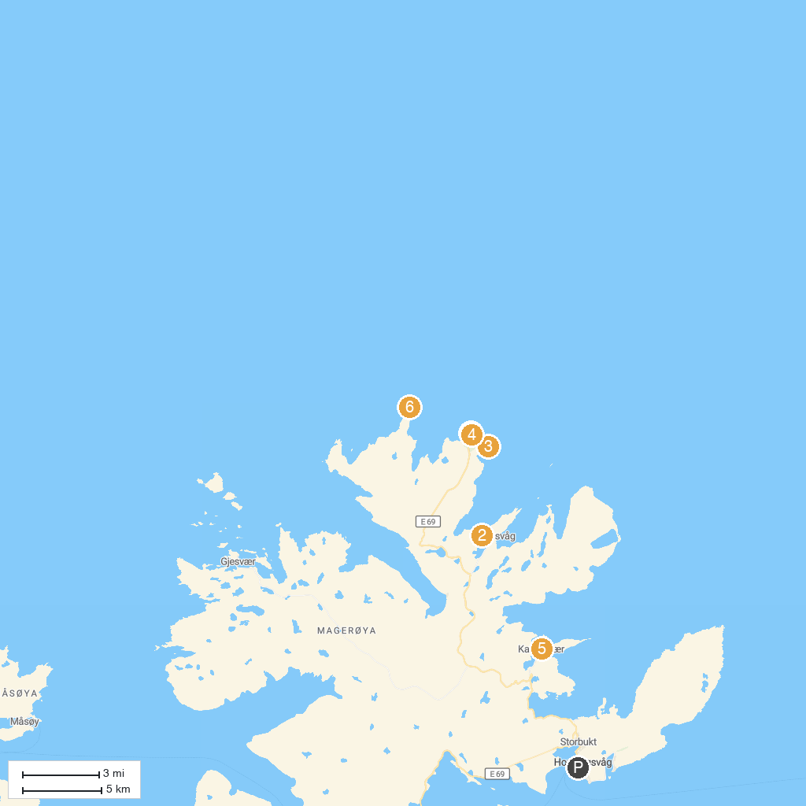
MAP KEY
1. North Cape | 4. Nordkapphallen
2. Kirkeporten in Skarsvåg | 5. The Gallery "East of the Sun"
3. Cuerno del Cabo Norte | 6. Northernmost Point of Europe
P. Cruise port / terminal
Map © MapTiler © OpenStreetMap contributors · cruiseports.org

