Skagway, Alaska, USA
A Gold Rush boomtown frozen in 1898 — ships dock steps from a National Historic Landmark where narrow-gauge railways, mountain trails, and Klondike saloons fill one of Alaska's longest shore days.
⚓ All ships dock downtown (no tender) · 🕒 Typical call: 7–10 hrs · 💵 US Dollar (USD) · 🗣️ English · 🚂 Iconic White Pass Railroad excursion
✍️ MY DAY IN PORT (FILL IN)
Ship / Date
In port | arrive ______ · all aboard ______
Booked excursion
Notes / meeting point
GETTING ASHORE
- Docking: Broadway, Ore, or Railroad Dock — all downtown
- Walk to center: 2–15 min depending on berth
- Best For: History · Railroad · Hiking · Flightseeing
- Don't Miss: White Pass & Yukon Route Railroad
GETTING AROUND
- 📱 Rideshare: ❌ not available
TOP THINGS TO DO
- White Pass & Yukon Route Railroad — The narrow-gauge railway that hauled stampeders in 1898 — now an International Historic Civil Engineering Landmark.
- Klondike Gold Rush National Historical Park — Skagway's entire downtown is a free NPS unit.
- Bicycle Descent from White Pass — Ride the bus or train up to the White Pass Summit, then freewheel 15 miles downhill back to Skagway on the historic South…
- Chilkoot Trail Day Hike — The legendary 33-mile Chilkoot Pass trail — called the world's longest outdoor museum — starts 9 miles from town at Dyea.
- Glacier & Fjord Flightseeing — Floatplanes and helicopters offer 30–60 minute flights over Skagway River valley, Meade Glacier, and the Brady Icefield.
BEST WALKS
- Broadway Historic District Stroll: ~1.5 km · 45–60 min · flat/easy — Walk Broadway end to end through the preserved Gold Rush townscape.
- Gold Rush Cemetery & Reid Falls: ~3 km round-trip · 1–1.5 hrs · easy flat road walk — A flat road walk north of town leads to the cemetery where con man Soapy Smith and his nemesis…
- Lower Dewey Lake Trail: ~3 km round-trip · 1–1.5 hrs · moderate (steep ascent) — A short but steep climb through Sitka spruce forest behind the railroad depot leads to a quiet…
WEATHER · DAYLIGHT · MONEY
Month | High °F | Low °F | Rainy days
May | 53 | 44 | 14
Jul | 66 | 57 | 16
Sep | 56 | 48 | 19
Daylight: May 4:26AM–9:30PM · Jul 4:11AM–10:01PM · Sep 6:31AM–7:19PM
cruiseports.org/skagway · Confirm terminal & all-aboard time with your ship

Skagway, Alaska, USA — Port Map
Red = walkable sights · Amber = excursions farther out · P = cruise terminal
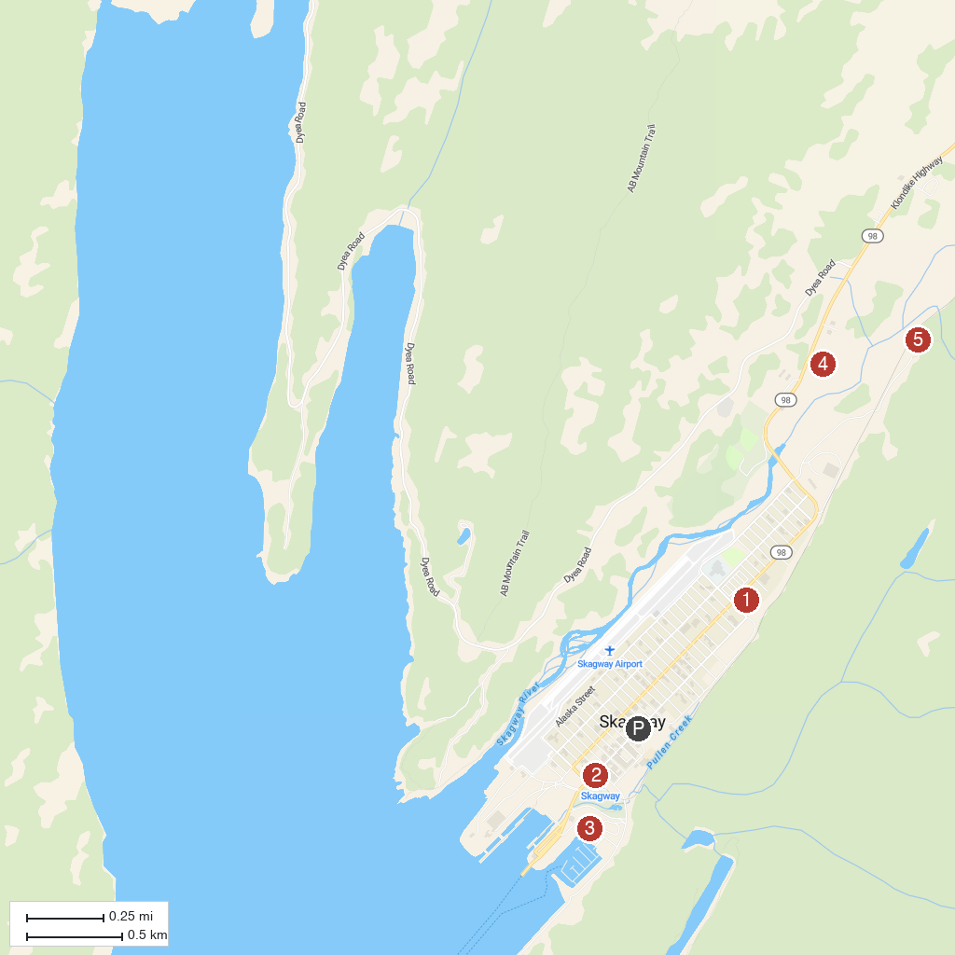
MAP KEY
1. Trail of '98 Tours | 4. Alaska 360's Dredge Town
2. Klondike Gold Rush National Historical Park Visitor Center | 5. Gold Rush Cemetery
3. Ocean Raft Alaska
P. Cruise port / terminal
Map © MapTiler © OpenStreetMap contributors · cruiseports.org

