Skagen, Jutland, Denmark
At the very tip of Denmark, two seas collide in a foamy line you can straddle with one foot in each. Add painted dunes, a buried church, and a 19th-century artist colony obsessed with this light, and a single cruise day barely scratches the surface.
⚓ Docked (pier) · 🕒 Typical call: 6-8 hrs · 💵 Danish Krone (DKK) — nearly cashless · 🗣️ Danish / English widely spoken · 🚲 Excellent cycling town
✍️ MY DAY IN PORT (FILL IN)
Ship / Date
In port | arrive ______ · all aboard ______
Booked excursion
Notes / meeting point
GETTING ASHORE
- Docking: Docked — cruise piers 9/10 in working harbour, ~1.6 km to town centre; free shuttle bus provided
- Walk to Centre: ~20 min on foot from cruise quay, or take free shuttle
- Best For: Grenen two-seas spit, Skagen Painters museum, cycling to sand-buried church
- Don't Miss: Standing at Grenen where Skagerrak and Kattegat collide — unique in the world
GETTING AROUND
- 🚕 Taxi: 85-110 DKK (~$12-16 USD) — The ride from the cruise pier to the city center is about 2.2 km and takes roughly 3 minutes. Taxis can be scarce in Ska
TOP THINGS TO DO
- Grenen — Where Two Seas Meet — Walk or ride the Sandormen tractor-wagon to Denmark's northernmost point where Skagerrak and Kattegat collide in a visible…
- Skagens Museum — The Skagen Painters — Denmark's most celebrated artist colony descended on Skagen in the 1870s-1900s, captivated by its extraordinary northern light.
- Den Tilsandede Kirke — The Sand-Buried Church — A 14th-century church swallowed by migrating dunes — abandoned in 1795 when sand reached the windows.
- Råbjerg Mile — Northern Europe's Migrating Dune — A vast inland sand dune up to 40 m high and 1 km wide that migrates ~15 m eastward every year.
- Anchers Hus & Drachmanns Hus — Visit the preserved homes of the Skagen Painters' most famous residents — Anna and Michael Ancher's house with 250+ works, and…
BEST WALKS
- Town Centre Stroll: 1.5 km loop • Easy • ~30 min — Wander Skagen's distinctive yellow-painted houses, ducking into galleries and amber jewellery shops…
- Grenen Point Walk: 3 km from town • Easy on sand • ~45 min each way — Cycle or walk the coast path from town to the Grenen car park, then continue on foot (or by…
- Buried Church & Lighthouse Loop (Bike): ~10 km loop • Easy cycling • ~1.5 hrs — Classic Skagen cycling route.
WEATHER · DAYLIGHT · MONEY
Month | High °F | Low °F | Rainy days
May | 56 | 48 | 10
Jul | 66 | 59 | 12
Sep | 61 | 56 | 12
Daylight: May 4:55AM–9:34PM · Jul 4:41AM–10:05PM · Sep 6:48AM–7:35PM
cruiseports.org/skagen · Confirm terminal & all-aboard time with your ship

Skagen, Jutland, Denmark — Port Map
Red = walkable sights · Amber = excursions farther out · P = cruise terminal
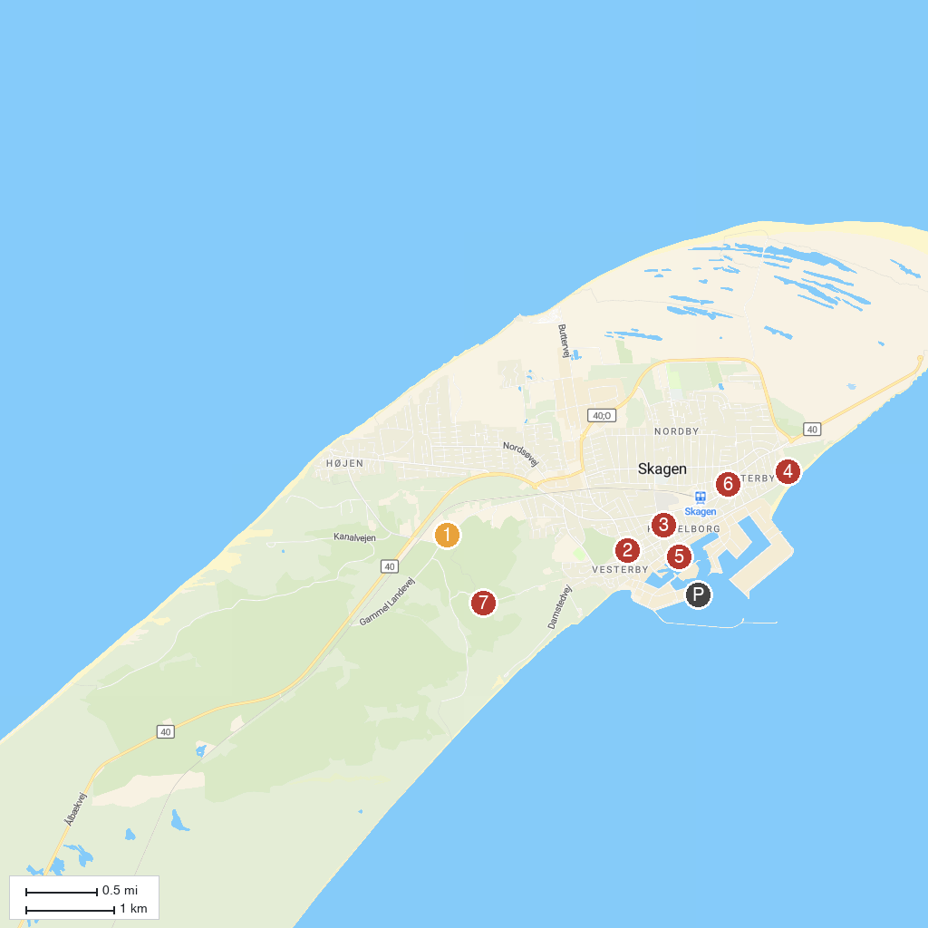
MAP KEY
1. Råbjerg Mile | 5. Vippefyret
2. Dino Minigolf | 6. Skagen Marina
3. Drachmanns Hus | 7. Skagen Vandtårn
4. Skagen Kirke | 8. Den Tilsandede Kirke
P. Cruise port / terminal
Map © MapTiler © OpenStreetMap contributors · cruiseports.org

