Sisak, Sisak-Moslavina County, Croatia
Where three rivers meet 2,000 years of history. Sisak — once the Roman city of Siscia and site of the battle that stopped the Ottoman advance — offers a crowd-free slice of real Croatia just 50 km from Zagreb.
⚓ Docked (river pontoon, no tender) · 🕒 Typical call: 6-8 hrs · 💶 Currency: Euro (€) · 🗣️ Language: Croatian (English widely spoken)
✍️ MY DAY IN PORT (FILL IN)
Ship / Date
In port | arrive ______ · all aboard ______
Booked excursion
Notes / meeting point
GETTING ASHORE
- Docking: River pontoon on the Kupa — step ashore directly into the city center
- Walk to center: 0 min — the promenade IS the city center
- Best For: Roman history, Renaissance fortresses, authentic Croatian river-town life
- Don't Miss: Sisak Fortress (site of the 1593 Battle of Sisak) and Škrlet wine from the Moslavina region
GETTING AROUND
- 🚕 Taxi: ~€5–€10 within city — Taxis are available at the quay and in the city center. Useful for reaching the train/bus station or points outside the
- 📱 Rideshare: ✅ Uber, Bolt
TOP THINGS TO DO
- Sisak Fortress & Battle of 1593 — The triangular Renaissance fortress built in 1544 is one of Croatia's best-preserved.
- Siscia Roman Archaeological Park — Walk over 2,000 years of history — preserved Roman defensive walls and a military granary sit in situ on Ban Jelačić Square.
- Dutch House Industrial Heritage Centre — A beautifully restored 19th-century grain warehouse with a stepped facade, now Croatia's first industrial heritage interpretation…
- Lonjsko Polje Nature Park & Stork Village — One of Europe's largest protected wetlands, just 30 min from the pier.
- Zagreb Day Excursion — Croatia's vibrant capital is just 50 km away — easily the biggest excursion option from Sisak.
BEST WALKS
- River Promenade to Sisak Fortress: 3 km round trip · ~1 hr · Flat · Historic — Follow the Kupa riverside path south from the pier past the Old Bridge (Stari Most) and the Mali…
- Roman City Walk: 1 km loop · 30-45 min · Flat · Free — From the pier, walk a few minutes into the city center to Ban Jelačić Square where the Siscia…
WEATHER · DAYLIGHT · MONEY
Month | High °F | Low °F | Rainy days
May | 70 | 52 | 15
Jul | 83 | 64 | 10
Sep | 73 | 55 | 10
Daylight: May 5:24AM–8:18PM · Jul 5:20AM–8:39PM · Sep 6:33AM–7:05PM
cruiseports.org/sisak · Confirm terminal & all-aboard time with your ship

Sisak, Sisak-Moslavina County, Croatia — Port Map
Red = walkable sights · Amber = excursions farther out · P = cruise terminal
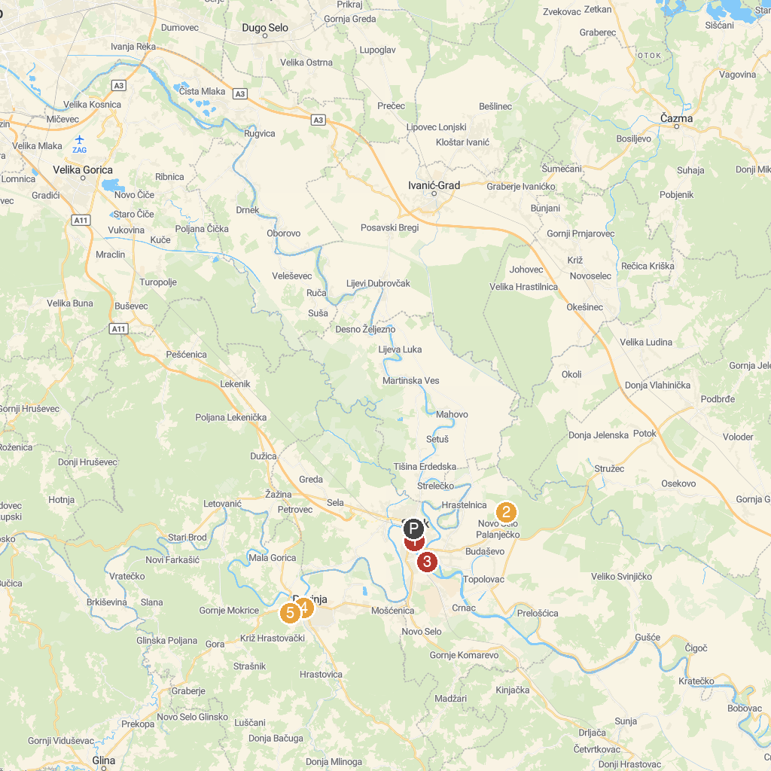
MAP KEY
1. Sisak City Museum | 4. Petrinjska šetnica - kružna poučno-rekreativna staza
2. Spomen-park Brezovica | 5. Petrinjska stucka
3. The old town of Sisak
P. Cruise port / terminal
Map © MapTiler © OpenStreetMap contributors · cruiseports.org

