Siracusa, Sicily, Italy
One of the ancient world's greatest cities, Siracusa delivers 2,700 years of history on a walkable island — Greek ruins, a cathedral built inside a temple, and some of Sicily's best street food, all minutes from the pier.
⚓ Pier port (Porto Grande) · 🕒 Typical call: 8–10 hrs · 💶 Currency: Euro · 🗣️ Language: Italian
✍️ MY DAY IN PORT (FILL IN)
Ship / Date
In port | arrive ______ · all aboard ______
Booked excursion
Notes / meeting point
GETTING ASHORE
- Docking: Pier — Molo Garibaldi or Molo Sant'Antonio, Porto Grande
- Walk to Ortigia: 5–10 min flat walk from the gangway
- Best For: Ancient history, Baroque architecture, Sicilian food
- Don't Miss: The Duomo — a Greek temple converted into a cathedral
GETTING AROUND
- 🚕 Taxi: €6–€10 — Taxis queue at the port gate and reach Ortigia in about 2 minutes. Expect a €3 flag-fall plus metered fare; agree on a p
- 📱 Rideshare: ✅ Uber Black
- 🚌 Hop-on hop-off: ✅ Siracusa Open Tour
TOP THINGS TO DO
- Neapolis Archaeological Park — The crown jewel of Sicily's ancient past: a massive 5th-century BC Greek Theatre carved from living rock, the eerie Ear of…
- Ortigia Walking Tour — Guided walk through Ortigia's layered history — Temple of Apollo, Piazza Archimede, the Baroque Piazza del Duomo, the Duomo…
- Ortigia Street Food & Market Tour — Dive into the morning market's shouting vendors, fresh swordfish, Sicilian cheeses, and giant lemons, then graze on arancini…
- Day Trip to Noto — Sicily's Baroque showpiece city, 30 km southwest.
- Ortigia Boat Tour & Sea Caves — Cruise around the island by small boat, gliding past Castello Maniace, the Fountain of Arethusa seen from the sea, and into…
BEST WALKS
- Ortigia Highlights Loop: 2.5 km · ~1.5 hrs · Easy / flat — Cross Ponte Umbertino from the port to the Temple of Apollo ruins, then wind through Ortigia's…
- Ortigia Southern Tip: 1.5 km add-on · ~45 min · Easy — From the Fountain of Arethusa, continue south along the seafront to Castello Maniace at the very…
WEATHER · DAYLIGHT · MONEY
Month | High °F | Low °F | Rainy days
May | 73 | 60 | 5
Jul | 89 | 74 | 1
Sep | 82 | 71 | 8
Daylight: May 5:50AM–8:00PM · Jul 5:51AM–8:18PM · Sep 6:41AM–7:06PM
cruiseports.org/siracusa · Confirm terminal & all-aboard time with your ship

Siracusa, Sicily, Italy — Port Map
Red = walkable sights · Amber = excursions farther out · P = cruise terminal
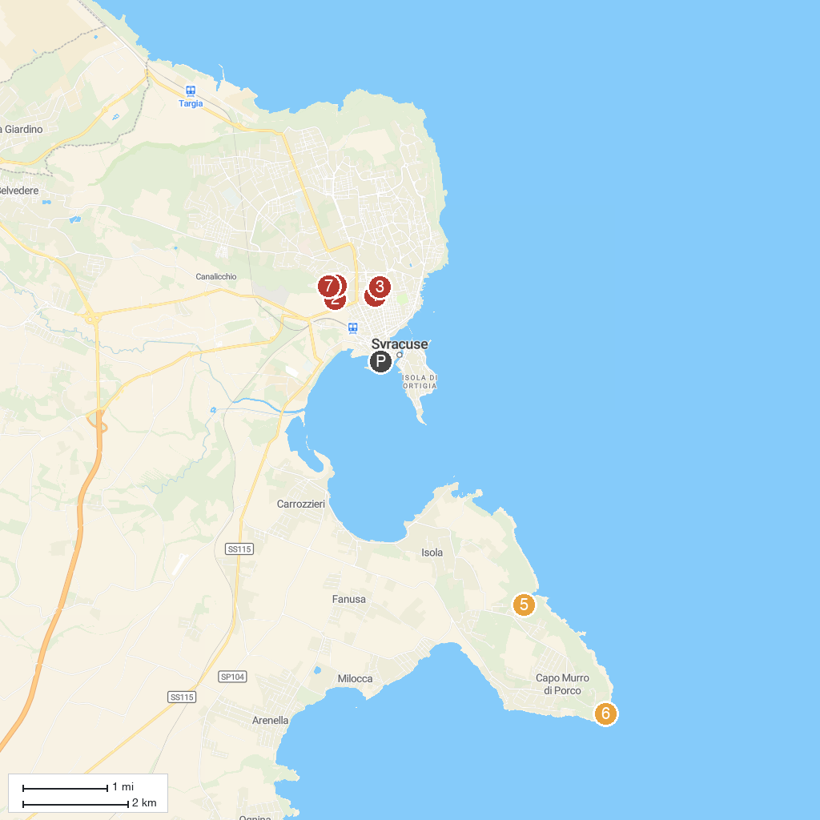
MAP KEY
1. Basilica Santuario Madonna delle Lacrime | 5. Cave of Pillirina
2. Altar of Hiero II | 6. Faro di Capo Murro di Porco
3. Museo Archeologico Regionale Paolo Orsi | 7. Riserva Naturale Integrale Grotta Monello
4. Latomie del Paradiso | 8. Ear of Dionysius
P. Cruise port / terminal
Map © MapTiler © OpenStreetMap contributors · cruiseports.org

