Sinop, Black Sea Coast, Turkey
Turkey's northernmost city rewards cruise visitors with ancient walls they can touch, a prison-fortress with a dramatic past, and a harbor promenade that begins the moment you step off the gangway.
⚓ Pier (docked) · 🕒 Typical call: 6-8 hrs · 💵 Turkish Lira (TRY) · 🗣️ Turkish (English limited) · 🏛️ History & culture
✍️ MY DAY IN PORT (FILL IN)
Ship / Date
In port | arrive ______ · all aboard ______
Booked excursion
Notes / meeting point
GETTING ASHORE
- Docking: Pier — ships berth directly at Sinop Limanı on the sheltered south side of the peninsula
- Walk to center: Virtually zero — the waterfront promenade begins at the port exit
- Best For: History walkers, Black Sea seafood lovers, off-the-beaten-path Turkey
- Don't Miss: Sinop Fortress Prison and a bowl of local Sinop mantısı (walnut-butter dumplings)
GETTING AROUND
- 🚕 Taxi: ₺80–₺150 (~$2–$3.50 USD) in-town — Metered yellow taxis are available near the port. Fares within the city are short and inexpensive; negotiate for longer
TOP THINGS TO DO
- Sinop Fortress Prison — The 'Alcatraz of Anatolia' — a 13th-century Seljuk fortress that became a notorious state prison, closed 1997.
- Old Town Walk & Pervane Medresesi — Stroll the 13th-century Islamic seminary turned artisan bazaar, where local craftspeople sell Sinop's signature wooden model…
- Hamsilos Bay (Turkey's Only Fjord) — A stunning narrow inlet lined with pine forest — technically a ria but Turkey's closest equivalent to a fjord.
- Sinop Archaeological Museum & Balatlar Church — The museum traces Sinop from the Bronze Age through the Ottoman era with a lovely garden of ancient sculptures.
- Karakum Beach — Sinop's famous black-sand beach, 3 km from the port.
BEST WALKS
- Harbor to Fortress Prison Loop: 2.5 km · ~1 hr · flat · historic — From the port gate, follow the waterfront promenade north past Uğur Mumcu Parkı, then turn inland…
- Archaeology & Byzantine Walk: 1.5 km · ~45 min · flat · cultural — From the port, head to the Sinop Archaeological Museum to see artifacts spanning 3,000 years, then…
WEATHER · DAYLIGHT · MONEY
Month | High °F | Low °F | Rainy days
May | 66 | 55 | 9
Jul | 81 | 70 | 6
Sep | 76 | 66 | 8
Daylight: May 5:19AM–7:52PM · Jul 5:17AM–8:13PM · Sep 6:19AM–6:48PM
cruiseports.org/sinop · Confirm terminal & all-aboard time with your ship

Sinop, Black Sea Coast, Turkey — Port Map
Red = walkable sights · Amber = excursions farther out · P = cruise terminal
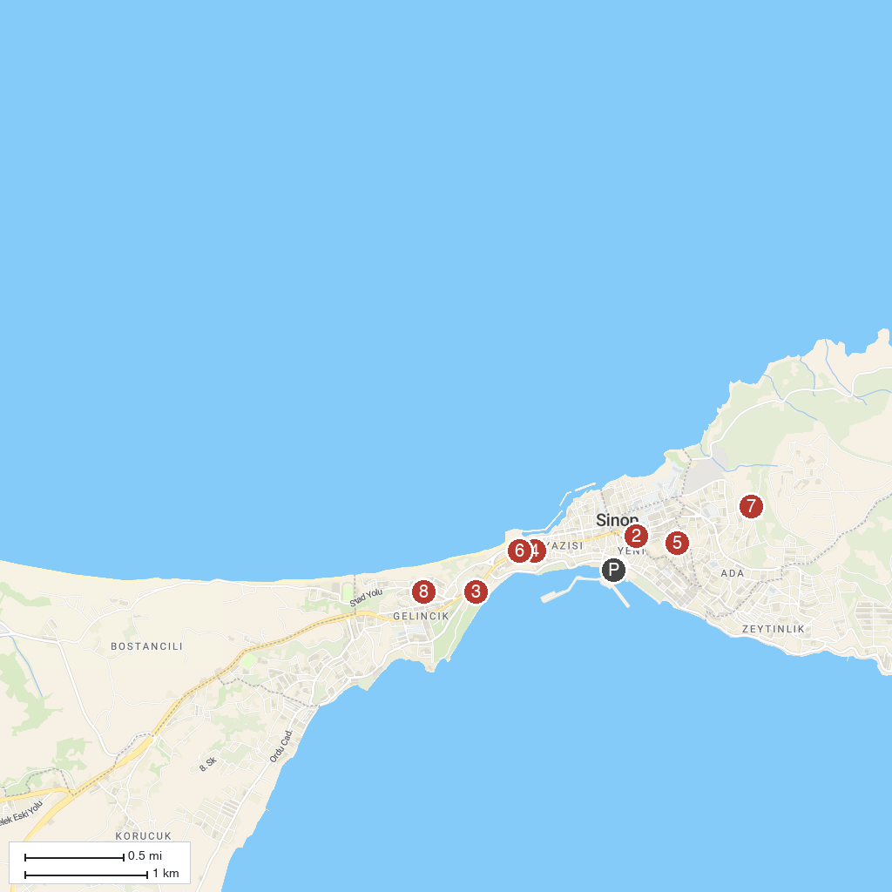
MAP KEY
1. Sinop Castle | 5. Balatlar Church
2. Arslan Torun Mansion and Ethnography Museum | 6. Statue of Diogenes
3. Sinope Tours | 7. Sahin Hill
4. Sinop Historic Prison | 8. Sinop Kuzey Butik Apart
P. Cruise port / terminal
Map © MapTiler © OpenStreetMap contributors · cruiseports.org

