Silver Islet, Ontario, Canada
A ghostly silver-rush village clings to the tip of the Sibley Peninsula, where $3 million in silver was wrestled from beneath Lake Superior — and the flooded shafts can still be seen from shore.
⚓ Tender (Zodiac landing) · 🕒 Typical call: 5–7 hrs · 💵 Canadian Dollar (CAD); some USD accepted · 🗣️ English · 🌲 Expedition/adventure vibe
✍️ MY DAY IN PORT (FILL IN)
Ship / Date
In port | arrive ______ · all aboard ______
Booked excursion
Notes / meeting point
GETTING ASHORE
- Docking: Tender / Zodiac — ships anchor offshore; land at historic Government Dock
- Walk to center: 1 min from dock to General Store; whole village walkable in 30 min
- Best For: History buffs, hikers, rock collectors, digital detox
- Don't Miss: Cinnamon buns at Silver Islet General Store & the flooded mine shafts visible from shore
GETTING AROUND
TOP THINGS TO DO
- Silver Islet General Store & Museum — The oldest business in Northwestern Ontario (est.
- Flooded Mine Shaft Lookout — Walk to the point and peer into the crystal-clear water to see the original wooden cribbing and concrete shaft openings still…
- Sea Lion Rock Arch Trail — A moderately challenging 1.5-mile round-trip hike from the Silver Islet trailhead leads to a spectacular natural rock arch…
- Sleeping Giant Provincial Park Guided Hike — Ship-organized guided excursions into the park cover Ojibwe legends, Boreal forest ecology, and the geology of the iconic…
- Lake Superior Agate & Rock Hunting — The cobblestone beach at Silver Islet is prime hunting ground for Lake Superior agates, Thomsonite, and Ontario's provincial…
BEST WALKS
- Avenue Road Cottage Stroll: 1.5 mi round-trip · Easy · 30–45 min — Walk the length of the settlement past 100+ preserved 1870s miners' cottages, the old stone…
- Mine Shaft Point Walk: 0.5 mi · Easy · 20 min — Head to the tip of the point past the General Store to reach the lake's edge, where you can look…
WEATHER · DAYLIGHT · MONEY
Month | High °F | Low °F | Rainy days
May | 49 | 38 | 10
Jul | 65 | 55 | 10
Sep | 61 | 54 | 10
Daylight: May 6:15AM–9:28PM · Jul 6:10AM–9:51PM · Sep 7:32AM–8:06PM
cruiseports.org/silver-islet-on · Confirm terminal & all-aboard time with your ship

Silver Islet, Ontario, Canada — Port Map
Red = walkable sights · Amber = excursions farther out · P = cruise terminal
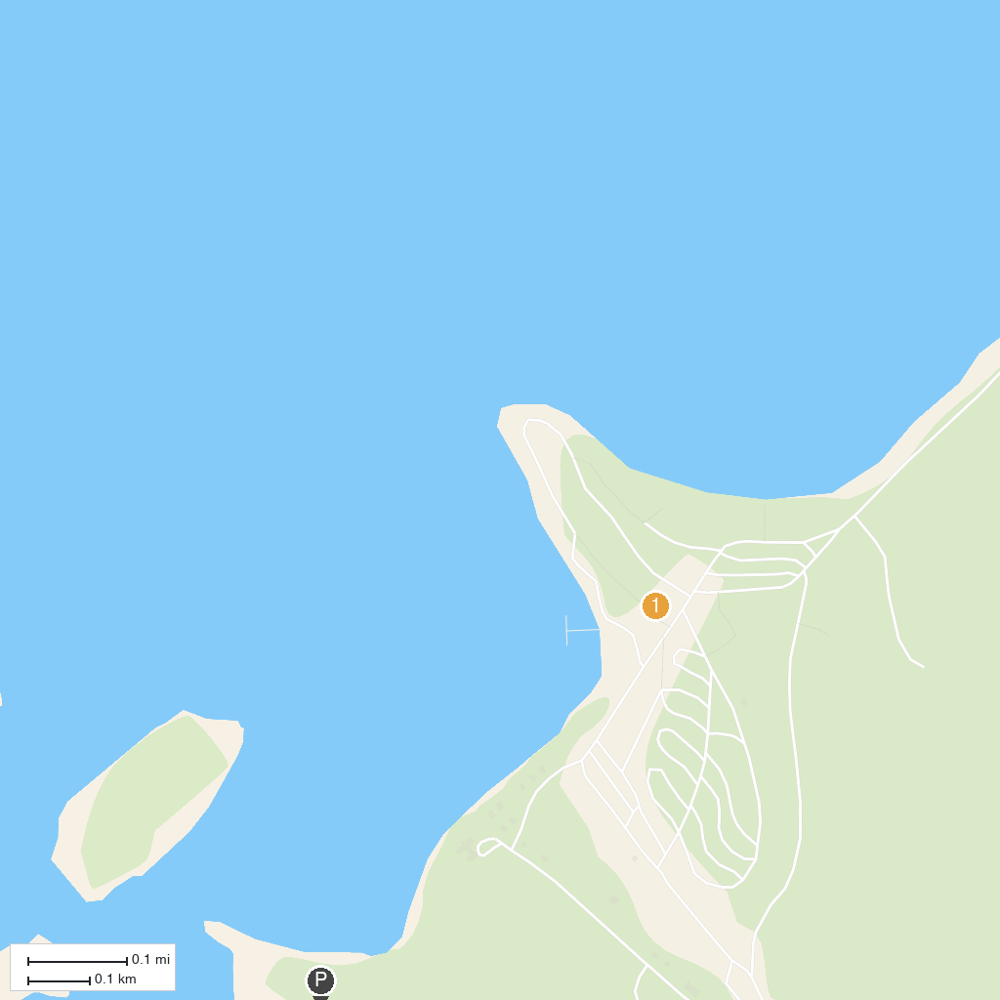
MAP KEY
1. Sleeping Giant Provincial Park | 3. Silver Harbour Conservation Area
2. Thunder Bay Lookout
P. Cruise port / terminal
Map © MapTiler © OpenStreetMap contributors · cruiseports.org

