Sihanoukville, Preah Sihanouk, Cambodia
Cambodia's southern port city offers white-sand beaches, ornate hilltop pagodas, and nearby island paradises — all framed by a dramatic transformation from sleepy backpacker town to gleaming casino strip.
⚓ Pier (Sihanoukville Autonomous Port) · 🕒 Typical call: 7-9 hrs · 💵 USD widely accepted · 🗣️ Khmer / some English · 🏖️ Beaches & islands
✍️ MY DAY IN PORT (FILL IN)
Ship / Date
In port | arrive ______ · all aboard ______
Booked excursion
Notes / meeting point
GETTING ASHORE
- Docking: Pier at Sihanoukville Autonomous Port; shuttle bus to city center
- Walk to center: Port is industrial — shuttle bus required (~10 min to city)
- Best For: Beach days, island hopping to Koh Rong, temple visits
- Don't Miss: Koh Rong Samloem island, Wat Leu hilltop temple, Ream National Park
GETTING AROUND
- 🚕 Taxi: $6–$20 — No metered taxis — always agree on price before getting in. Port to city center runs roughly $6–$10; private transfers f
- 📱 Rideshare: ✅ Grab, PassApp
TOP THINGS TO DO
- Koh Rong Samloem Island Day — A 45-minute speedboat ride delivers you to Saracen Bay — pristine white sand, turquoise water, and virtually no development.
- Otres Beach & Seafood Lunch — The cleanest and most relaxed of Sihanoukville's beaches, about 20 minutes from the port.
- Wat Leu Temple & City Panorama — A hilltop Buddhist temple reached via a steep staircase, offering sweeping views over Sihanoukville, the coastline, and the…
- Ream National Park Boat Tour — About 30–40 minutes from the port, this protected coastal park offers mangrove river cruises, bird watching, and a chance to spot…
- Kbal Chhay Waterfall — A multi-tiered waterfall set in jungle, about 16 km north of the city.
BEST WALKS
- City Center Stroll: Monuments & Market: 1–2 km · 30–45 min · Flat — From the cruise shuttle drop-off near the Independence Monument, walk to the Golden Lions…
- Serendipity Beach Walk: Easy · 1 km beachfront · ~30 min — Tuk-tuk to Serendipity Beach (5–10 min from the city drop-off), then walk the beachfront strip past…
WEATHER · DAYLIGHT · MONEY
Month | High °F | Low °F | Rainy days
May | 87 | 79 | 29
Jul | 84 | 77 | 29
Sep | 83 | 77 | 29
Daylight: May 5:44AM–6:20PM · Jul 5:51AM–6:32PM · Sep 5:55AM–6:06PM
cruiseports.org/sihanoukville · Confirm terminal & all-aboard time with your ship

Sihanoukville, Preah Sihanouk, Cambodia — Port Map
Red = walkable sights · Amber = excursions farther out · P = cruise terminal
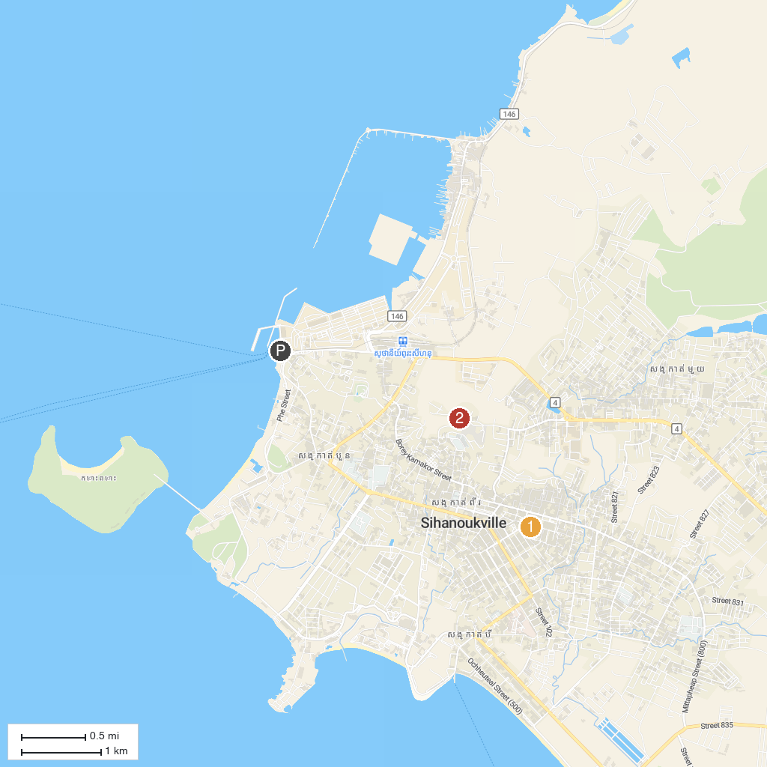
MAP KEY
1. Phsar Leu Market | 2. Wat Leu Pagoda
P. Cruise port / terminal
Map © MapTiler © OpenStreetMap contributors · cruiseports.org

