Siglufjordur, North Iceland, Iceland
Once the "Herring Capital of the World," Siglufjordur is a compact, colorful town squeezed between steep mountains and a mirror-calm fjord — and one of Iceland's most rewarding small-ship stops.
⚓ Pier (small ships) / Tender (large ships) · 🕒 Typical call: 6–8 hrs · 💵 Icelandic Króna (ISK) — cards accepted everywhere · 🗣️ Icelandic (English widely spoken) · 🧊 Arctic & Greenland
✍️ MY DAY IN PORT (FILL IN)
Ship / Date
In port | arrive ______ · all aboard ______
Booked excursion
Notes / meeting point
GETTING ASHORE
- Docking: Small ships dock at Bæjarbryggja pier in town; larger vessels anchor and tender to the same pier
- Walk to center: 0 min — pier is in the heart of the harbor
- Best For: History buffs, hikers, craft beer fans, Nordic noir TV fans (filming location of Trapped)
- Don't Miss: Herring Era Museum — Iceland's largest maritime and industrial museum, with live herring-salting demos in summer
GETTING AROUND
- 🚕 Taxi: ~$15 USD — A very limited number of local taxis serve Siglufjörður. Best arranged through your accommodation or cruise line; street
- 📱 Rideshare: ❌ not available
TOP THINGS TO DO
- Herring Era Museum — Iceland's largest maritime and industrial museum spans three historic buildings.
- Héðinsfjörður Valley Hike — The old tunnel road leads to the uninhabited neighboring fjord — dramatic abandoned farmsteads, waterfalls, and Arctic silence.
- Fjord Kayaking — Paddle the calm waters of Siglufjörður with mountain walls rising on both sides.
- Folk Music Centre — Housed in the town's oldest building, this intimate museum presents Icelandic folk music, traditional rímur chanting, and video…
- Segull 67 Brewery Tour & Tasting — This family-run craft brewery — just 300 m from the pier — occupies a converted fish factory and brews with pure Icelandic…
BEST WALKS
- Harbor Loop & Colorful Old Town: 1.5 km · 25 min · Easy · Free — A leisurely loop around the harbor taking in the brightly painted wooden buildings, fishing boats…
- Avalanche Barrier Viewpoint: 2 km return · 45 min · Easy–Moderate · Free — Follow the road uphill from the town center to the massive avalanche protection barriers built into…
WEATHER · DAYLIGHT · MONEY
Month | High °F | Low °F | Rainy days
May | 43 | 37 | 13
Jul | 51 | 46 | 14
Sep | 49 | 43 | 18
Daylight: Sep 6:36AM–7:42PM
cruiseports.org/siglufjordur · Confirm terminal & all-aboard time with your ship

Siglufjordur, North Iceland, Iceland — Port Map
Red = walkable sights · Amber = excursions farther out · P = cruise terminal
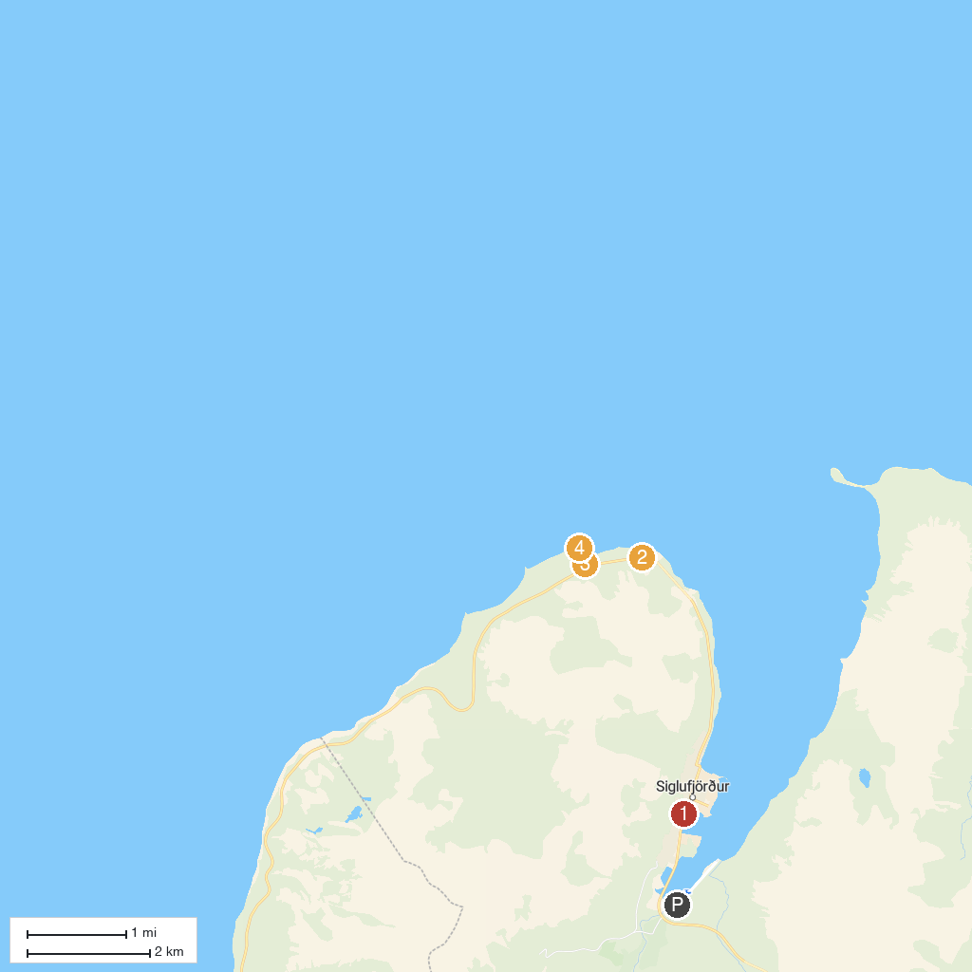
MAP KEY
1. The Herring Era Museum | 3. Trollaskagi
2. Útsýnispallur | 4. Sauðanesviti
P. Cruise port / terminal
Map © MapTiler © OpenStreetMap contributors · cruiseports.org

