Sifnos Island, Cyclades, Greece
One of the Cyclades' best-kept secrets, Sifnos rewards cruise visitors with medieval clifftop villages, a legendary food culture, over 300 blue-domed churches, and some of the most beautiful sandy beaches in Greece — all refreshingly free of mass tourism.
⚓ Tender (most ships anchor in Kamares Bay) · 🕒 Typical call: 6–8 hrs · 💶 Currency: Euro · 🗣️ Language: Greek · 🍲 Famous for: Pottery & cuisine
✍️ MY DAY IN PORT (FILL IN)
Ship / Date
In port | arrive ______ · all aboard ______
Booked excursion
Notes / meeting point
GETTING ASHORE
- Docking: Tender — ships anchor in Kamares Bay; tender to the village pier
- Walk to center: Kamares village: 2–5 min flat from tender dock; Apollonia (capital): 5 km — bus or taxi required
- Best For: Villages, pottery shopping, beaches, hiking, authentic Greek food
- Don't Miss: Kastro medieval village & the Church of the Seven Martyrs perched on the sea rocks
GETTING AROUND
- 🚕 Taxi: €10–€20 — Only ~10 taxis on the whole island. Kamares to Apollonia runs about €15. Book in advance during peak season — they go fa
- 📱 Rideshare: ❌ not available
TOP THINGS TO DO
- Kastro Medieval Village & Church of the Seven Martyrs — Kastro, the ancient fortified capital of Sifnos, sits on a dramatic cliff above the Aegean.
- Apollonia & Artemonas Village Walk — Apollonia, the island's capital, is a maze of whitewashed lanes, boutique shops, and flower-draped churches.
- Traditional Pottery Workshops — Sifnos is the pottery capital of Greece, famous for its high-quality clay and centuries-old tradition.
- Sifnos Hiking Trails — Over 100 km of professionally marked trails crisscross the island through ancient olive groves, clifftop villages, and sea-view…
- Platys Gialos or Vathi Beach Day — Platys Gialos is Sifnos's longest sandy beach, lined with tavernas and a Blue Flag recipient.
BEST WALKS
- Kamares Waterfront & Beach Stroll: 1–2 hrs • Flat • No transport needed — From the tender pier, walk the waterfront past cafes, pottery shops, and the old fishing harbor.
- Apollonia to Artemonas Village Loop: 1.5–2 hrs • Moderate cobbles • Bus to Apollonia — Take the bus from Kamares port up to Apollonia.
WEATHER · DAYLIGHT · MONEY
Month | High °F | Low °F | Rainy days
May | 68 | 65 | 2
Jul | 79 | 76 | 0
Sep | 76 | 73 | 2
Daylight: May 6:13AM–8:22PM · Jul 6:13AM–8:40PM · Sep 7:03AM–7:28PM
cruiseports.org/sifnos-island · Confirm terminal & all-aboard time with your ship

Sifnos Island, Cyclades, Greece — Port Map
Red = walkable sights · Amber = excursions farther out · P = cruise terminal
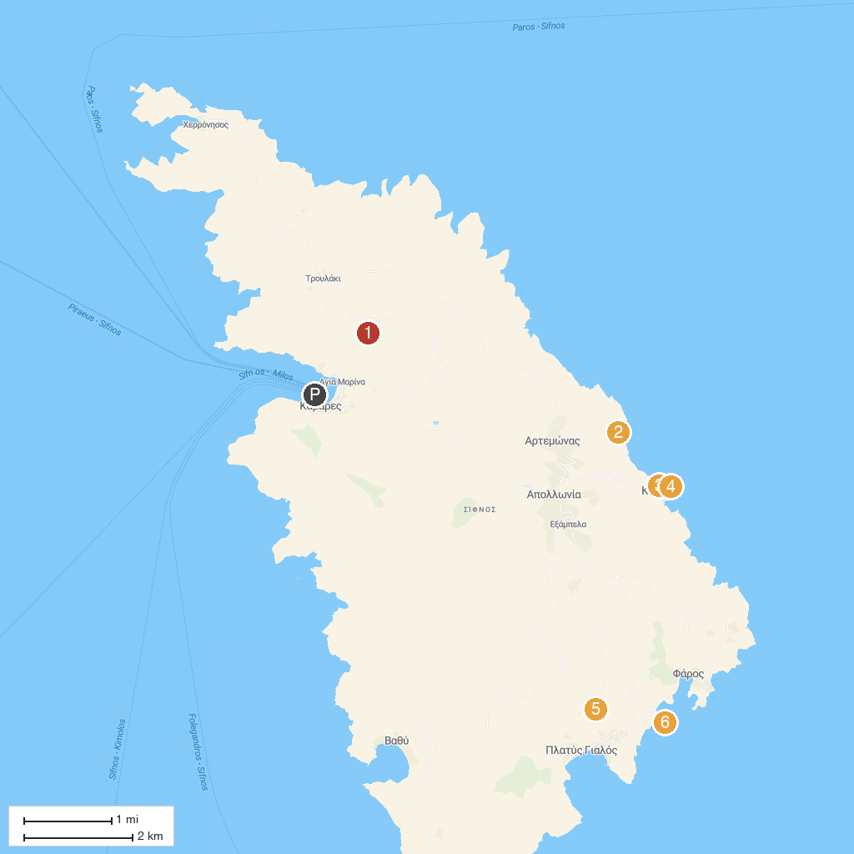
MAP KEY
1. Agios Symeon | 4. Church of the Seven Martyrs
2. Panagia Poulati | 5. Panagia tou Vounou
3. Castle of Sifnos | 6. Chrisopigi Monastery
P. Cruise port / terminal
Map © MapTiler © OpenStreetMap contributors · cruiseports.org

