Siem Reap, Siem Reap Province, Cambodia
Home to Angkor Wat — the largest religious monument on earth — Siem Reap rewards river cruise passengers with ancient jungle temples, floating villages, and some of Southeast Asia's most memorable street food.
⚓ River cruise (Tonle Sap Lake) · 🕒 Typical call: full day or 2-night land stay · 💵 USD + Cambodian Riel · 🗣️ Khmer / English widely spoken · 🏛️ UNESCO World Heritage
✍️ MY DAY IN PORT (FILL IN)
Ship / Date
In port | arrive ______ · all aboard ______
Booked excursion
Notes / meeting point
GETTING ASHORE
- Docking: Tender to Chong Kneas pier (high water) or overland bus from Kampong Cham (low water, 4–5 hrs)
- Pier to Center: ~30–45 min by tuk-tuk or coach from Chong Kneas; not walkable
- Best For: Ancient temples, Khmer history, floating villages, cultural immersion
- Don't Miss: Sunrise at Angkor Wat and the giant stone faces of Bayon Temple
GETTING AROUND
- 🚕 Taxi: $10–15 USD — Air-conditioned taxis or private cars available from the Tonle Sap dock to city center. Book via Grab app for upfront pr
- 📱 Rideshare: ✅ Grab, PassApp
- 🚌 Hop-on hop-off: ✅ Big Bus Angkor
TOP THINGS TO DO
- Angkor Wat Sunrise Tour — Watch the sun rise over the world's largest religious monument, its five lotus towers reflected in the long pools — then explore…
- Angkor Thom & Bayon Temple — Enter the ancient walled city of Angkor Thom through a giant causeway flanked by stone giants.
- Ta Prohm (Jungle Temple) — Famously left half-consumed by giant silk-cotton and strangler fig trees, Ta Prohm feels like a genuine discovery.
- Floating Village on Tonle Sap — Tour the extraordinary floating villages of Kampong Phluk or Chong Kneas by small boat — entire communities of houses, schools…
- Phare, The Cambodian Circus — An electrifying evening show by a non-profit that trains underprivileged youth in circus arts, theater, and music.
BEST WALKS
- Old Market & Pub Street Stroll: 1–2 hrs · Flat · Free — From the riverside area, walk through the Old Market (Psar Chaa) — stalls packed with silk scarves…
- Wat Preah Prom Rath & Riverside: 45 min · Easy · Free — A short walk from the town center leads to Wat Preah Prom Rath, a beautiful active Buddhist temple…
WEATHER · DAYLIGHT · MONEY
Month | High °F | Low °F | Rainy days
May | 92 | 79 | 22
Jul | 89 | 78 | 25
Sep | 87 | 76 | 27
Daylight: May 5:38AM–6:23PM · Jul 5:45AM–6:35PM · Sep 5:53AM–6:05PM
cruiseports.org/siem-reap · Confirm terminal & all-aboard time with your ship

Siem Reap, Siem Reap Province, Cambodia — Port Map
Red = walkable sights · Amber = excursions farther out · P = cruise terminal
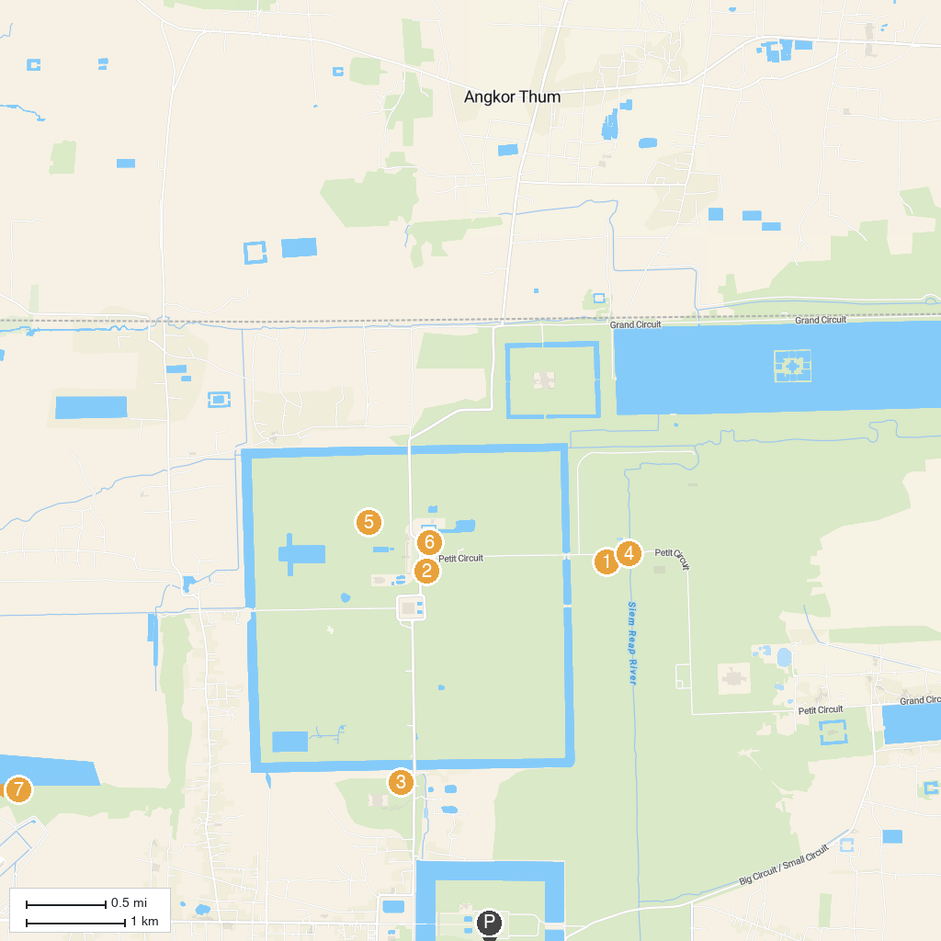
MAP KEY
1. Prasat Chau Say Tevoda | 5. Palilay Temple
2. Suor Proat Temple | 6. Prasat Khleang Khang Cheung (Prasat North Khleang)
3. Baksei Chamkrong Temple | 7. Bakong Temples
4. Spean Thmor | 8. Ak Yum Temple
P. Cruise port / terminal
Map © MapTiler © OpenStreetMap contributors · cruiseports.org

