Šibenik, Dalmatia, Croatia
Croatia's oldest native Adriatic city, Šibenik packs two UNESCO World Heritage Sites, three hilltop fortresses, and a labyrinth of polished stone alleys into one compact, walkable old town — with Krka's famous waterfalls just 20 minutes away.
⚓ Pier (most ships) or tender (large vessels) · 🕒 Typical call: 8–10 hrs · 💶 Currency: Euro (€) · 🗣️ Language: Croatian · 🏛️ 2 UNESCO World Heritage Sites
✍️ MY DAY IN PORT (FILL IN)
Ship / Date
In port | arrive ______ · all aboard ______
Booked excursion
Notes / meeting point
GETTING ASHORE
- Docking: Gat Vrulje pier for most ships; tender for very large vessels
- Walk to center: ~10–15 min flat waterfront walk (800 m) to the cathedral
- Best For: Medieval history, fortress views, Krka day-trip, Dalmatian food
- Don't Miss: Cathedral of St. James — 71 carved stone faces on the outer frieze
GETTING AROUND
- 🚕 Taxi: €3–8 — Taxis are available at the port. The base fare is about €2 with ~€0.67/km — city center rides are very short and inexpen
- 📱 Rideshare: ✅ Uber, Bolt
TOP THINGS TO DO
- Krka National Park Waterfalls — The cascading travertine falls at Skradinski Buk are arguably Croatia's most spectacular.
- Cathedral of St. James & Old Town — The 15th-century Renaissance cathedral built entirely of stone — no mortar — features 71 carved portrait heads ringing the…
- St. Nicholas Fortress Boat Tour — The second UNESCO site — a striking triangular Venetian sea fortress at the mouth of St.
- Šibenik's Three Hilltop Fortresses — St.
- Banj Beach Swim — A pebble beach 20–25 minutes' walk north along the promenade, with crystal-clear water and a postcard view back to the Old Town…
BEST WALKS
- Waterfront to Cathedral Walk: ~1 km · 15 min · Flat · Free — Leave the pier heading north along the promenade, pass the ferry terminal, and arrive at the…
- Fortress Loop: ~2 km · 45–60 min · Hilly · Paid — From the Cathedral, climb the steep lanes to St.
- Promenade to Banj Beach: ~1.5 km · 20–25 min · Flat · Free — Head north from the pier along the flat waterfront all the way to Banj Beach.
WEATHER · DAYLIGHT · MONEY
Month | High °F | Low °F | Rainy days
May | 72 | 57 | 11
Jul | 87 | 70 | 4
Sep | 78 | 63 | 8
Daylight: May 5:31AM–8:14PM · Jul 5:28AM–8:35PM · Sep 6:36AM–7:06PM
cruiseports.org/sibenik · Confirm terminal & all-aboard time with your ship

Šibenik, Dalmatia, Croatia — Port Map
Red = walkable sights · Amber = excursions farther out · P = cruise terminal
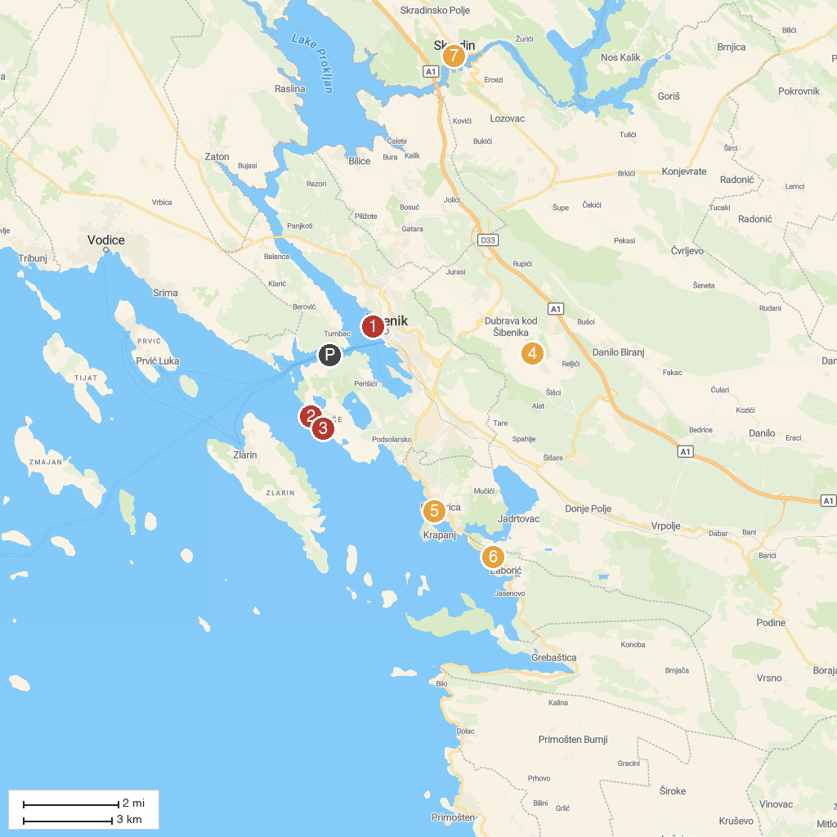
MAP KEY
1. Šibenik City Museum | 5. Пляж "Бродарица"
2. Beach Zablaće | 6. Plaża Žaborić
3. Beach Solina | 7. Skradinski Buk waterfall
4. Falconry center
P. Cruise port / terminal
Map © MapTiler © OpenStreetMap contributors · cruiseports.org

