Shimonoseki, Yamaguchi, Japan
Where Honshu meets Kyushu across rushing tidal straits, Shimonoseki rewards curious cruisers with a legendary fish market, a pedestrian tunnel under the ocean floor, and the best pufferfish in Japan.
⚓ Pier (docked) · 🕒 Typical call: 8-10 hrs · 💴 Japanese Yen (JPY) · 🗣️ Japanese
✍️ MY DAY IN PORT (FILL IN)
Ship / Date
In port | arrive ______ · all aboard ______
Booked excursion
Notes / meeting point
GETTING ASHORE
- Docking: Pier — ships dock at Shimonoseki Port International Terminal or Arcaport Berth; no tender required
- Walk to center: 15–20 min flat walk along the Kaikyo Yume seaside boardwalk to Karato Market
- Best For: Seafood lovers, history buffs, anyone wanting to visit two Japanese islands in one day
- Don't Miss: Fresh fugu sashimi at Karato Market (weekends best) and the pedestrian tunnel to Kyushu
GETTING AROUND
- 🚕 Taxi: ¥1,400–¥1,800 (~$10–12 USD) — Taxis available at the pier. The port is less than 2 miles from city center — typically a 5-minute ride to Karato Market
- 📱 Rideshare: ✅ Uber (taxi dispatch), DiDi
TOP THINGS TO DO
- Karato Market & Fugu Feast — Shimonoseki's crown jewel.
- Kanmon Pedestrian Tunnel — Walk 780 metres under the ocean floor between Honshu and Kyushu.
- Mojiko Retro Day Trip (Kyushu) — Catch the 5-minute Kanmon Kisen Ferry (¥400 each way) to Mojiko, a charming Meiji-era port district in Kitakyushu with…
- Akama Shrine & Mimosusagawa Park — The brilliant red-and-white Akama Shrine honours child Emperor Antoku, who drowned in the 1185 Battle of Dan-no-ura fought just…
- Tsunoshima Bridge & Beach — One of Japan's most photographed spots — a 1.7 km bridge arching over crystal-clear emerald water to a white-sand beach and…
BEST WALKS
- Waterfront to Karato Market: 2.5 km · ~25 min · Flat & easy — Follow the Kaikyo Yume Road seaside boardwalk from the terminal past Kaikyo Yume Tower to Karato…
- Akama Shrine & Battle Site Loop: 1.5 km from Karato · ~20 min · Flat — From Karato Market, stroll along the waterfront to Akama Shrine and Mimosusagawa Park at the…
WEATHER · DAYLIGHT · MONEY
Month | High °F | Low °F | Rainy days
May | 71 | 59 | 10
Jul | 83 | 75 | 18
Sep | 79 | 71 | 13
Daylight: May 5:15AM–7:10PM · Jul 5:16AM–7:27PM · Sep 5:59AM–6:22PM
cruiseports.org/shimonoseki · Confirm terminal & all-aboard time with your ship

Shimonoseki, Yamaguchi, Japan — Port Map
Red = walkable sights · Amber = excursions farther out · P = cruise terminal
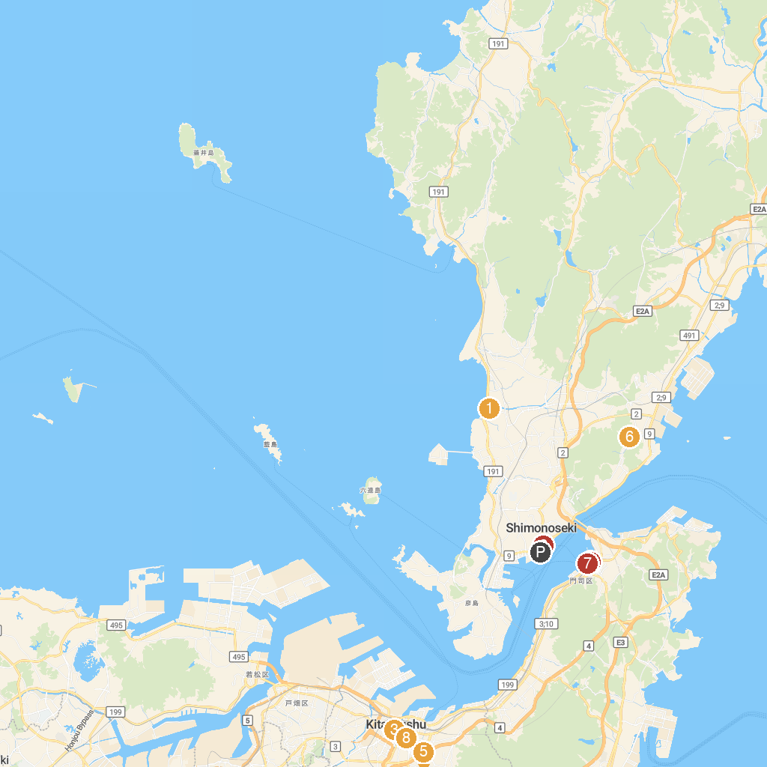
MAP KEY
1. Nakayama Shrine | 5. Kitakyushu Media Dome
2. Kaikyokan | 6. Kozan-ji
3. Kokura Castle | 7. Blue Wing Moji
4. Mojiko Retro Observation Gallery | 8. Tanga Market
P. Cruise port / terminal
Map © MapTiler © OpenStreetMap contributors · cruiseports.org

