Shenzhen, Guangdong, China
China's Silicon Valley rose from fishing villages to a 17-million-person megacity in four decades. Shenzhen dazzles with futuristic towers, massive theme parks, the world's largest electronics market, and a metro so clean you could eat off the floor.
⚓ Pier (Shekou Cruise Homeport) · 🕒 Typical call: 8-10 hrs · 💴 Currency: Chinese Yuan (CNY) · 🗣️ Language: Mandarin / Cantonese · 📵 VPN/eSIM needed for Google, social media
✍️ MY DAY IN PORT (FILL IN)
Ship / Date
In port | arrive ______ · all aboard ______
Booked excursion
Notes / meeting point
GETTING ASHORE
- Docking: Pier — Shekou Cruise Homeport (Prince Bay), no tendering
- Walk to center: 5 min to Sea World; downtown Futian ~40 min by metro
- Best For: Theme parks, tech sightseeing, skyline views, electronics shopping
- Don't Miss: Sea World Minghua ship & fountain show; Window of the World
GETTING AROUND
- 🚕 Taxi: ¥80–100 (~–14) — Metered taxis from Shekou Cruise Homeport reach city center in 20–25 minutes. Night fares (23:00–06:00) are 20% higher.
- 📱 Rideshare: ✅ DiDi
- 🚌 Hop-on hop-off: ✅
TOP THINGS TO DO
- Window of the World — Over 130 scaled-down global landmarks — Eiffel Tower, Pyramids, Taj Mahal — spread across a sprawling theme park.
- Splendid China Folk Village — Adjacent to Window of the World, this park showcases miniature replicas of China's greatest historical sites alongside live…
- Ping An Finance Centre Observation — Ride the world's fastest elevators to the 116th floor of the 5th-tallest building on Earth.
- Dafen Oil Painting Village — A suburban village where thousands of artists copy Western masterworks and create original canvases.
- Huaqiangbei Electronics Market — The world's largest electronics bazaar — multi-story towers packed with components, gadgets, drones, custom LEDs, and every tech…
BEST WALKS
- Shekou Waterfront & Sea World Stroll: 1.5 km · 20 min · Easy — From the cruise terminal, walk along the Shekou waterfront promenade to Sea World plaza.
- OCT-LOFT Creative District: 45 min by metro · Leisurely walk · Easy — Take Line 2 to Qiaocheng North Station and wander the converted factory complex of OCT-LOFT — indie…
WEATHER · DAYLIGHT · MONEY
Month | High °F | Low °F | Rainy days
May | 84 | 74 | 21
Jul | 88 | 79 | 23
Sep | 87 | 77 | 19
Daylight: May 5:43AM–6:56PM · Jul 5:48AM–7:11PM · Sep 6:10AM–6:27PM
cruiseports.org/shenzhen · Confirm terminal & all-aboard time with your ship

Shenzhen, Guangdong, China — Port Map
Red = walkable sights · Amber = excursions farther out · P = cruise terminal
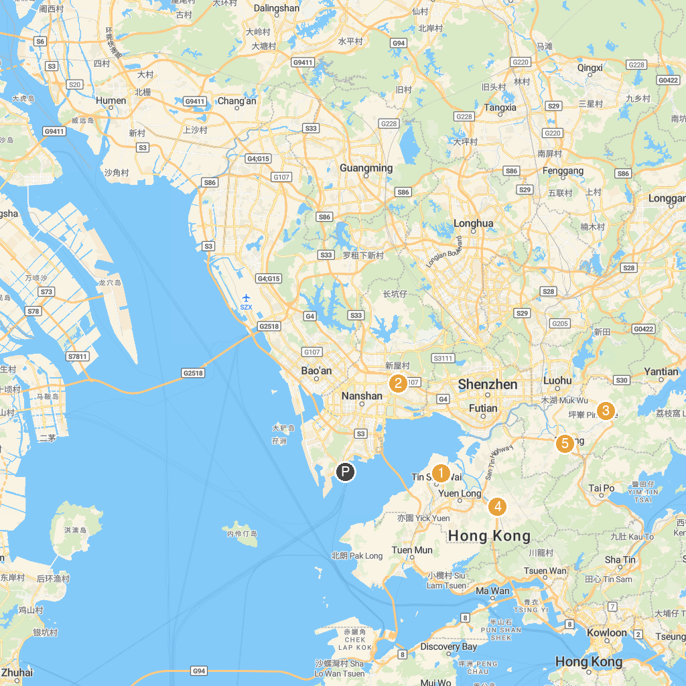
MAP KEY
1. Hong Kong Wetland Park | 5. Longhua Park
2. Dashahe Park | 6. Lixiang Park
3. Cheung Shan Monastery, Robin's Nest | 7. Lam Tsuen Wishing Tree
4. Red Brick House Market | 8. North District Park
P. Cruise port / terminal
Map © MapTiler © OpenStreetMap contributors · cruiseports.org

