Shelburne, Nova Scotia, Canada
One of the best-preserved Loyalist towns in North America, Shelburne's cobbled Dock Street and working dory shop feel frozen in 1783 — yet the lobster chowder is very much of the present.
⚓ Tender (most ships) or docked (small ships) · 🕒 Typical call: 6-8 hrs · 💵 Canadian Dollar (CAD); USD and cards accepted · 🗣️ English · 📜 Loyalist & Black history
✍️ MY DAY IN PORT (FILL IN)
Ship / Date
In port | arrive ______ · all aboard ______
Booked excursion
Notes / meeting point
GETTING ASHORE
- Docking: Most ships tender to Dock Street Wharf; smaller vessels may dock at the Marine Terminal (T-Wharf, 169 m, 9.2 m depth)
- Walk to centre: 0–5 min — you land directly on Historic Dock Street
- Best For: History buffs, heritage walks, fresh seafood, Black Loyalist heritage
- Don't Miss: Dory Shop Museum and the Black Loyalist Heritage Centre in Birchtown
GETTING AROUND
- 🚕 Taxi: Quoted at booking — Sou'West Nova Transit Association operates demand-responsive transport in Shelburne County. Fares are quoted when you bo
TOP THINGS TO DO
- Black Loyalist Heritage Centre, Birchtown — In 1783 Birchtown became the largest free Black settlement outside Africa.
- Dory Shop Museum — Watch master boatbuilders handcraft traditional Shelburne dories using 19th-century tools — you can even hammer a copper nail…
- Historic Dock Street Walking Tour — Stroll past 33 original United Empire Loyalist homes from 1783, visit the Shelburne County Museum (oldest fire engine in Canada!)…
- Sandy Point Lighthouse & Beach — A scenic sandbar lighthouse at the mouth of Shelburne Harbour.
- Sandhills & Roseway Beach — Sweeping white-sand Atlantic beaches south of town.
BEST WALKS
- Historic Dock Street Waterfront Walk: 1 km · 20–30 min · Flat — From the tender wharf, walk north along Dock Street past the Dory Shop Museum, Shelburne County…
- Downtown King Street Stroll: 0.5 km · 10–15 min · Flat — Head up from the waterfront to King Street for cafés, independent shops, and the Osprey Arts Centre.
WEATHER · DAYLIGHT · MONEY
Month | High °F | Low °F | Rainy days
May | 60 | 44 | 10
Jul | 75 | 61 | 11
Sep | 70 | 56 | 8
Daylight: May 5:55AM–8:40PM · Jul 5:53AM–9:00PM · Sep 7:01AM–7:30PM
cruiseports.org/shelburne-ns · Confirm terminal & all-aboard time with your ship

Shelburne, Nova Scotia, Canada — Port Map
Red = walkable sights · Amber = excursions farther out · P = cruise terminal
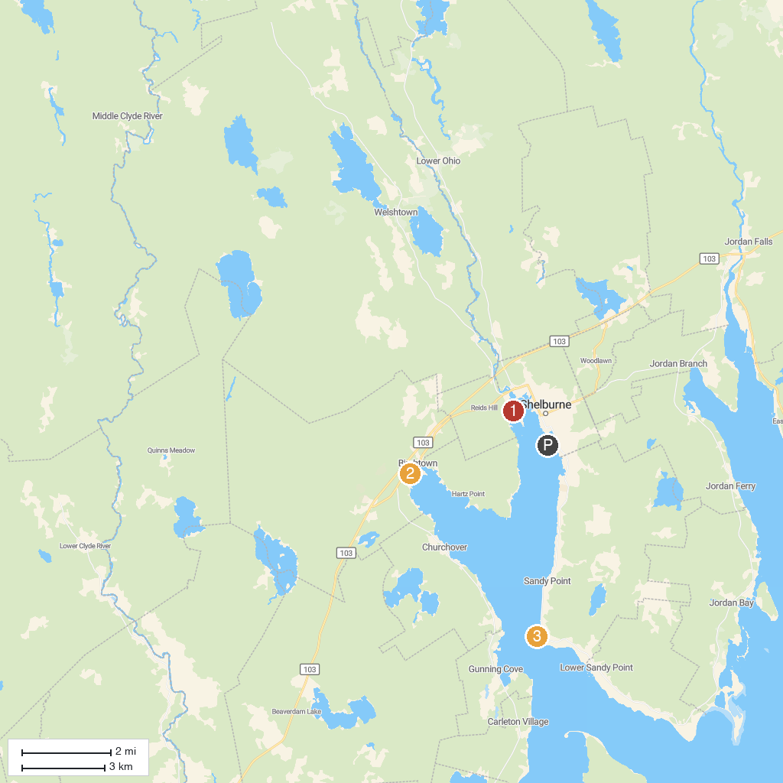
MAP KEY
1. The Islands Provincial Park | 3. Sandy Point Lighthouse
2. Black Loyalist Heritage Society
P. Cruise port / terminal
Map © MapTiler © OpenStreetMap contributors · cruiseports.org

