Sfantu Gheorghe, Danube Delta, Romania
Where the great Danube finally surrenders to the Black Sea, a roadless Lipovan village of 800 souls sits surrounded by one of Europe's wildest wetlands — pelicans, wild horses, and silence.
⚓ River pier (small ships dock direct) · 🕒 Typical call: 6–8 hrs · 💵 Romanian Leu (RON) — cash essential · 🗣️ Romanian / Ukrainian dialect · 🦅 UNESCO Biosphere Reserve
✍️ MY DAY IN PORT (FILL IN)
Ship / Date
In port | arrive ______ · all aboard ______
Booked excursion
Notes / meeting point
GETTING ASHORE
- Docking: River cruise ships dock at the village pontoon pier; expedition/ocean vessels anchor offshore and tender in
- Walk to beach: ~2 km (30–40 min on deep sand) or take the local tractor-trailer (Trokarici)
- Best For: Delta wildlife boat tours, wild beach, birdwatching, Lipovan village culture
- Don't Miss: Storciag sturgeon soup at a local guesthouse and a guided canoe into the reed canals
GETTING AROUND
TOP THINGS TO DO
- Danube Delta Boat Tour — The essential Sfantu Gheorghe experience.
- Wild Beach & Wild Horses — Sfantu Gheorghe Beach is one of Europe's last truly wild shores — no sunbeds, no umbrellas, just vast fine sand backed by dunes…
- Kayak or Canoe Through the Canals — Paddle silently through the delta's smaller channels — the quieter approach lets you get much closer to nesting birds and…
- Lipovan Village Walk & Traditional Lunch — Explore the sandy lanes lined with pastel-painted Lipovan (Ukrainian Cossack) houses with thatched reed roofs.
- Sacalin Peninsula Birdwatching — The Sacalin Peninsula is a 19-km spit of Romania's youngest land, strictly protected, hosting over 200 nesting species.
BEST WALKS
- Village Waterfront & Orthodox Church: ~1 km · 20 min · flat (deep sand) — From the pier, follow the waterfront path past the wooden boat landings, then wind into the sandy…
- Pier to Wild Beach: ~2 km one-way · 30–40 min · sandy track — Head east from the village pier along the main dirt-and-sand track that cuts through the dunes.
WEATHER · DAYLIGHT · MONEY
Month | High °F | Low °F | Rainy days
May | 68 | 56 | 8
Jul | 81 | 69 | 6
Sep | 74 | 63 | 4
Daylight: May 5:33AM–8:23PM · Jul 5:29AM–8:44PM · Sep 6:40AM–7:12PM
cruiseports.org/sfantu-gheorghe · Confirm terminal & all-aboard time with your ship

Sfantu Gheorghe, Danube Delta, Romania — Port Map
Red = walkable sights · Amber = excursions farther out · P = cruise terminal
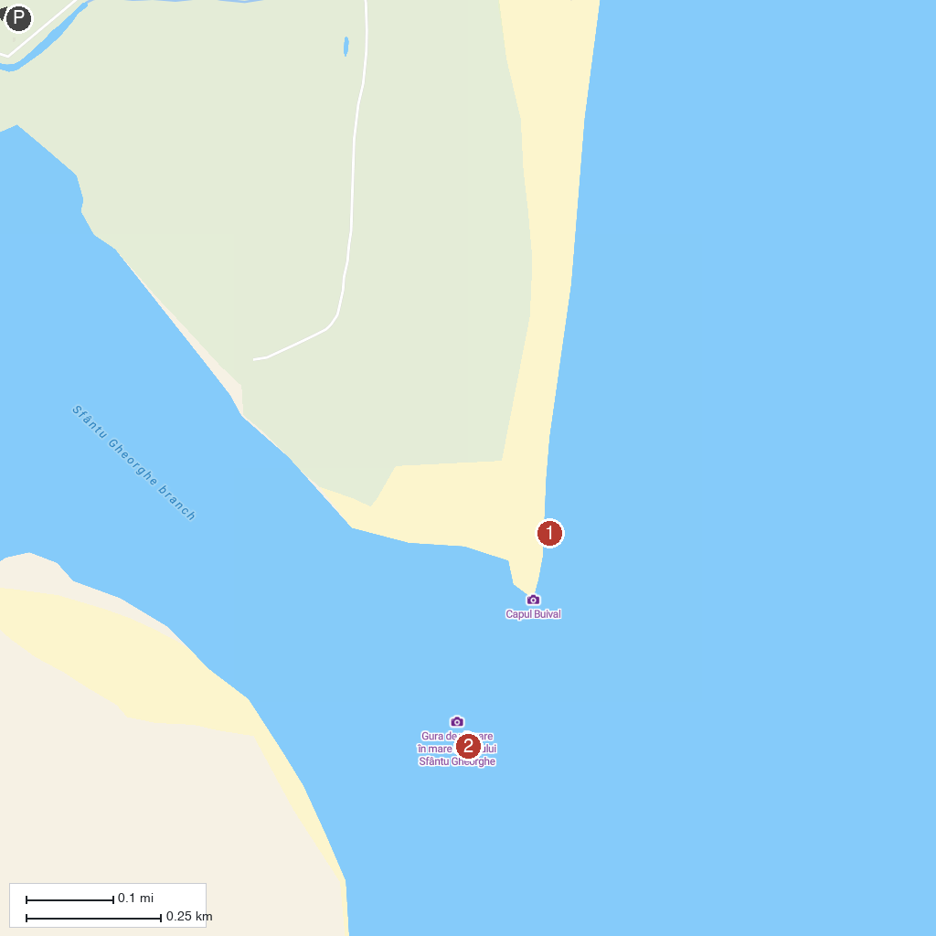
MAP KEY
1. Cape Buival | 2. Gura de vărsare în mare a Brațului Sfântu Gheorghe
P. Cruise port / terminal
Map © MapTiler © OpenStreetMap contributors · cruiseports.org

