Seward, Alaska, USA
Gateway to Kenai Fjords National Park, Seward sits at the head of Resurrection Bay ringed by glacier-carved mountains — most passengers start or end their Alaska cruise right here.
⚓ Pier (docked) · 🕒 Typical call: embark/disembark port · 💵 USD · 🗣️ English · 🦅 Wildlife capital
✍️ MY DAY IN PORT (FILL IN)
Ship / Date
In port | arrive ______ · all aboard ______
Booked excursion
Notes / meeting point
GETTING ASHORE
- Docking: Pier — Alaska Railroad Intermodal Dock (new floating terminal 2026)
- Walk to center: ~1.5 mi to downtown; free shuttle runs cruise days
- Best For: Kenai Fjords day cruises, sea kayaking, Alaska SeaLife Center
- Don't Miss: Sea otters floating in the Small Boat Harbor
GETTING AROUND
- 🚕 Taxi: $10–$15 — Local taxis (Golden Cab Alaska, Alaska Yellow Dispatch) operate in Seward. The cruise terminal is ~2 miles from downtown
TOP THINGS TO DO
- Kenai Fjords National Park Day Cruise — Catamaran tours into the fjords deliver near-guaranteed humpback whale, orca, sea otter, sea lion, and puffin sightings alongside…
- Exit Glacier Hike (Kenai Fjords NP) — The only road-accessible part of the national park.
- Alaska SeaLife Center — World-class marine research and rehabilitation center on the downtown waterfront.
- Sea Kayaking in Resurrection Bay — Paddle the protected waters of Resurrection Bay with dramatic mountain backdrops, bald eagles overhead, and sea otters nearby.
- Iditarod Husky Kennel Tour — Visit the Seavey family kennel — multi-time Iditarod champions — for a tour, puppy playtime, and a wheeled dog-sled ride through…
BEST WALKS
- Waterfront Path: Cruise Dock to Downtown: 1.5 mi one-way · 30-35 min · Flat & paved — Follow the bay south along the multi-use waterfront path from the cruise terminal to the Alaska…
- Small Boat Harbor Loop: 0.75 mi loop · 20 min · Flat — Wander the docks of the Small Boat Harbor to watch commercial fishermen offload halibut and salmon…
WEATHER · DAYLIGHT · MONEY
Month | High °F | Low °F | Rainy days
May | 48 | 38 | 18
Jul | 62 | 53 | 17
Sep | 54 | 45 | 19
Daylight: May 5:18AM–10:31PM · Jul 5:02AM–11:04PM · Sep 7:27AM–8:16PM
cruiseports.org/seward · Confirm terminal & all-aboard time with your ship

Seward, Alaska, USA — Port Map
Red = walkable sights · Amber = excursions farther out · P = cruise terminal
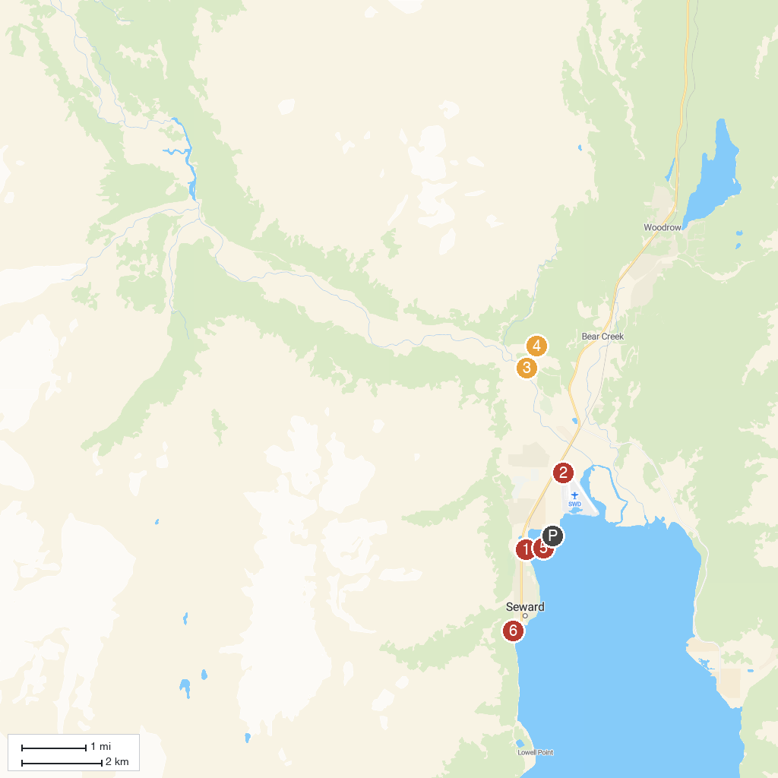
MAP KEY
1. Kenai Fjords National Park Visitor Center | 5. IdidaRide Sled Dog Tours
2. AA Seward Air Tours | 6. Seward Boat Harbor
3. Turning Heads Kennel | 7. Lowell Creek Waterfall
4. Kenai Fjords National Park Exit Glacier Nature Center
P. Cruise port / terminal
Map © MapTiler © OpenStreetMap contributors · cruiseports.org

