Seville, Andalusia, Spain
Spain's most theatrical city — a riverside Andalusian capital of Moorish palaces, a soaring Gothic cathedral, orange-blossom squares, and flamenco echoing through whitewashed lanes.
⚓ Docked (Guadalquivir riverbank) · 🕒 Typical call: 8–10 hrs · 💶 Euro (EUR) · 🗣️ Spanish · limited English
✍️ MY DAY IN PORT (FILL IN)
Ship / Date
In port | arrive ______ · all aboard ______
Booked excursion
Notes / meeting point
GETTING ASHORE
- Docking: Muelle de las Delicias (riverfront)
- Walk to center: 10–15 min
- Best For: History · Architecture · Culture
- Don't Miss: Alcázar & Giralda tower
GETTING AROUND
- 🚕 Taxi: €7–€12 — Metered taxis are available at the port and reach the city center in 8–15 minutes. A port supplement of ~€2.45 is added
- 📱 Rideshare: ✅ Uber, Bolt, Cabify
- 🚌 Hop-on hop-off: ✅
TOP THINGS TO DO
- Real Alcázar & Cathedral — Two of Spain's most stunning monuments side by side.
- Barrio Santa Cruz Walking Tour — The old Jewish quarter behind the Alcázar is a labyrinth of white-walled lanes, hidden plazas, orange trees, and tapas bars.
- Flamenco Show — Seville is the birthplace of flamenco.
- Plaza de España & María Luisa Park — The grand semicircular Plaza de España — built for the 1929 Ibero-American Exposition — is one of Europe's most theatrical…
- Triana Market & Tapas Crawl — Cross the Triana Bridge to the working-class Triana neighbourhood for the covered market (Mercado de Triana) and the city's best…
BEST WALKS
- Riverfront to the Cathedral: 1 km · Easy · 20 min — From the Muelle de las Delicias terminal, walk north along Paseo de Cristóbal Colón past the Torre…
- Barrio Santa Cruz Loop: 2 km · Easy · 45 min — From the Alcázar's Santa Cruz gate, weave through the old Jewish quarter to Plaza de Santa Cruz…
WEATHER · DAYLIGHT · MONEY
Month | High °F | Low °F | Rainy days
May | 83 | 60 | 4
Jul | 98 | 71 | 0
Sep | 88 | 67 | 4
Daylight: May 7:15AM–9:25PM · Jul 7:15AM–9:44PM · Sep 8:06AM–8:31PM
cruiseports.org/seville · Confirm terminal & all-aboard time with your ship

Seville, Andalusia, Spain — Port Map
Red = walkable sights · Amber = excursions farther out · P = cruise terminal
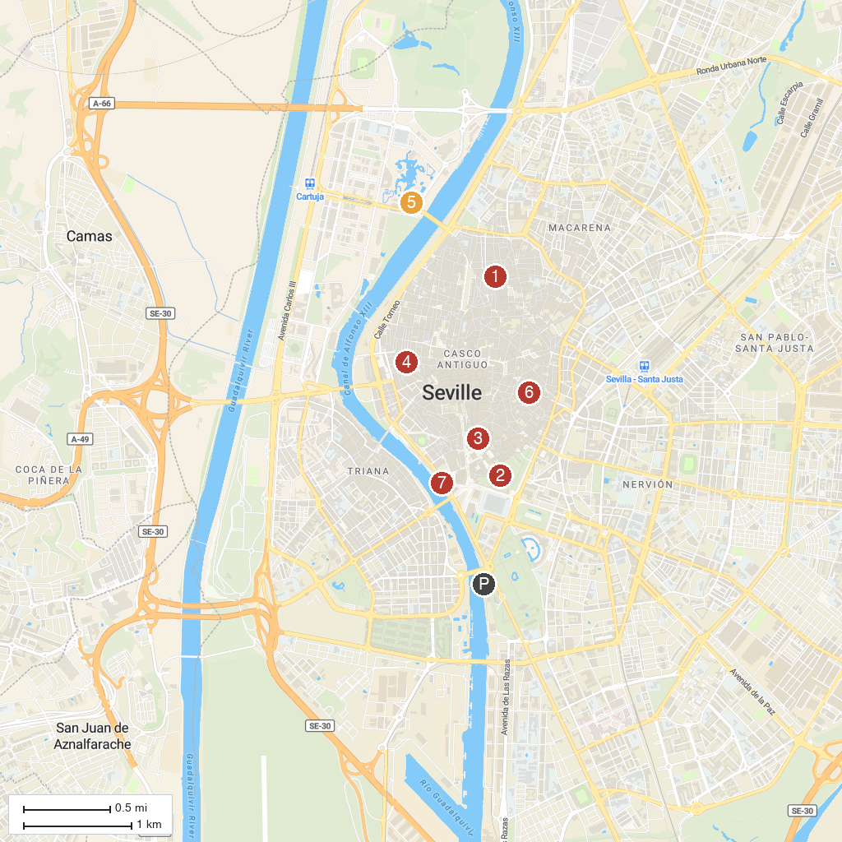
MAP KEY
1. Palacio Marqueses de la Algaba | 5. Isla Mágica
2. Royal Alcázar of Seville | 6. Casa de Pilatos
3. La Giralda | 7. Torre del Oro
4. Seville Museum of Fine Arts
P. Cruise port / terminal
Map © MapTiler © OpenStreetMap contributors · cruiseports.org

