Sète, Occitanie, France
Forget the Riviera glitz — Sète is a real, working port city where fishermen mend nets on the Canal Royal and the tielle (spicy octopus pie) is sold warm from the bakery. The 'Venice of Languedoc' punches well above its tourist profile.
⚓ Pier (most ships dock; very large ships may tender) · 🕒 Typical call: 8–10 hrs · 💶 Currency: Euro · 🗣️ Language: French · 🚂 Train to Montpellier: 20 min
✍️ MY DAY IN PORT (FILL IN)
Ship / Date
In port | arrive ______ · all aboard ______
Booked excursion
Notes / meeting point
GETTING ASHORE
- Docking: Pier — Quai d'Alger or Quai du Maroc for most ships; Epi Dellon dolphin berth (tender shuttle) for mega-ships
- Walk to center: 5–10 min from Quai d'Alger to Canal Royal
- Best For: Authentic French markets, seafood, canal walks, day trip to Montpellier or Carcassonne
- Don't Miss: La Tielle Sétoise (octopus pie) at Les Halles, panoramic views from Mont Saint-Clair
GETTING AROUND
- 🚕 Taxi: €5–€10 — Taxis are available at the port. The city center is only ~2 km away; expect a short, inexpensive ride.
- 📱 Rideshare: ✅ Uber
TOP THINGS TO DO
- Montpellier by Train — DIY Half-Day — Catch a direct train from Gare de Sète (20 min, ~€6 return) to Montpellier's vibrant medieval old town.
- Carcassonne — Medieval Fortress City — The double-walled UNESCO fortress of Carcassonne is ~90 min by car or train.
- Canal Royal & Old Town Walking Tour — The heart of Sète on foot: the Canal Royal, La Pointe Courte fishing district, the Cimetière Marin with its sea views (resting…
- Market & Culinary Tour — Tielle, Oysters & Picpoul — Visit Les Halles de Sète (open to 1:30 PM) for warm tielle sétoise, fresh Bouzigues oysters from the Étang de Thau lagoon, and a…
- Mont Saint-Clair Panorama — At 183m, the top of Mont Saint-Clair delivers 360° views over the canals, the Mediterranean, the Étang de Thau lagoon, and on a…
BEST WALKS
- Canal Royal Loop: 1.5 km · 25 min · Easy · Free — From the cruise dock, walk along the quay to the Canal Royal.
- La Pointe Courte & Cimetière Marin: 3 km · 45 min · Easy–Moderate · Free — Head northeast from the canal to the La Pointe Courte fishing quarter — a labyrinth of tiny lanes…
WEATHER · DAYLIGHT · MONEY
Month | High °F | Low °F | Rainy days
May | 71 | 56 | 8
Jul | 85 | 68 | 3
Sep | 77 | 62 | 6
Daylight: May 6:21AM–9:02PM · Jul 6:18AM–9:23PM · Sep 7:25AM–7:54PM
cruiseports.org/sete · Confirm terminal & all-aboard time with your ship

Sète, Occitanie, France — Port Map
Red = walkable sights · Amber = excursions farther out · P = cruise terminal
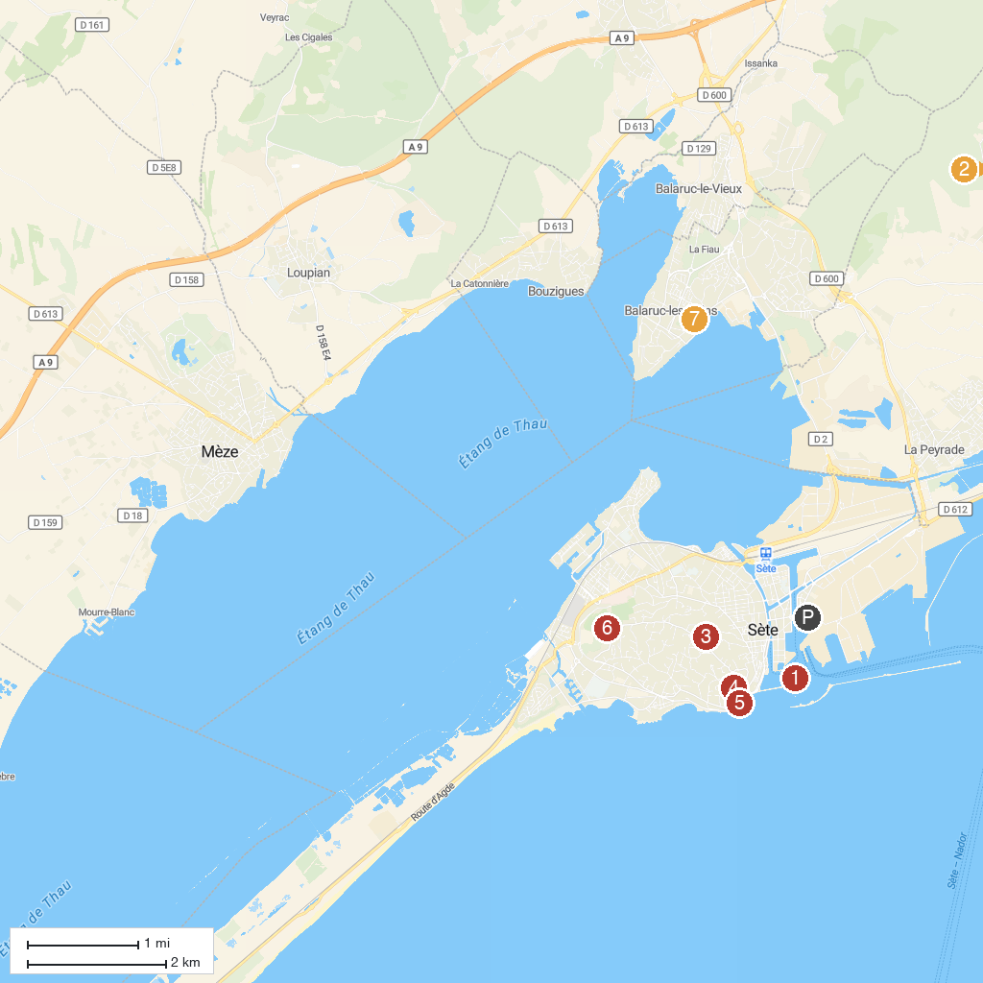
MAP KEY
1. Valmagne Sainte-Maria's Abbey | 5. Musee Paul Valery
2. Lighthouse Saint Louis | 6. Museum Of The Sea
3. Ferme DromaSud | 7. Pierres Blanches Forest
4. Panoramique du Mont Saint-Clair | 8. Jardin Antique Méditerranéen
P. Cruise port / terminal
Map © MapTiler © OpenStreetMap contributors · cruiseports.org

