Serifos Island, Cyclades, Greece
One of the Cyclades' best-kept secrets, Serifos pairs a dramatic whitewashed hilltop Chora with pristine beaches, an extraordinary mining heritage, and the mythology of Perseus and Medusa — all without the crowds of its famous neighbors.
⚓ Docking (Livadi pier) · 🕒 Typical call: 6–8 hrs · 💶 Euro (€) · 🗣️ Greek · 🏖️ Beach day possible
✍️ MY DAY IN PORT (FILL IN)
Ship / Date
In port | arrive ______ · all aboard ______
Booked excursion
Notes / meeting point
GETTING ASHORE
- Docking: Pier at Livadi port; most ships dock, some smaller vessels may tender
- Walk to center: Livadi town: immediate; Chora hilltop: 4.5 km (bus or taxi recommended)
- Best For: Authentic Cycladic culture, beaches, mythology, mining history
- Don't Miss: Chora's Venetian Kastro for panoramic Aegean views; Psili Ammos beach
GETTING AROUND
- 🚕 Taxi: €8 — Taxis wait at Livadi port and can take you to Chora (the hilltop capital) in about 10 minutes. Numbers are limited — gra
TOP THINGS TO DO
- Chora & Venetian Kastro — Ride the bus up to Hora, the island's photogenic hilltop capital.
- Psili Ammos Beach — Widely regarded as Serifos' finest beach: fine powdery white sand, shallow turquoise water, and two beachfront tavernas.
- Megalo Livadi Mining Ruins — Serifos was once a major iron-ore exporter.
- Monastery of the Taxiarches — A fortified 16th-century monastery in the north of the island, built like a small castle to resist pirate raids.
- ATV Island Exploration — Rent an ATV or scooter at the port and explore Serifos on your own terms: remote beaches like Agios Sostis, Ganema, and Kalo…
BEST WALKS
- Livadi Waterfront Stroll: Easy · 30 min · Flat — Walk the length of Livadi's harbourfront from the pier south to Livadakia beach.
- Chora Alleys & Kastro: Moderate · 1–2 hrs · Steep steps — From the bus stop at Chora's windmill square, wind upward through Kato Chora's lanes, past the…
WEATHER · DAYLIGHT · MONEY
Month | High °F | Low °F | Rainy days
May | 67 | 65 | 3
Jul | 79 | 76 | 0
Sep | 76 | 73 | 2
Daylight: May 6:13AM–8:23PM · Jul 6:14AM–8:41PM · Sep 7:04AM–7:29PM
cruiseports.org/serifos-island · Confirm terminal & all-aboard time with your ship

Serifos Island, Cyclades, Greece — Port Map
Red = walkable sights · Amber = excursions farther out · P = cruise terminal
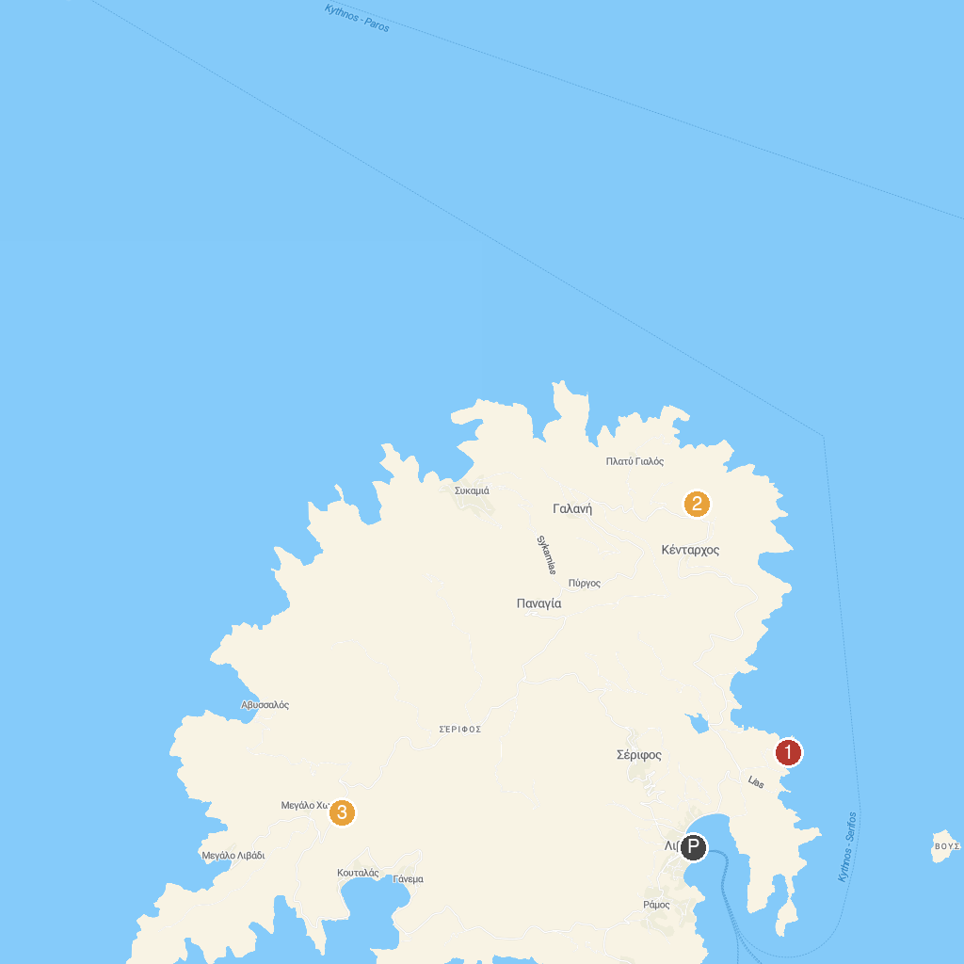
MAP KEY
1. Ag. Sostis | 3. White Tower Serifos
2. Panagia Skopiani
P. Cruise port / terminal
Map © MapTiler © OpenStreetMap contributors · cruiseports.org

