Sept-Îles, Quebec, Canada
Perched on a sweeping bay protected by seven islands, Sept-Îles blends living Innu culture, iron-ore grit, puffin sanctuaries, and some of the finest cold-water seafood in North America — a surprisingly rich stop on any St. Lawrence cruise.
⚓ Pier (dedicated cruise dock) · 🕒 Typical call: 7-9 hrs · 💵 Canadian Dollar (CAD) · 🗣️ French (some English) · 🦞 Seafood & Indigenous culture
✍️ MY DAY IN PORT (FILL IN)
Ship / Date
In port | arrive ______ · all aboard ______
Booked excursion
Notes / meeting point
GETTING ASHORE
- Docking: Pier — dedicated cruise wharf, no tender required
- Walk to center: ~1 km (10–15 min) or free port shuttle
- Best For: Wildlife, Innu culture, archipelago boat tours, seafood
- Don't Miss: Archipelago Zodiac tour to Île Corossol puffin colony
GETTING AROUND
- 🚕 Taxi: ~$15 CAD round-trip to shopping centre — Taxis are available at the pier. A round-trip to the main shopping centre runs around $15 CAD, making them a cheap optio
- 📱 Rideshare: ✅ Uber
- 🚌 Hop-on hop-off: ✅
TOP THINGS TO DO
- Archipelago Zodiac Adventure — Zodiac or small-boat tour through the seven islands.
- Shaputuan Museum & Innu Culture — The Shaputuan Museum is dedicated to the Innu (Montagnais) nation — their nomadic traditions, seasonal cycle, and contemporary…
- Grande Basque Island Nature Walk — A short boat ride brings you to Grande Basque Island for guided nature walks, a marine basin exhibit with local sea creatures…
- Vieux-Poste (Old Trading Post) — An open-air living-history site depicting a mid-19th-century fur-trading post where French traders and Innu people met.
- Seafood & Scallop Tasting at Purmer Farm — Take a boat to Grosse Boule Island to tour the Purmer mariculture farm, learning how scallops, mussels, and seaweed are…
BEST WALKS
- Waterfront Boardwalk — Pier to Vieux-Quai: 2 km | ~25 min one-way | Flat, paved — Walk the paved path from the cruise pier along the bay to the Vieux-Quai (Old Wharf) district.
- Downtown & Dining Loop: 1.5 km | ~20 min | Flat — From the Vieux-Quai, head up rue des Jésuites or avenue Brochu into the downtown core.
WEATHER · DAYLIGHT · MONEY
Month | High °F | Low °F | Rainy days
May | 50 | 37 | 12
Jul | 67 | 56 | 14
Sep | 59 | 48 | 13
Daylight: May 4:38AM–8:05PM · Jul 4:32AM–8:29PM · Sep 6:02AM–6:38PM
cruiseports.org/sept-iles · Confirm terminal & all-aboard time with your ship

Sept-Îles, Quebec, Canada — Port Map
Red = walkable sights · Amber = excursions farther out · P = cruise terminal
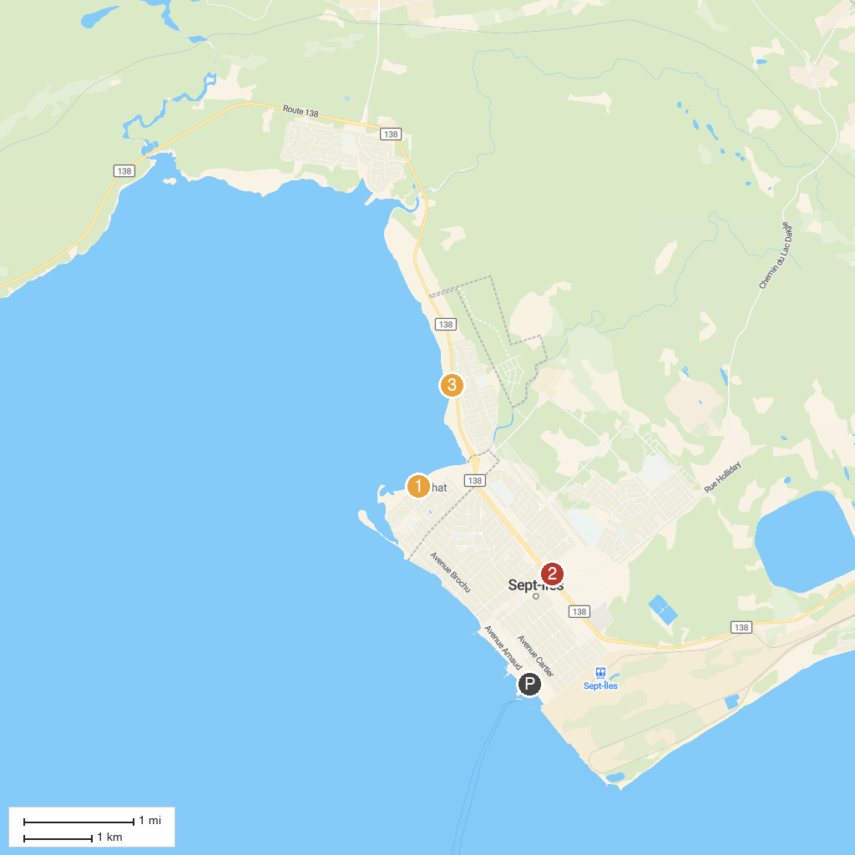
MAP KEY
1. Old Post Sept-Îles | 3. Jardins de l’Anse
2. Museum Of The North Shore Region
P. Cruise port / terminal
Map © MapTiler © OpenStreetMap contributors · cruiseports.org

