Sens, Burgundy, France
A medieval French town where Gothic architecture was born and an exiled archbishop took refuge — all within a short stroll of the river pontoon.
⚓ Docked (river pontoon) · 🕒 Typical call: 6–8 hrs · 💶 Euro (€) · 🗣️ French
✍️ MY DAY IN PORT (FILL IN)
Ship / Date
In port | arrive ______ · all aboard ______
Booked excursion
Notes / meeting point
GETTING ASHORE
- Docking: River pontoon (halte fluviale), right bank — direct walk to center
- Walk to center: 5–10 min flat (500–700 m) to St-Étienne Cathedral
- Best For: Gothic architecture, medieval history, Burgundian food & wine
- Don't Miss: St-Étienne Cathedral treasury — includes Thomas Becket's vestments
GETTING AROUND
- 🚕 Taxi: €5–€15 — Local taxi companies (Taxi Sens, Groupement Taxi Any/G7 partner) serve the area. Fares within town are low given the sho
- 📱 Rideshare: ✅ Uber
TOP THINGS TO DO
- Cathédrale Saint-Étienne & Treasury — The world's first Gothic cathedral, consecrated 1164 and the model for Notre-Dame and Canterbury.
- Musées de Sens — Gallo-Roman Vaults — Beneath the Palais Synodal lie extraordinary underground vaults with Roman mosaics, reconstructed baths, and funerary monuments.
- Covered Market & Burgundian Tasting — The 19th-century Baltard-style covered market (Mon/Fri/Sat mornings) opposite the cathedral offers local cheeses, Chablis wine…
- Parc du Moulin à Tan — A 16-hectare public park about 1.5 km from the dock with rose gardens, tropical greenhouses, and a small wildlife area.
- Medieval Half-Timbered Streets — Wander Rue de la République and surrounding lanes to find the Maison d'Abraham — an elaborately carved 16th-century timber-frame…
BEST WALKS
- Cathedral Quarter Loop: 1.2 km · 20–30 min · Flat · Self-guided — From the halte fluviale, walk north along the quay then into the pedestrian center to the…
- River & Park Stroll: 3 km · 45–60 min · Flat · Easy — Head south along the river from the pontoon to the Parc du Moulin à Tan, enjoy the rose gardens and…
WEATHER · DAYLIGHT · MONEY
Month | High °F | Low °F | Rainy days
May | 66 | 49 | 12
Jul | 78 | 61 | 8
Sep | 72 | 55 | 8
Daylight: May 6:07AM–9:19PM · Jul 6:02AM–9:42PM · Sep 7:24AM–7:58PM
cruiseports.org/sens-yonne · Confirm terminal & all-aboard time with your ship

Sens, Burgundy, France — Port Map
Red = walkable sights · Amber = excursions farther out · P = cruise terminal
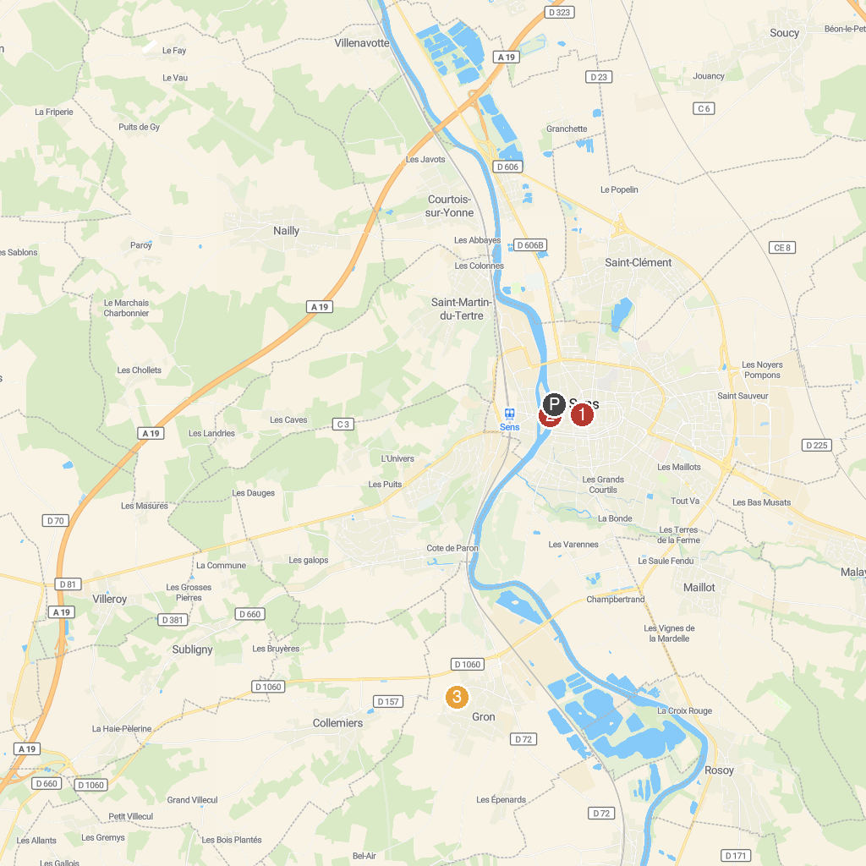
MAP KEY
1. Marché Couvert | 3. Parc de la Fosse-aux-Loups
2. Église Saint-Maurice de Sens
P. Cruise port / terminal
Map © MapTiler © OpenStreetMap contributors · cruiseports.org

