Senggigi, Lombok, Indonesia
Bali's quieter, wilder neighbor — Lombok's Senggigi blends volcanic black-and-gold beaches, Hindu cliff temples, and the gateway to the car-free Gili Islands, all against a backdrop of smoldering Mount Rinjani.
⚓ Pier (Gili Mas) or Tender (small ships) · 🕒 Typical call: 8-10 hrs · 💵 Indonesian Rupiah (IDR) · 🗣️ Bahasa Indonesia / Sasak · 🕌 Predominantly Muslim island
✍️ MY DAY IN PORT (FILL IN)
Ship / Date
In port | arrive ______ · all aboard ______
Booked excursion
Notes / meeting point
GETTING ASHORE
- Docking: Most ships dock at Gili Mas Cruise Terminal (~1 hr south); small ships may tender to Senggigi pier
- Walk to Center: At Gili Mas: must take transport; at Senggigi pier: immediate town access
- Best For: Gili Islands snorkeling with sea turtles, South Sea pearl shopping, Sasak culture
- Don't Miss: Pura Batu Bolong temple on the rock, Malimbu Cliff viewpoint over the Gilis
GETTING AROUND
- 🚕 Taxi: IDR 250,000–300,000 (~$17–18 USD) — Bluebird taxis are the most reliable option from Lembar Harbour to Senggigi (~40 km, 45–60 min). Always insist on the me
- 📱 Rideshare: ✅ Grab, Gojek
TOP THINGS TO DO
- Gili Islands Snorkeling — Speedboat to the Gili Islands (Trawangan, Meno, or Air) for snorkeling with sea turtles and the famous underwater statue garden…
- Sasak Village Cultural Tour — Visit a traditional Sasak village (Sade or Ende) to see earth-and-dung houses, hand-loom weaving demonstrations, and Lombok's…
- Pura Batu Bolong Temple Walk — A Hindu cliff temple built on a rock with a natural hole, just south of Senggigi beach.
- Mangsit Beach & Pearl Shopping — Spend the morning on quieter Mangsit Beach north of town, then visit a certified South Sea pearl shop in Senggigi — Lombok pearls…
- Malimbu Cliff & Rinjani Views — Drive 15 minutes north of Senggigi to Malimbu Cliff for sweeping panoramas over the Gili Islands and Bali.
BEST WALKS
- Senggigi Beach Strip: 1.5 km · Flat · 20 min one-way — From the Senggigi Fast Boat Pier, walk south along the beach road past the Art Market (Pasar Seni)…
- Senggigi Town to Kerandangan Beach: 1.5 km north · Flat · 20 min — Head north from the main resort strip to Kerandangan Beach — much quieter, shaded by coconut palms…
WEATHER · DAYLIGHT · MONEY
Month | High °F | Low °F | Rainy days
May | 86 | 76 | 11
Jul | 85 | 73 | 6
Sep | 86 | 74 | 10
Daylight: May 6:20AM–6:03PM · Jul 6:31AM–6:11PM · Sep 6:09AM–6:12PM
cruiseports.org/senggigi · Confirm terminal & all-aboard time with your ship

Senggigi, Lombok, Indonesia — Port Map
Red = walkable sights · Amber = excursions farther out · P = cruise terminal
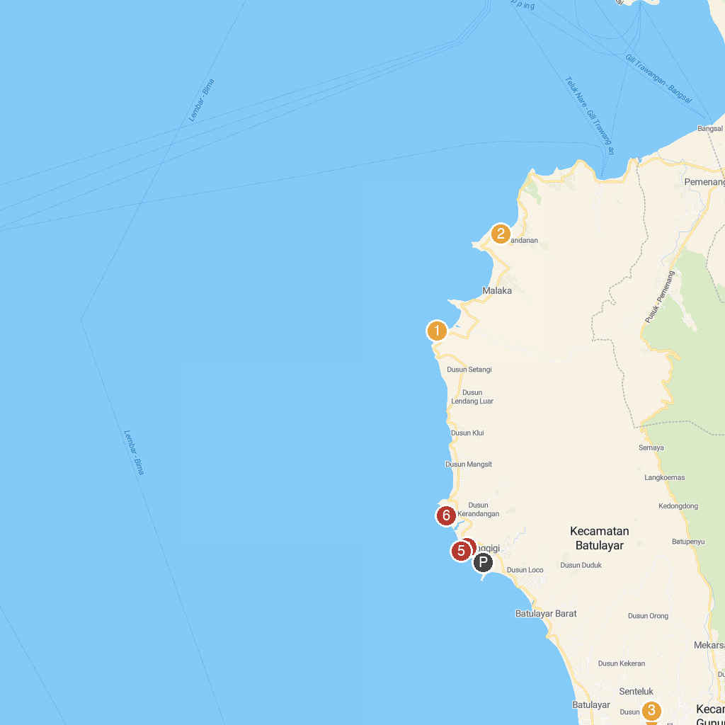
MAP KEY
1. Malimbu Hill | 5. Logo Senggigi View
2. Pantai PANDANAN MALAKA | 6. Pura Kaprusan
3. State Museum of West Nusa Tenggara | 7. Coconut Beach
4. Lombok Wildlife Park
P. Cruise port / terminal
Map © MapTiler © OpenStreetMap contributors · cruiseports.org

