Sendai, Miyagi, Japan
Gateway to the "One-Eyed Dragon" country — Sendai blends feudal samurai drama with one of Japan's most celebrated bay views and a festival culture that turns entire city blocks into forests of color.
⚓ Pier (Sendai-Shiogama Port) · 🕒 Typical call: 8-10 hrs · 💴 Japanese Yen (JPY) · 🗣️ Japanese (limited English)
✍️ MY DAY IN PORT (FILL IN)
Ship / Date
In port | arrive ______ · all aboard ______
Booked excursion
Notes / meeting point
GETTING ASHORE
- Docking: Pier at Sendai-Shiogama Port, ~16 km east of downtown
- To City Center: ~30 min by shuttle bus or taxi — not walkable
- Best For: Samurai history, Matsushima Bay, whisky, Japanese food
- Don't Miss: Zuihoden Mausoleum and Matsushima Bay cruise
GETTING AROUND
- 🚕 Taxi: ¥3,000–¥5,000 to Sendai city center — Metered taxis available at Marine Gate Shiogama pier. Journey to central Sendai is approximately 30–40 min depending on
- 📱 Rideshare: ✅ Uber
- 🚌 Hop-on hop-off: ✅ Loople Sendai
TOP THINGS TO DO
- Zuihoden Mausoleum & Aoba Castle Ruins — Visit the ornate Momoyama-style mausoleum of Date Masamune, then head uphill to Aoba Castle ruins for panoramic city views and an…
- Matsushima Bay Cruise — One of Japan's Three Scenic Views — hundreds of pine-covered islands scattered across a calm bay.
- Nikka Whisky Miyagikyo Distillery — Set in a forested river valley outside Sendai, this scenic distillery offers guided tours of the pot stills and blending halls…
- Osaki Hachimangu Shrine — A National Treasure shrine built by Date Masamune in 1607, with stunning lacquerwork and gold leaf in the classic Momoyama style.
- Tanabata Decorations & Ichibancho Arcade — Even outside the August festival, Sendai's covered shopping arcades display enormous handcrafted paper streamers year-round.
BEST WALKS
- Jozenji-dori to Zuihoden: 3 km | 45 min | Easy–Moderate — Start on Jozenji-dori Avenue — Sendai's elegant zelkova-tree-lined boulevard — then follow the…
- Aoba Castle Ruins Loop: 2 km | 30 min | Easy (with Loople bus up) — Ride the Loople bus to Aoba Castle, explore the stone walls and Date Masamune equestrian statue…
WEATHER · DAYLIGHT · MONEY
Month | High °F | Low °F | Rainy days
May | 69 | 51 | 11
Jul | 80 | 68 | 18
Sep | 76 | 63 | 15
Daylight: May 4:26AM–6:40PM · Jul 4:25AM–6:59PM · Sep 5:18AM–5:44PM
cruiseports.org/sendai · Confirm terminal & all-aboard time with your ship

Sendai, Miyagi, Japan — Port Map
Red = walkable sights · Amber = excursions farther out · P = cruise terminal
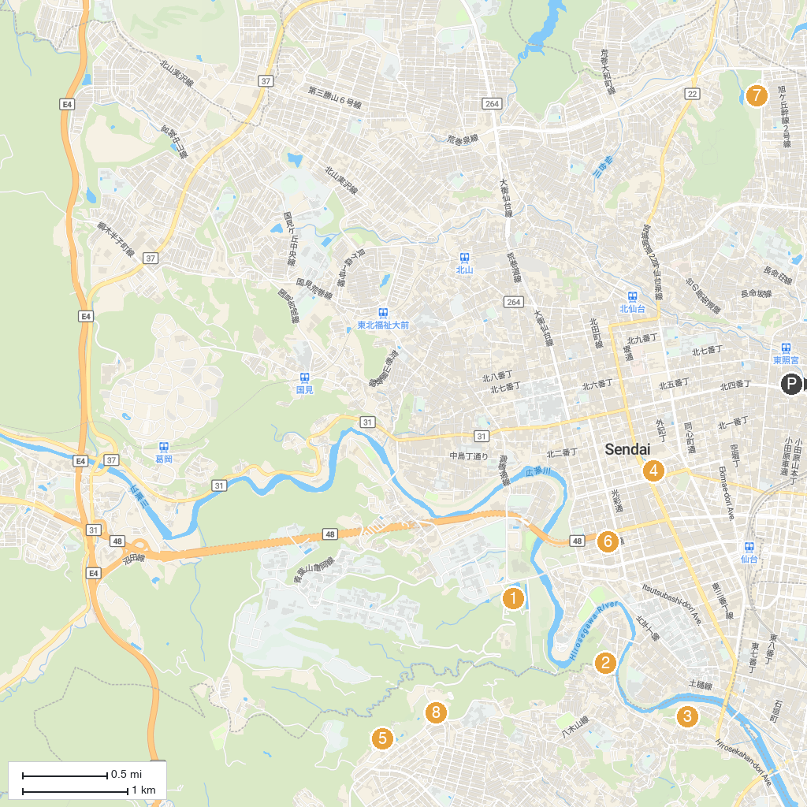
MAP KEY
1. Sendai City Museum | 5. Yagiyama Zoological Park
2. Zuihōden (Mausoleum of Date Masamune) | 6. War Reconstruction and Memorial Hall
3. Atago Shrine | 7. HOKUSHU Sendai City Science Museum
4. Kotodai Park | 8. Yagiyama Benyland
P. Cruise port / terminal
Map © MapTiler © OpenStreetMap contributors · cruiseports.org

